“I am veru profiesional ples hirar me”

[Go Grid, or go home]

Not to toot my own horn, but I do GRID

[Jacob]



[Master Thesis]

[Study programme]

[30/60 credits]

[Institute]

Abstract

The linear-quadratic (LQ) model is a well-established tool that explain the dose-response of in vitro irradiated cells. However, the model fails to describe effects occurring when spatially modulating the field during spatially fractionated radiation therapy (SFRT/GRID), creating high and low dose regions. Cell flasks containing A549 human lung carcinoma cells were irradiated by Magnus Børsting, former M.Sc student, with and without a GRID block (striped or dotted). The flasks were then scanned and segmented by Delmon Arous, PhD student. A traditional LQ model was fitted for OPEN field irradiations, then used to predict SFRT survival. Resulting in $α=0.06± 0.04$ and $β=0.010±0.008$. Survival for high dose areas was overestimated by the LQ model with a (RPD) of $40\%$. In low dose areas, the relative difference was about $5\%$.  
A 2D approach was proposed, where the segmented cell flasks were divided into equally sized quadrats and the number of surviving colonies within each quadrat was found before feeding the data to a Poisson regression model. Cell dosimetry was established for the spatially modulated field, where GafchromicTM EBT3 films were calibrated and irradiated with 5 Gy nominally to obtain dose maps. The mean dose calculated for all OPEN field dose maps were $4.98±0.05 Gy$.  
Dose and dose squared was used as explanatory variables in the Poisson regression, to obtain comparative results to the 1D LQ model. The 2D evaluated OPEN field regression with 0.5 mm2 quadrats, resulted in $α=0.06±0.01$ and $β=0.013±0.002$**.** The model was subsequently extended to include survival data from all GRID irradiated cell flasks, and the ratio of high dose and low dose area along with distance from the quadrat centers to the nearest peak were added as explanatory variables. They were added to explain the effects occurring when spatially modulating the irradiation field. More analysis needs to be performed, but the preliminary result is all regressors having a sub 0.05 p-value for 0.5 mm2 quadrats.

# Abbreviations and explanations

**AICc**– Corrected Akaike Information Criterion

**ANOVA** – ANalysis of VAriances

**Apoptosis** – A mechanism allowing damaged cells to initiate self-destruction (*Apoptosis | Cytology | Britannica*, 2013).

**ATM** – A protein activated by DNA damage. Its purpose is to phosphorylate (activate) numerous proteins related to cellular response after exposure to ionizing radiation (Samuel et al., 2002).

**ATP** – Adenosine triphosphate a molecule, which provides cells with energy for the cell and phosphate groups for protein activation. Through the process of hydrolysis, ATP is converted to ADP (adenosine diphosphate) (*Adenosine Triphosphate | Definition, Structure, Function, & Facts | Britannica*, 2020).

**BM** – Biomolecule. There are four types of biomolecules: carbohydrates, lipids, nucleic acids and proteins (*Biomolecule | Definition, Structure, Functions, Examples, & Facts | Britannica*, 2020). These are molecules important for normal cell functioning, and damage to them can have harmful consequences.

**CDK** – Cyclin dependent kinase

**CT** – Computed Tomography is an image modality using an X-ray source that creates an X-ray beam, which rotates around the patient, which lays between the source and a detector array. Attenuation values in different tissues are found and used to create an image (Villarraga-Gómez, 2016).

**Cytokines** – A category for signaling molecules that mediate immune responses by enabling cell to cell communication (Mandal Ananya, 2019). The cytokines relevant to this thesis are different variants of IL (interleukin) cytokine, TNF- $α$ and TGF- $β$. They are all important in regulating cell division (Najafi et al., 2014).

**DNA** – Deoxyribose nucleic acid

**DNA transcription** – A process of creating a messenger ribonucleic acid (mRNA), which is used to create specific proteins. A transcription factor binds to the DNA, telling the enzyme RNA-polymerase to read a gene sequence of interest. As each base (Adenine, Cytosine, Thymine and Guanine) in the sequence is read, a complementary nucleotide is attached to form the mRNA strand (*Transcription | Definition, Steps, & Biology | Britannica*, 2019). In the DNA Adenine binds to Thymine, but during transcription, Thymine is replaced with Uracil (Mason et al., 2020, p.48).

**EBT** – External Beam Therapy

**GD** – Gradient Descent

**GLCM** – Grey-level co-occurrence matrix

**GLM** – Generalized Linear Models

**GN** – Gaussian-Newton

**HR** – Homologous recombination

**IAEA** – International Atomic Energy Agency

**IQR** – Interquartile Range

**KDE** – Kernel Density Estimation

**LET** – Linear energy transfer

**LINAC** – Linear accelerator is a device that accelerates charged particles using an alternating electric field. They are used in radiation treatment to accelerate electrons into a high atomic-number target, creating high energy (MV) bremsstrahlung (Philip Mayes et al., 2007).

**LM** – Levenberg-Marquardt algorithm

**MC** – Monte Carlo

**MN** – Micronuclei are chromosome fragments not included in either daughter cells following cell division. They are a result of DNA damage, and might lead to immune responses (Harding et al., 2017).

**MLC** – Multileaf collimators are individual metal (often Tungsten) blocks used to shape a radiation beam coming from an external radiation therapy machine (Galvin et al., 1993).

**MLE** – Maximum likelihood estimator

**NHEJ** – Nonhomologous End-Joining

**OD** – Optical density

**P53** – A protein that is bound to another protein called mdm2. When DNA damage occur, it is released from mdm2, and it will bind to a gene for transcription of the p21 protein. This protein will in turn inactivate a protein complex responsible for promoting cell division (Alberts et al., 2014, p.1014).

**PCA** – Principal Component Analysis

**Phosphorylation** – Is the process of transferring a phosphate group (PO3) to a molecule. Proteins are activated by phosphorylation, and the addition of a phosphate group might change the proteins in different ways: Extra charge from PO3 can attract amino acid chains that connect to the existing protein, or the structure of the binding cite can change (Alberts et al., 2014, p.153-154). Both processes regulate the activity level of the protein.

**PAR** – Peak Area Ratio

**PMF** – Probability Mass Function

**PreRC** – Prereplicative complex

**Proteins** – Chains of amino acids with different shapes, sizes and functions. One main function is catalyzing certain chemical reactions. These proteins are called enzymes and have binding cites where specific molecules fit. The enzymes can both break and form chemical bonds (Mason et al., 2020, p.38).

**RNA-primer** – Ribonucleic acid primers are short nucleotide sequences generated by RNA-polymerase. They exist as a starting point for DNA-polymerase, because they are only able to continue an existing strand (Mason et al., 2020, p.292). The RNA-polymerase will attach Uracil instead of Thymine (see 1.7.1), and they must be removed and replaced by a different DNA-polymerase (Cooper, 2000b).

**ROS** – Reactive Oxygen Species is a collective term for highly reactive molecules based on oxygen. It has been shown an increase in ROS after exposure to radiation, and it has been hypothesized that they mediate DNA damage (Narayanan et al., 1997).

**RPD** – Relative Percentage Difference

**SC** – Surviving Colonies

**SCE** – Sister Chromatid Exchange is the process of sister chromatids exchanging genetic material. Increased SCE reflect the activity of homologous recombination (see 1.7.3), which again reflect the degree of DNA double strand breaks occurrences (see 1.7.3).

**SDD** – Source to Detector Distance

**SF** – Survival Fraction

**SVD** – Singular Value Decomposition

Contents

Abbreviations and explanations 5

1 Introduction 12

1. Theory 13

1.1 Ionizing Radiation 13

1.1.1 Photon interaction in matter 14

1.1.2 Charged Particle interaction in matter 19

1.2 Creating the radiation beam 23

1.2.1 X-ray tube 23

1.2.2 X-ray filtering 24

1.3 Dosimetry 25

1.3.1 Quantities 26

1.4 Cavity Theory 30

1.4.1 Bragg-Gray cavity 31

1.4.2 Bragg-Gray-Laurence 32

1.4.3 Burlin 33

1.5 Dosimetry methods 34

1.5.1 Parallel- Plate Ionization Chamber 34

1.5.2 Thimble Ionization Chamber 36

1.5.3 Radiochromic film 37

1.6 Statistics 38

1.6.1 Non-linear curve fit 38

1.6.2 Poisson Regression 41

1.6.3 Confidence interval 43

1.7 Radiobiology 43

1.7.1 DNA basics 43

1.7.2 Cell Cycle and Checkpoint 45

1.7.3 DNA damage and repair 48

1.7.4 Cell Survival Curves 51

1.7.5 LQ-model 52

1.7.6 Radiation Induced Bystander Effect 55

1.7.7 Spatially Fractionated Radiation Therapy 56

2 Materials and Methods 58

2.1 Dosimetry 58

2.1.1 X-ray dosimetry 58

2.1.2 Gafchromic film dosimetry 63

2.2 Cell Experiments 78

2.3 Segmentation 79

2.4 Cell Survival Analysis 82

2.4.1 Data acquisition and image registration 82

2.4.2 1D Analysis 84

2.4.3 2D Analysis 86

3 Results 94

3.1 X-ray dosimetry 94

3.2 Gafchromic film 96

3.3 Cell survival 110

3.3.1 1D survival 112

3.3.2 2D analysis 116

4 Discussion 123

4.1 X-ray Dosimetry 123

4.2 Gafchromic film dosimetry 123

4.3 Cell Survival 127

4.4 1D survival analysis 128

4.5 2D survival analysis 129

1 DUMP 136

2 References 139

3 Appendix 159

3.1 Appendix A 159

3.1.1 Compton Scattering 159

3.1.2 Mean free path 163

3.1.3 Nearest Peak Code 165

3.1.4 Reference conditions of FC65-G ionization chamber 166

3.1.5 X-ray dosimetry 167

3.1.6 Gafchromic film fitting 168

3.1.7 Initial guess LM 171

3.1.8 Cell flask registration 173

3.1.9 Poisson eval 176

3.1.10 Average Distance 183

# Introduction

Cancer is uncontrolled cell division where cancerous cells invade surrounding tissue and might cause fatal disruptions. Around 10 million deaths were cancer related in 2018 (WHO), making it the second leading cause of death. As life expectancy increase, the probability of developing cancer during your lifetime increases (*Risk Factors*, 2015). However, numerous methods have been developed to treat the disease, with surgery, chemotherapy, radiotherapy and combinations of these being the most common. Resulting in a steadily decreasing cancer death rate since the 1990’s (Sandy McDowell, 2019).   
In this thesis the focus is radiotherapy where ionizing radiation is used to damage the cancer cell’s DNA to such a degree their killed. The most common radiotherapy treatment is external-beam radiation therapy using high energy photons. In its most basic form, a beam of photons is shot towards the patient at different angles achieving as homogeneous dose distribution to your target as possible (L. Yan et al., 2019). However, because photons distribute their energy further into the medium (*Photon Dose Distributions | Oncology Medical Physics*, n.d.), they also damage healthy tissue positioned behind the tumor. And if the tumor is deep seated the dose must be increased damaging more tissue in front of the tumor. One solution was to move away from a homogeneous dose distribution by spatially fractionated radiation therapy (a.k.a. GRID therapy). Irradiating the patient with high doses through a GRID block generates low dose areas wherein tissue sparing can occur (Mohiuddin et al., 1999), while retaining high tumor control (R. Asur et al., 2015). The radiobiological effects of spatially fractionating the radiation field such as abscopal effects and bystander effects are well known, but the physical and biological parameters that characterize the effects are yet to be clearly defined (Blyth & Sykes, 2011; Grass et al., 2016).

**The aim of this thesis**

I want to explain that the effects are not the same everytime, and there are numerous factors that decide

Why should you be interested, check

What do we know, what is missing, check

Goal of the thesis

A lot of folks die of cancer, that might be a bad thing. Lets explore. [A very wise man, 2022]

Using dose as an explanatory variable in the LQ model is well documented, but we wanted to see if we could expand the model using other variables, and maybe explain how survival is affected by having a spatially fractionated radiation field.

(ikke ferdig, some explanation of cancer treatment and how spatially fractionated radiotherapy has the potential of improving tissue sparing but keep tumour control)

We know how well it reduces large bulky tumours. But the mechanisms behind it is not well defined. The LQ model does not include spatial fractionation and how it affects survival. Is there another parameter that might explain effects such as the bystander effect?

This thesis examines the 2D survival of A549 lung cancer cells irradiated with a spatially modulated X-ray radiation field. The thesis is therefore separated into two parts: First we need to establish the dosimetry of the cells. Then we need to establish a model that explains how the spatial modification affects survival.

We will use segmentation data from Arous et al. of irradiated cells from experiments performed by (Magnus Børsting, 2020). Because the cells have been irradiated using a spatially fractionated radiation field, the dose is not uniform, and dosimetry experiments have been made.

# Theory

## Ionizing Radiation

Radiation is transfer of energy. The main categories are ionizing and non-ionizing radiation. I.e., it either has enough energy to liberate an electron from the atom, or it doesn’t. Non-ionizing radiation consists of low-energy electromagnetic (EM) waves such as UV-light and microwaves. Further right in the EM spectrum the frequency of the radiation increases. Because energy is $E=hf$, with $h$ being the Planck constant and f being the frequency, the energy also increases, and the radiation becomes ionizing X-ray and $γ$ particles. To clarify: The EM waves do not become particles, but it is know from the discovery of the photo-electric effect that you might interpret EM waves as “showers” of photons (Einstein & Infeld, 1938). Together with neutrons, they make up a group called uncharged particles. They are highly penetrating because they need to interact directly with a target.

Charged particles are different, they consist of particles with either positive or negative charge. Some examples are protons (+), electrons (-), and $α$-particles (+2). Their interaction probability is greater compared to uncharged particles. A photon must be close to either a nucleus or an electron for an interaction to occur. A charged particle may interact at a distance. Their Coulomb field interacts with the Coulomb fields of other electrons, causing a “Continuous Slowing Down” (Attix, 1986, p. 160).

The path of a charged particle through a medium is highly dependent on the particle at hand. What is the charge, its velocity, and its weight?   
In medical physics, the primary interested is ionizing radiation and using its properties to identify or treat medical lesions. This is further examined in the radiobiology section (1.7).

### Photon interaction in matter

Photons are energy-carrying particles, without mass, traveling at the speed of light. They interact with the surrounding medium in several ways. The main interactions are Rayleigh Scattering, Photoelectric effect, Compton Scattering, pair/triplet production, and photonuclear interactions (Attix, 1986, p.124-125). Which interaction you’ll have is highly dependent on the atomic number $Z$ of the photon absorber and the energy of the incoming photon. The probability of interaction is defined as interaction cross-section, with the unit $cm^{2}$. In Figure 1‑1 we see which interaction type dominates for specific energies and atomic number Z. Pair production is the annihilation of photons in the presence of a nucleus’s Coulomb field, producing a positron ($e^{+}$) electron ($e^{-}$) pair. The interaction demands, at minimum, the rest energy of two electrons ($2m_{0}c^{2}=1.02 MeV$) (Attix, 1986, p.146-148). We will use photons with energies in the kV region, where the photoelectric effect and Compton scattering dominate, and these interaction types will naturally be our focus.

Rayleigh scattering is a relevant interaction type for lower energy photons. The photons are deflected from their path, but no energy transfers occur; hence, Rayleigh scattering does not contribute to the absorbed dose in the medium. Nevertheless, it is still an important interaction type because it gives a complete picture of the photon’s path.   
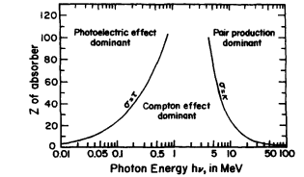

Figure 1‑1. Photon interaction probability (defined as interaction cross-section $σ$ [$cm^{2}$] as a function of atomic number Z and photon energy $hν$ [MeV] The curves represent the area where two interactions have the same probability (Attix, 1986, p.125).

#### Photoelectric effect

The photoelectric effect is when an incident photon’s energy is absorbed by an electron bound to an atom. The kinetics is illustrated in Figure 1‑2. If the energy is equal to or larger than the binding energy of the electron $E_{b}$ it will ionize the electron. The energy transferred from the photon to the electron depends on its initial energy and the electron’s binding energy (Attix, 1986, p. 139).

|  |  |
| --- | --- |
| $$T=hν- E_{b}.$$ | 1‑1 |

The photon might liberate an inner shell electron with higher binding energy (K- or L-shell electron). A looser bound electron will deexcite, filling the vacancy. The energy difference is either emitted as characteristic X-rays or by ionization of a valence electron (outer shell electron). The latter is called the auger effect, and the ionized electrons are known as auger electrons (Attix, 1986, p.143).   
The cross-section per atom for the photo-electric effect is proportional to atomic number and incident energy of the photon

$$τ α \frac{Z^{n}}{{\left(hν\right)}^{m}} \left[\frac{cm^{2}}{atom}\right] , 4<n<5 , 1<m<3 ,$$

The expression confirms Figure 1‑1, as photoelectric effect increases with atomic number, and decreases with energy.

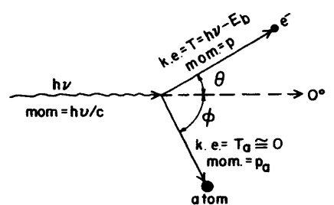

Figure 1‑2. Illustration of the photoelectric effect. A bound electron absorbs all the energy of incoming a photon. If the energy is high enough, it will ionize the electrons (Attix, 1986, p.138). The kinetic energy of the electron is dependent on the initial energy of the photon $hν$ and the binding energy of the electron $E_{b}$. Recoil energy is given to the atom, but it is approximately $0$.

#### Compton Scattering

The scattering process differs from the photo-electric effect in that the electron orbiting the nucleus is assumed free, which results in an inelastic collision. It is illustrated in Figure 1‑3. The errors from this assumption have proved negligible, as the errors don’t become substantial until we have a high atomic number Z and low initial energy $hν$. When these conditions are reached, the photoelectric become the dominating interaction type (Attix, 1986,p. 125).

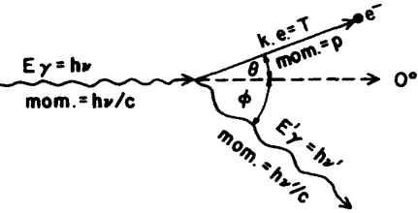

Figure 1‑3. Illustration of Compton scattering, where the electron is assumed free.

The second difference compared to the photo-electric effect is that the photon only transfers part of its energy. The energy of the scattered photon follows this expression, which is derived in Appendix A

|  |  |
| --- | --- |
| $$hν^{'}=\frac{hν}{1+\frac{hν}{\left(m_{e}c^{2}\right)\left(1-cosϕ\right)}}$$ | 1‑2 |

We observe a strong correlation with the energy of the incident photon, and the scattering angle. And a maximum energy transfer to the electron for ${180}^{∘}$.   
The Compton cross section per electron was derived by Klein and Nishina. They improved on the existing theory of Thomson scattering. Thomson’s cross section was independent of incident photon energy, and assumed $hν=hν^{'}$ (Attix, 1986, p.130). This is correct for low energies. However, in Figure 1‑4 we see the energy of the scattered photon starts decreasing for increasing scattering angle around $0.01 MeV$, and reaches its minimum at ${180}^{∘}$.

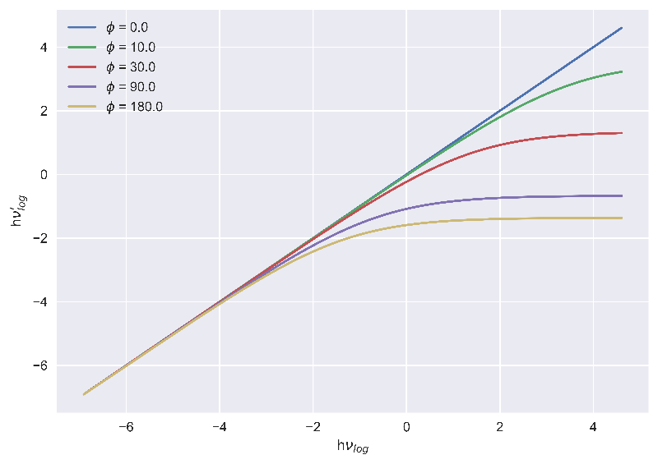

Figure 1‑4. Compton scatter energies in $\log{eV}$. $hν$ is energy of incident photon, $hν'$ is energy of scattered photon.

The Klein-Nishina cross section is represented by the symbol $σ$.

Each interaction has its cross section. The photo-electric effect has $τ$, Compton scatter has $σ$ pair production has $κ$ and Rayleigh scattering has $σ_{R}$. It is practical to sum each cross section to create a combined interaction variable. It is defined as the attenuation coefficient

|  |  |
| --- | --- |
| $$μ= σ + τ+ κ+σ_{R} \left[cm^{2}/atom\right] .$$ | 1‑3 |

However, it is more insightful to normalize it with density $ρ$. This way, we get $μ/ρ\left[\frac{cm^{2}}{kg}\right]$, which represents how a photon is attenuated in a medium. This is called the **mass attenuation coefficient**.

For a polyenergetic photons, you must average the coefficient to include the full energy spectrum of the photons, but for simplicity we’ll assume monoenergetic photons.   
Now that we have the probability of interaction, we can include the fraction of kinetic energy transferred from the incident photon to a secondary electron within a volume of interest. This is called the **mass energy-transfer coefficient**

|  |  |
| --- | --- |
| $$\frac{μ_{tr}}{ρ}=\frac{σ}{ρ}⋅\frac{T}{hν}+\frac{τ}{ρ}⋅\frac{hν-E_{X}}{hν}+\frac{κ}{ρ}⋅\frac{hν-2m_{0} c^{2}}{hν} ,$$ | 1‑4 |

Where $T$ is the energy of the liberated electron after Compton scatter, $E_{X}$ is the energy of either K- or L-shell (highest binding energy) characteristic X-rays generated after the Auger effect. These X-rays carry energy away from the volume of interest and we therefore subtract their energy. $2m_{0}c^{2}$ 
 is the rest energy of the electron-positron pair created by pair production. We subtract because it’s the energy needed to create the electron-positron pair, leaving us with the kinetic energy (Attix, 1986, p.155).  
  
The last expression we want is the **mass energy-absorption coefficient $μ_{en}/ρ$** . It represents the energy absorbed by the volume. It relates to the mass energy-transfer coefficient by

|  |  |
| --- | --- |
| $$\frac{μ_{en}}{ρ}=\frac{μ_{tr}}{ρ} (1-g),$$ | 1‑5 |

Where g is the fraction of energy lost to radiative loss (Attix, 1986, p.155-156).

#### Photon range

(Might remove)

Mean free path is the expected distance a photon will travel before interacting with the medium (*Mean Free Path | Physics | Britannica*, 2007). In Appendix A we derived an expression for mean free path for a photon traversing a slab of material with infinitesimal area $da$ and thickness $dx$

|  |  |
| --- | --- |
| $$<x> =\frac{1}{μ} .$$ | 1‑6 |

The pathlength of the photon decreases with increasing attenuation. This is an important result because it allows us to predict the path of the photon. It is especially useful when performing Monte Carlo (MC) simulations, which we will come back to in 2.1.2.4.

### Charged Particle interaction in matter

A charged particle has either positive or negative net electrical charge, such as electrons ($e^{-}$), protons ($e^{+}$) and ions (an atom with a surplus of electrons or protons). Because of their charge, the particles will interact with other charged particles through their Coulomb fields. Two equal charges will repel, and two opposite charges will attract. A charged particle traversing a medium is surrounded by Coulomb fields of positive (nuclei, positive ions) and negative (electrons, negative ions) charges, enabling the charged particles to interact at a distance. This distance is known as the impact parameter and is defined as the distance from the charged particle to the closest nucleus. We have three main categories of interactions:  
Soft collisions, hard collisions, and Coulomb interactions with the nucleus.

#### Soft collisions

Soft collisions are small Coulomb interactions between the Coulomb fields of an atom and a charged particle. The impact parameter is much larger than the atomic radius (distance from valence electrons to nuclei), and small amounts of energy are transferred to the orbiting electrons of an atom, mainly causing excitations. Even though the energy transfers are very small, the interaction is highly probable, therefore contributing to half of the energy loss of the charge particle (Attix, 1986, p.161).

#### Hard collision

Hard collisions happen when the impact parameter has the same order of magnitude as the atomic radius. The result is a significant kinetic energy transfer to an assumed free and stationary electron. These electrons are called $δ$-rays, which undergo the same charge particle interactions. The hard collisions might also result in liberation of an inner shell electron as described in 1.1.1.1, resulting in emission of characteristic X-rays (Attix, 1986, p.162).

#### Radiative transfer

Radiative transfer, also known as bremsstrahlung, is a process where a charged particle interacts with the nucleus’s Coulomb field. The impact parameter must be much lower than the atomic radius for this to happen. The interaction mainly occurs with electrons and will therefore be the focus point (Attix, 1986, p.163). The radiative transfer refers to an inelastic collision between the nucleus and the electron (See Figure 1‑5). The electron with its negative charge is attracted to the nucleus’s positive charge, causing a deacceleration and deflection of the electron from its incident path. The decrease in kinetic energy $ΔE_{e}$ is converted to a photon, thus conserving energy.   
The probability of radiative transfer Is much lower compared to elastic scattering (2-3%) and is proportional to $q^{2}z^{2}T/M_{e}^{2}$ (Grieken & Markowicz, 1993, p.3), where q is the charge, Z is the atomic number of the atom, T is the kinetic energy of the electron and $M_{e}$ is the rest mass of the electron. With a larger Z, the atom has a higher proton count, resulting in the nucleus having a larger Coulomb field attracting the electron. The kinetic energy of the electron is important because the electron needs to penetrate the electron cloud surrounding the nucleus.  
Radiative transfer is used when creating X-rays inside an X-ray tube, but we will come back to this in the section covering the X-ray tube (1.2.1).

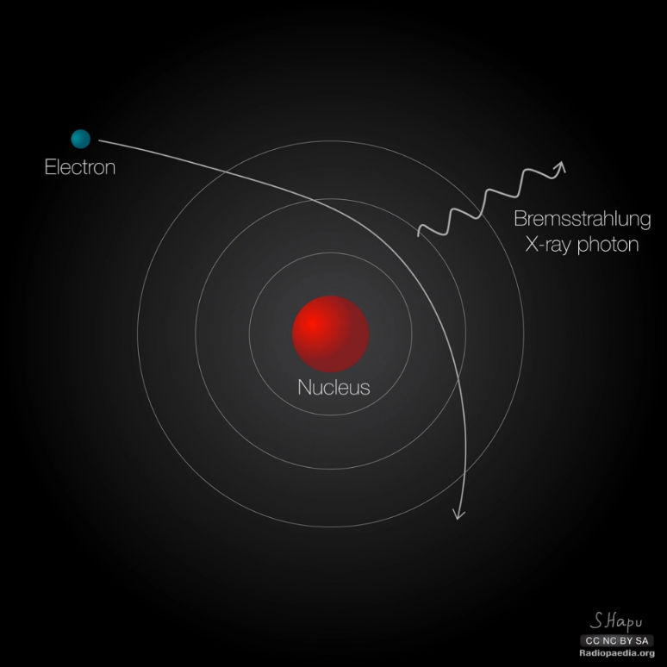

Figure 1‑5. Illustration of radiative transfer, where an electron inelastically collides with an atom’s nucleus deflecting it from its path. The result is an emitted photon with energy equaling the energy loss of the electron (Hapugoda, 2017).

#### Stopping Power

Stopping power is how much energy we expect the charged particle to lose per unit length. It can be found by integrating differential energy loss per length $dT\backslash dx$ over possible energy transfers.   
As discussed, the charged particle might lose its energy by colliding or by radiative transfer, we therefore separate these contributions (Attix, 1986, .165)

$$S=S_{c}+S_{r}$$

Energy lost to radiative transfer does not contribute to dose, because of the larger range of the bremsstrahlung. Radiative stopping power is still important to accurately describe the range of the charged particle.   
Collision stopping power is split into two parts: for soft $S_{soft}$ and hard collisions $S_{hard}$. Energy loss is dependent on the material it penetrates, we therefore introduce **mass stopping power** by dividing the stopping power by the material density $S/ρ$.   
The total collision mass stopping power is

|  |  |
| --- | --- |
| $$\frac{4πN_{A}Z}{A}\frac{r_{e}^{2}m_{e}c^{2}}{β^{2}}z^{2}\left[\ln{\frac{2m_{e}v^{2}}{I}}-\ln\left(1-β^{2}\right)-β^{2}-\frac{C}{Z}\right] \left[MeV\frac{cm^{2}}{g}\right] .$$ | 1‑7 |

Where $N_{A}Z/A$ is electrons per gram, $r_{e}$ is classical electron radius, $β=v/c$, *I* is mean excitation potential in the medium, z is electron charge, and $C/Z$ is shell correction. The collision stopping power assumes the electron’s velocity to be much greater than that of the orbiting electrons in atoms. As the electrons slow down the assumption becomes untrue, and the shell correction accounts for this. Stopping power is inversely dependent on the square of the velocity and electrons with high kinetic energy will lose more energy further into the medium.

Mass collision stopping power is closely related to absorbed dose (energy absorbed per mass). When CPE is achieved absorbed dose is expressed as

$$D=ϕ\frac{S_{c}}{ρ} \left[MeV/g\right],$$ $ϕ$ is electron fluence in a radiation field (1.3.1) (Seuntjens et al., 2005).

Stopping power is useful because we can estimate the range of the charged particle, but we also need to know how much of that energy is absorbed by the medium. Linear Energy Transfer (LET) represents this quantity with the unit $keV/μm$. It is also known as restricted stopping power (Attix, 1986, p.179). When high energy electrons experience hard collisions, they liberate secondary electrons. A cutoff energy $Δ$ is introduced, because some electrons might have high enough energy to escape the volume of interest. If none of the secondary electrons can escape, we have CPE (1.3.1) and

$$LET=S_{c}.$$

LET is especially important in radiobiology because it measures how damaging a radiation type might be. A higher density of energy depositions results in higher dose absorbed and more damage. A typical percentage depth dose curve from photon beams of various energies is shown in Figure 1‑6. As photons attenuate through the medium, they dissipate their energy by interactions mentioned in 1.1.1. For high-energy photons we see a buildup of dose. Because of the high energies of the photons, the generated electrons will also have high energies. As seen in equation 1‑7 the stopping power is lower for charged particles with high kinetic energy. So, the secondary electrons will lose their energy further into the medium, causing the buildup of dose we see in Figure 1‑1. For kV photons the buildup is small but not negligible.

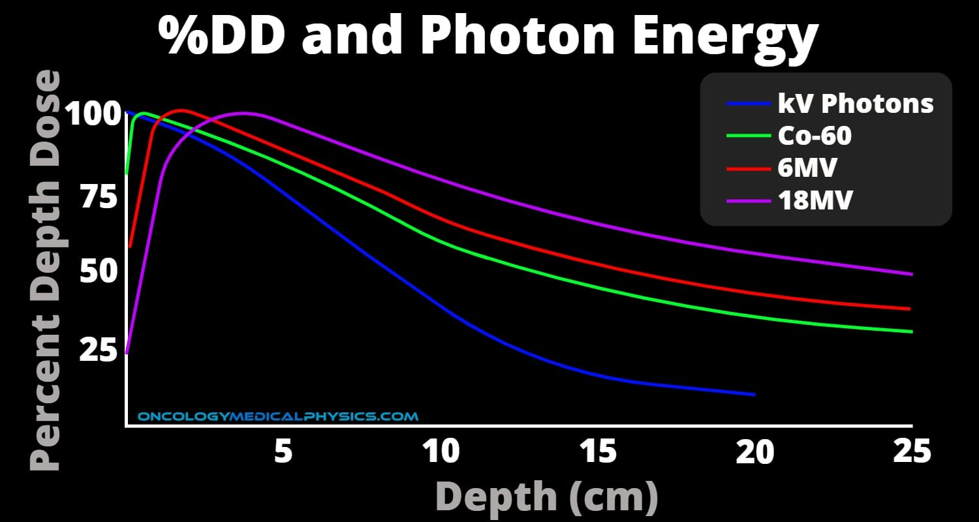

Figure 1‑6. Percent Depth Dose curve for photon beams of different energies. As the photons attenuate through the medium they lose energy to electrons, which in turn lose energy through various interactions. A buildup region is seen for high energy photons before the maximum relative dose is reached. The same effect is not seen for photons of kV energy (Photon Dose Distributions | Oncology Medical Physics, n.d.).

#### CSDA

If we assume that the electrons are continuously slowing down (i.e., neglecting fluctuations in energy loss) as they interact, we can integrate total mass stopping power to get an approximate range called the continuously slowing down approximation (CSDA) range

$$R_{CSDA}=\int_{0}^{T_{max}}{\frac{dT_{c+r}}{ρdx}} \left[\frac{g}{cm^{2}}\right] .$$

This lets us describe the path of secondary charged particles following an ionization event. It is different to **projected range**, as it describes the total range of the particle including all twists and turns. Projectedrange is a measure of how deep into the medium the particle penetrates (Attix, 1986, p.181).

## Creating the radiation beam

When treating or diagnosing patients using radiation, you need a stable and reliable beam. Various techniques are used for this purpose, but for our case we will focus on the X-ray tube.

### X-ray tube

The X-ray tube’s purpose is to convert electron energy into X-rays. As mentioned in 1.1.2 we have two interaction types generating X-rays from electrons interacting with matter. The first is characteristic X-rays generated after ionization of an inner-shell electron and the second is generation of bremsstrahlung from deacceleration of electrons traversing close to the atomic nucleus. In Figure 1‑7 we see an illustration of the tube. The first component of the X-ray tube is the cathode, which is a spiraled wire called the filament. The filament is often placed inside a glass chamber called the envelope (Nadrljanski, 2021b). The filament is heated through resistance heating of a wire running through the cathode (Goel, 2021a). When the cathode reaches the right temperature, it will emit electrons through thermionic emission. A process where the heating energy surpasses the binding energy of electrons, and they are emitted from the metallic structure (*Thermionic Emission | Physics | Britannica*, 2021). The electrons are released into an evacuated tube with a high voltage. The potential difference accelerates the electrons toward a positively charged anode/target. Most anodes in x-ray tube targets are made of tungsten, because of their high atomic number and high melting point (Nadrljanski, 2021a).

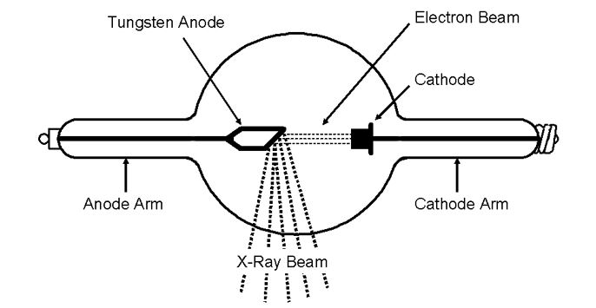

Figure 1‑7. Coolidge hot cathode X-ray tube with heated cathode, that releases electrons into vacuum sealed tube with potential difference $dV$ causing acceleration of the electrons. The electrons are focused using a magnetic lens before hitting a target of high density material image ref. (Aksnes, 2020).

The electrons generate bremsstrahlung at different impact parameters (see 1.1.2), we therefore get a spectrum of possible X-ray energies, which is decided by Kramer’s rule. The essence of this rule is that when electrons hit a thick target the probability of direct impact with the nucleus, i.e., the impact parameter (see 1.1.2) is 0, is small. It is more probable that the electron experiences many smaller energy transfers and gradually deaccelerates, creating X-rays with less energy (Attix, 1986, p.211-214). X-ray tubes usually produce photon energies between 20 and 100 kV (Potts, 2005). The intensity of the beam follows the inverse square law where intensity decreases with the square of the distance away from the source following the equation (Attix, 1986, p.44)

$$I=α/r^{2} ,$$

where $α$ is a proportionality constant.

### X-ray filtering

It is often desirable to remove the smaller X-ray energies from the X-ray beam. This is done by inserting a filter inside the X-ray beam. The filter attenuates lower energy X-rays and creates a more homogeneous energy spectrum (Goel, 2021). Figure 1‑8 illustrates the difference between an unfiltered and filtered X-ray beam created in an X-ray tube with tungsten as target. The first peak is the low energy photons such as background radiation, the second and third peak is X-rays emitted after ionization of K-shell electrons (Amiri et al., 2021).

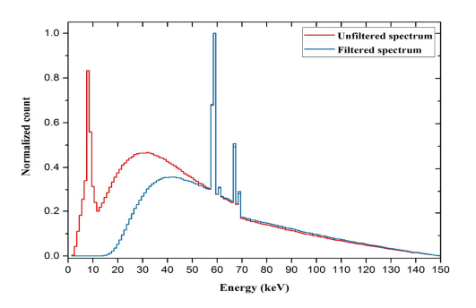

Figure 1‑8. Unfiltered vs filtered X-ray energy spectrum created from a Tungsten anode with 2.5 mm aluminum filtering (Amiri et al., 2021).

## Dosimetry

Taking any medicine requires knowledge about the correct dosage. Medicine is often administered through pills with carefully measured ingredients to give the right effect. Radiation does not have that advantage. Radiation dose is dependent on the energy, exposure time, distance from source, material of the absorber and quality (e.g., photons, protons or neutrons) of the radiation.   
The solution has been to use the effects of radiation on different substances such as discoloring (film dosimeter), temperature change (calorimeter) and light emission (thermoluminescence). To understand all the intricacies of dose measurement we need to define important quantities.

### Quantities

#### Ionizing radiation field

We wish to find number of ionizations in a point P inside a field of ionizing radiation. A ray cannot interact with a 0-dimensional point, we therefore define a finite area $a$ around the point. The incident angle of the ray might not be parallel to the area $a$, we therefore need to account for all possible angles. This results in a sphere around P as seen in **Error! Reference source not found.** with infinitesimal volume dV, mass dm and cross-sectional area da (Attix, 1986, p.5-6).   
The number of traversing rays per cross sectional area da is defined as **fluence $Φ$** .

$$Φ=\frac{dN}{da}$$

If the number of rays differs over time, the fluence needs to be integrated over time to get the fluence rate.   
The radiant energy of the rays is equally as important as the number of rays, for a polyenergetic beam with energies E, we have **energy fluence $Ψ$**  **.**

$$Ψ=\frac{d^{2}N\left(E\right)}{dadE}=\frac{dΦ\left(E\right)}{dE}$$

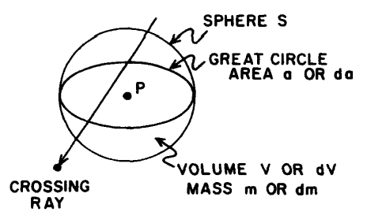

Figure 1‑9. Ionizing radiation field defined as a sphere encapsulation a point P with infinitesimal volume dV, mass dm, with a cross sectional area da (Attix, 1986, p.6).

#### KERMA

With the energy fluence we have the energies traversing the sphere, but to get a dose we need the rays to interact and release energy. This is where KERMA comes in. Kinetic Energy Release per Mass. It describes the process where uncharged particles (photons and neutrons) enters a defined volume and transfers some or all of their energy to electrons in the volume. The energy transfer is expressed by

|  |  |
| --- | --- |
| $$ϵ_{tr}=E_{γ,in}-E_{γ-rl,out}+∑Q ,$$ | 1‑8 |

Where $ϵ_{tr}$ is the expected energy transferred from uncharged radiation with energy $E_{γ,in}$ into the volume minus the energy of the uncharged radiation $E_{γ-rl,out}$ leaving the volume without interacting.   
RL stands for radiative losses and represents interactions where charged particles generate photon energy after the initial ionization. If these photons leave the volume, it does not matter because we are only interested in the energy transferred by the incident particles entering the volume.  
The final term is conversion of rest mass to energy or energy to rest mass e.g., pair production (see 1.1.1) where a photon annihilates creating an electron positron pair.   
With $ϵ_{tr}$ we can define KERMA

|  |  |
| --- | --- |
| $$K=\frac{dϵ_{tr}}{dm} \left[\frac{J}{kg}\right]$$ | 1‑9 |

For monoenergetic photons, KERMA is related to energy fluence using the expression

$$K=Ψ\frac{μ_{tr}}{ρ} ,$$

Where $μ_{tr}/ρ$ is the mass energy transfer coefficient (see 1.1.1), which represents the probability of the photons transferring energy to the volume (Attix, 1986, p. 21-22).

Until now, we’ve neglected how the electrons have spent their energy after they’ve received it from the incident photons. Accounting for radiative loss gives net energy transfer $ϵ_{tr}^{n}$ represented by this expression

$$ϵ_{tr}^{n}=E_{γ,in}-E_{γ,out}+ΣQ.$$

$ϵ_{tr}^{n}$ represents the energy of the electrons, not lost to radiative transfer. We can now separate KERMA into two parts: collision KERMA $K_{c}$ and radiative KERMA $K_{r}$, where $K_{c}$ for monoenergetic photons is expressed as

$$K_{c}=\frac{dϵ_{tr}^{n}}{dm} .$$

We can relate $K_{c}$ and energy fluence to another known quantity: mass energy-absorption coefficient $μ_{en}/ρ$ (see 1.1.1) (Attix, 1986, p.24-25)

$$K_{c}=Ψ\frac{μ_{en}}{ρ} .$$

#### Absorbed dose

When describing KERMA, we are interested in how energy is transferred from the photon to the medium. But photons aren’t the only contributors to dose; charged particles also transfer energy to the volume. We therefore define total energy transfer as

$$ϵ=E_{e,in}+E_{γ,in}-E_{e,out}-E_{γ,out}+ΣQ$$

Where we include the energy transferred by charged particles $E_{e}$ entering the volume.   
We can now define dose as (Attix, 1986, p.26-27)

$$D=\frac{dϵ}{dm} [J/kg].$$

The unit is the same as KERMA, but it is called Gray or Gy. The unit is especially important in radiobiology, because the amount of absorbed energy affect an organism’s chance of repairing the damage caused by the radiation (see 1.7.3).

#### Exposure

Exposure is defined as total charge Q of ions of one sign (+ or -) produced by X-rays or $γ$-rays per mass m of air when all secondary electrons are stopped in the air and charged particle equilibrium (see next paragraph) is achieved (Attix, 1986, p.29-30). The expression for exposure in an infinitesimal air volume is

|  |  |
| --- | --- |
| $$X=\frac{dQ}{dm} [C/kg].$$ | 1‑10 |

We can relate exposure to mass energy absorption coefficient ($μ_{en}/ρ$) and energy fluence $Ψ$ by introducing the variable $\overline{W}$. $\overline{W}$ is the mean energy required to create an ion pairs (Podgorsak, 2016, p. 744). The resulting expression for monoenergetic photons is

|  |  |
| --- | --- |
| $$X=Ψ {\left(\frac{μ_{en}}{ρ}\right)}_{air}{\left(\frac{e}{\overline{W}}\right)}_{air}=K_{c} {\left(\frac{e}{\overline{W}}\right)}_{air}.$$ | 1‑11 |

$e$ is the elementary charge.

#### Charged Particle Equilibrium (CPE)

If $E_{e,in}=E_{e,out}$ the energy distribution of charged particles entering the volume is equal to the energy distribution of charged particles leaving the volume (visualized in Figure 1‑10) (Attix, 1986, p.65). This situation is called **charged particle equilibrium** (CPE), and if satisfied,  
reduces absorbed dose to $K_{c}$ (Attix, 1986, p.69).

|  |  |
| --- | --- |
| $$D=K_{c}=Ψ\frac{{ μ}_{en}}{ρ} .$$ | 1‑12 |

CPE essentially demands constant photon fluence everywhere around and within the smaller volume v in Figure 1‑10. If the fluence dropped significantly when entering the large volume V, more secondary electrons would be generated at the entrance of v, compared to the exit and we don’t have CPE (Attix, 1986, p.67).

When CPE is achieved, we can easily find the dose ratio between two volumes. This is a practical metric because we often need to relate dose to mediums of different densities.   
CPE is not necessarily easy to achieve. If the volumes are near the source, we’ll have much higher fluence on the side closest to the source (Attix, 1986, p.72). This causes more ionizations closer to the surface of V, compared to the surface of v, and CPE fails.   
For larger photon energies, the range of the liberated charged particles will increase compared to the range of the photons. Therefore, charged particles ionized near the surface of V have larger ranges than the charged particles ionized near the surface of v. The generated charged particles will therefore enter volume v but doesn’t exit, and CPE fails.

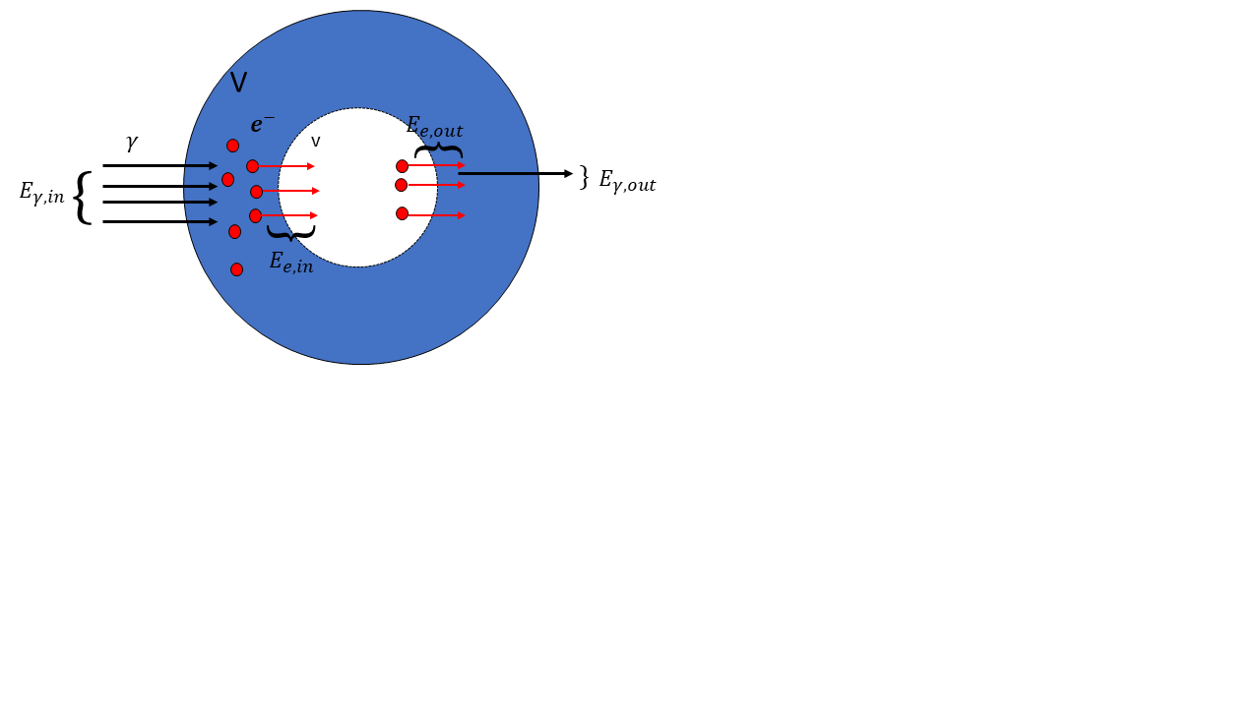

Figure 1‑10. Charged particle equilibrium visualized, where photon energy enters a volume $V$ transferring energy to charged particles (electrons in this case), that traverses a smaller volume $v$. The electrons exiting $v$ are of same type and energy distribution as the electrons entering, and we have CPE.

**Transient Charged Particle Equilibrium (TCPE)**

CPE demands no significant attenuation of photons within the smaller volume in Figure 1‑10. As mentioned, this would require an infinitesimal small volume. A more realistic approach is that the photons ionize electrons inside the smaller volume. As the photons traverse, they lose energy, causing a decrease in dose contribution. Instead of dose being equal to $K_{c}$ we assume proportionality, and the expression for dose becomes

$$D=K_{c}(1+f) ,$$

where f is the dose contribution from attenuation of photons through the volume.

## Cavity Theory

When measuring dose, we use a dosimeter. A very popular dosimeter is the ionization chamber, which we’ll discuss in detail (1.5). A more fundamental description of an ion chamber is a gas filled chamber connected to an electrometer. Radiation ionizes the gas, and the electrometer measures a charge proportional to absorbed dose.   
However, dose (a.k.a., energy absorbed in the medium) is not equal between mediums of different density. We therefore need to relate the dose absorbed by the gas to the medium we are interested in. The situation is visualized in Figure 1‑11.

### Bragg-Gray cavity

In Bragg-Gray cavity theory, dose to water is related to dose to air by

$$D_{W}=D_{Air}⋅{\left(\frac{S}{ρ}\right)}_{air}^{w} ,$$

where ${\left(\frac{S}{ρ}\right)}_{w}^{air}$ is the mass stopping power ratio between water and air. Dose to water is often used because radiation beams in the clinic are calibrated with the assumption that all tissue is “water-like” (Andreo, 2015). We see that the electron fluence is assumed constant, but for this to be true two conditions needs to be fulfilled (Attix, 1986, p. 232):

1. The fluence of charged particles should not be perturbed in the cavity
2. Only charged particles crossing the cavity contributes to the dose.

The second condition requires no significant attenuation of photons inside the cavity. Which in turn requires an infinitesimally dimensioned cavity. Gray calculated the size that satisfies these conditions and found that for unfiltered $γ$-radiation you would need a $3 cm^{3}$ air volume, while $100 kV$ X-rays require $0.1 cm^{3}$ for air filled cavity with graphite walls (Alm Carlsson, 2001).



Figure 1‑11. A volume with material w (e.g., water), with an air-filled cavity inside. Energy $Ψ$ traverses the volume releasing energy contributing to dose inside the cavity.

### Bragg-Gray-Laurence

The ideal Bragg-Gray scenario is not possible, as it would require an infinitesimally dimensioned dosimeter not to alter the charged particle fluence. It also demands the stopping power ratio ${\left(\frac{S}{ρ}\right)}_{W}^{Air}$ to be independent on energy, which is not the case for increasingly different mediums (Alm Carlsson, 2002). The theory was improved by introducing CSDA of the charged particles. This allows the charged particles to slow down inside the cavity, and we need to integrate over the stopping power ratio

$$\frac{D_{w}}{D_{air}}= \int_{0}^{T_{max}}{\frac{ϕ\left(T\right){\left(\frac{S}{ρ}\right)}_{w}}{{ϕ\left(T\right)\left(\frac{S}{ρ}\right)}_{air}} dT . }$$

Bragg-Gray-Laurence in its simplest form requires CPE to accurately calculate the energy distribution of the electrons (Alm Carlsson, 2001). It might seem like a contradiction to incorporate CSDA, because CPE requires the energy of entering charged particles to be equal to the energy of the exiting charged particles. However, the cavity is still assumed to be small compared to the charged particle range and the energy loss inside the cavity is negligible. And because of the small size of the cavity, even small energy transfers will result in a significant dose.

The Bragg-Gray-Laurence cavity theory does not account for secondary electrons ($δ$-rays) generated inside the cavity. The **Spencer-Attix** cavity theory accounts for these electrons, and sets a cutoff energy $Δ$, where all $δ$-rays with energy higher than $Δ$ escapes the cavity. As a result, more low energy electrons are added to the fluence.

### Burlin

All previous cavity theories concern small cavities. Burlin cavity theory tries to make a general theory for small, intermediate and large cavities (Attix, 1986, p.248). Looking at Figure 1‑12, we see that the dose contribution from charged particles generated inside the cavity g outweighs the dose contribution from charged particles generated in w. The dose is therefore collision KERMA ratio $D_{air}=D_{w}{\left(\frac{μ_{en}}{ρ}\right)}_{w}^{air}$.   
For intermediate sized cavities we have a mix of charged particles that are generated inside and outside the cavity. We also have charged particles that are either stopped inside the cavity or they escape.

The expression for dose ratio using the same air-water example

|  |  |
| --- | --- |
| $$\frac{D_{air}}{D_{w}}=d{\left(\frac{S}{ρ}\right)}_{w}^{air}+\left(1-d\right){\left(\frac{μ_{en}}{ρ}\right)}_{w}^{air} ,$$ | 1‑13 |

where d is a factor that becomes 0 for large cavities and 1 for small cavities.

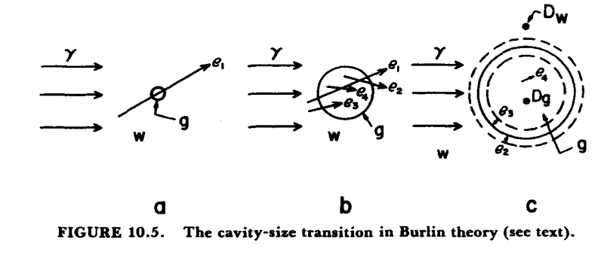

Figure 1‑12. From left to right we see increasing cavity sizes, where dose contribution differs. W is the medium surrounding the cavity, g is the medium of the cavity. e is charged particles released in either w or g and $γ$ is incoming photons. Burlin cavity is a general cavity theory which includes small, intermediate and large cavity sizes.

## Dosimetry methods

As mentioned in 1.3 different techniques are used for dose measuring. However, this thesis will focus on three different dosimeters: Ionization chamber, Gafchromic film and Alanine EPR (Electron Paramagnetic Resonance) dosimeter. These dosimeters fall into one of two categories: Absolute and relative dosimeters. The volume of an absolute dosimeter responds to radiation in such a way, that we are able to directly measure the received dose and does not require calibration in a known radiation field (Attix, 1986, p. 277). E.g., a free-air ionization chamber is an ionization chamber without walls, where the goal is to measure exposure (1.3.1) in a known mass of air. However, for photon energies surpassing 1.5 MeV the secondary electrons have such a large range, that the free-air ionization chamber cannot fulfill CPE without becoming unpractically large (Podgorsak, 2016, p. 737). The ionization chambers we’ll discuss here are relative dosimeters.

### Parallel- Plate Ionization Chamber

The purpose of an ionization chamber is measuring ionizations inside a gas-filled cavity. A fundamental type of ionization chamber is the parallel plate chamber illustrated in Figure 1‑13  
The chamber is connected to a polarizing (negative cathode) and measuring electrode (positive anode). The polarizing electrode is directly connected to the power supply and creates the voltage difference, which in turn generates an electric field. Adjacent to the measuring electrode you have the guarding ring/electrode with the purpose of preventing leaking current from being measured by the electrometer (Podgorsak, 2016, p. 702). Looking at Figure 1‑13 you see that the electrometer is connected to the power supply. Ideally the impedance (a circuit’s opposition to charge) inside the electrometer is high enough (typically ${10}^{14} Ω$) and no charge moves through it (*High Accuracy Electrometers for Low Current/High Resistance Applications | Tektronix*, n.d.). However, some leakage will occur, and the guard rings are there to prevent this from being measured. The second purpose is to help define the effective collection volume of the chamber (see 1.5.2), by ensuring straight electric field lines (Podgorsak, 2016, p.703).

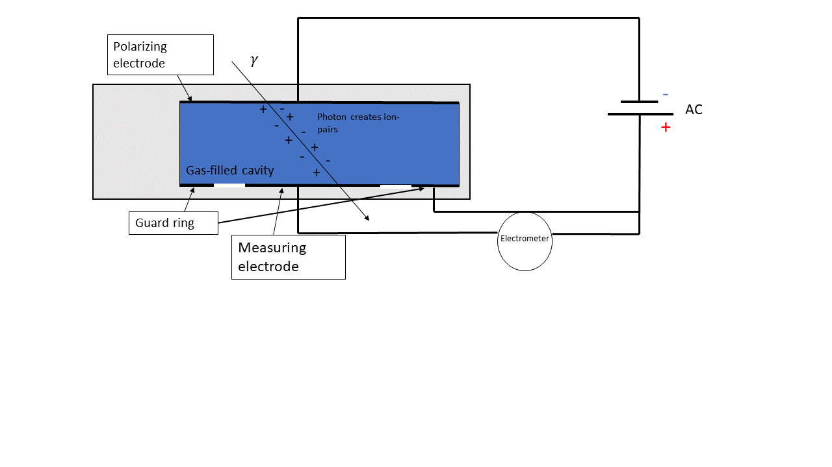When the electrons are ionized one of two things may happen: If the cavity is filled with electronegative gas with high electron affinity, the electrons will bind to the gas to create an ion. The ion will move toward the positively charged plate and the charge is “collected” by a measuring electrode connected to the electrometer. If the cavity does not have electronegative gas the ionized electrons moves directly to the measuring electrode (Podgorsak, 2016, p.705). The electrometer measures the accumulated charge, which is converted to dose.   
If the applied voltage is too low the negative ion will tend to recombine with the positive ion. The solution is increasing the voltage until the measured current is no longer dependent on voltage, this is called the saturation region (Attix, 1986, p.330-331). The measured output in this region is known as the saturation charge, or $Q_{sat}$.

Figure 1‑13. The schematics of a parallel plate ionization chambers. An electric field is established on the gas-filled cavity, so when the gas is ionized electrons will move toward the positively charged side, where they are collected by a measuring electrode connected to an electrometer.

### Thimble Ionization Chamber

In Figure 1‑14 we see a thimble (a.k.a. farmer type) ionization chamber. The chamber differs from the parallel-plate type by having a graphite thimble surrounding the gas-filled cavity. The graphite is chosen because it protects the sensitive volume and it is air equivalent, therefore minimizing the density difference between cavity and wall. This achieves charged particle equilibrium (Shortt et al., 2002). The protection cap is not shown in Figure 1‑14 but surrounds the wall and ensures that we are passed the buildup region when the secondary electrons reach the wall and the cavity (see 1.1.2.4). The chamber has a central electrode connected to the electrometer.   
In a thimble ionization chamber, we want to find the exposure (see 1.3.1) to measure absorbed dose in the sensitive volume. Rearranging equation 1‑11 we see that collision KERMA might be written as

$$K_{c}= X\left(\frac{\overline{W}}{e}\right) .$$

From equation 1‑10 we have the expression for exposure. Replacing the infinitesimal $dQ/dm$ with the saturated charge $Q_{sat}$ and total air mass $m_{air}$, we get collision KERMA for air

$$K_{air}=\frac{Q_{sat}}{m_{air}} \left(\overline{\frac{W}{e}}\right) .$$

CPE is achieved in a thimble ionization chamber, so absorbed dose can be found using equation 1‑12. But the challenge arises when finding $m_{air}$. $m_{air}$ is found using the effective volume, which is not necessarily the same as the geometrical volume of the chamber. The effective volume is defined by the electric field lines running from polarizing electrode to measuring electrode (Podgorsak, 2016, p.745). The field lines tend to bend outward away from the center, and this affects the fate of the ionized electron, thereby affecting the effective volume where electrons can be collected.   
To ensure most accurate dose measuring, a primary standards laboratory is given the job of calibrating the ionization chamber and finding its effective volume.

The calibration of a thimble ionization chamber is performed by measuring exposure $X$ using a free-air chamber, then replacing it with a thimble chamber and measure the air KERMA $K_{air}$. The measurements are performed under specific reference conditions such as temperature, air pressure and humidity, using a reference beam energy and quality (typically 60Co photons). From this we get a calibration factor $N_{k}$ that relates output in nC to dose Gy (Podgorsak, 2016, p.744). The thimble chamber is then inserted into a water phantom, still in the known radiation field, where the $K_{air}$ is measured again and converted to dose to undisturbed water (as if the ionization chamber wasn’t present) using a conversion factor and correction factors ) (P.Andreo et al., 1996, p.48).

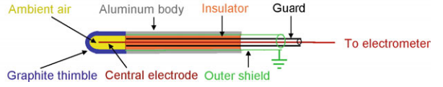

Figure 1‑14. Schematic of thimble ionization chamber, where the sensitive air-filled volume is encapsulated in a thimble (Podgorsak, 2016, p. 741).

### Radiochromic film

Radiochromic film is a self-developing film, which reacts when exposed to radiation (McLaughlin & Chalkley, 1965). The film is typically made ­up of a protective layer and an active layer (see Figure 1‑15). The active layer consists of one or two layers of monomers called diacetylene. Monomers are molecules that interact with other monomer molecules to create polymer chains (*Monomer | Definition & Facts | Britannica*, 2022). When diacetylene is exposed to radiation it polymerizes to create polydiacetylene, changing both the chemical and optical characteristic of the active layer (McLaughlin et al., 1996).   
The color of the film darkens and optical density (OD) can be measured either by measuring light transmitted through the film, or light reflected by the film (Andreo et al., 2017, 562). Extracting absolute dose from the films requires an established relationship between the film response and absorbed dose, which demands calibrating the films and accounting for factors that might change the response, such as time waited after irradiation before scanning the films, temperature, and light exposure (Girard et al., 2012; Park et al., 2012). New calibrations are necessary for every new batch, because of batch-to-batch variation caused by e.g., variation in the thickness of the sensitive layer or different scanner sensitivities and (Devic et al., 2016).

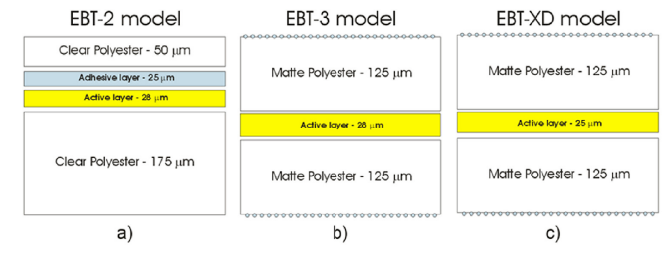

Figure 1‑15. Different radiochromic film structures used for external beam therapy (EBT) (Devic et al., 2016). The active layer is made from monomers that polymerize when exposed to radiation, causing a darkening of the film. The optical density (OD) is measured and related to dose.

## Statistics

### Non-linear curve fit

Regression is a tool used for predicting data. In traditional linear regression you have a dataset containing m response/dependent variables $y$ and n explanatory/independent values $x$. Linear regression tries to find the optimal coefficients/parameters $\hat{β}$, to fit the equation

|  |  |
| --- | --- |
| $${\hat{y}}_{i} =β_{0}+β_{1}x_{0}+β_{2}x_{1}+…+β_{n}x_{n} ,$$ | 1‑14 |

using the method of least squares. I.e., find the line that minimizes deviation between the true response variables $y_{i}$ and the predicted values ${\hat{y}}_{i}$ . $β^{T}=[β_{0}, β_{1}…, β_{n}]$ represents the true coefficients, that explain the model perfectly. The linear regression assumes standard normal distributed errors ($μ=0, σ=1$) and does not account for measurement error in $x$ itself, which might lead to the coefficients being biased towards zero (Griliches & Ringstad, 1970). However, accounting for this is beyond the scope of this thesis. The deviation is defined as the cost function, and both linear and nonlinear regression uses the sum of squared residuals (RSS)

|  |  |
| --- | --- |
| $$\sum_{i=0}^{n}{{\left(\frac{y_{i}-{\hat{y}}_{i}(x_{i})}{σ_{y,i}}\right)}^{2}} ,$$ where $σ_{y,i}$ is the individual weight of the ith residual, which is used when the assumption of approximately equal residual for every ${\hat{y}}_{i}$ is not satisfied (Kirkup, 2012, p.226-232). | 1‑15 |

For linear regression, one can find differentiate the RSS w.r.t. both coefficients $β_{0}$ and $β_{1}$ and find a closed form expression for both coefficients (Bingham & Fry, 2010, p.3-5).   
Not all response variables are linearly dependent on the explanatory variable, which might lead to the ${\hat{y}}_{i}$ expression in RSS not having a closed form solution when differentiated. The solution is to guess the values of the unknown coefficients, then iteratively tune them to find the minimum RSS (Kirkup, 2012, p.335-337).

#### Levenberg-Marquardt algorithm

*This section is based on (Gavin, 2020)*.  
Levenber-Marquardt algorithm (LM) combines two minimization methods known as the Gradient descent (GD) and the Gaussian-Newton (GN) method. **GD** uses the derivative of the RSS to update the parameters towards the steepest descent towards the minimum of RSS. For all n parameters $p^{T}=[p_{0},p_{1}, …, p_{n}]$ we have a weighted RSS of

|  |  |
| --- | --- |
| $${\left(y(x)-\hat{y}\left(x;p\right)\right)}^{T}W\left(y(x)- \hat{y}\left(x;p\right)\right) ,$$ | 1‑16 |

$W$ is a diagonal matrix with shape m x m for m datapoints, with all the weights on the diagonal.   
Using the second binomial formula we remove the parentheses and get

|  |  |
| --- | --- |
| $$y^{T}Wy-2y^{T}W\hat{y}+ {\hat{y}}^{T}W\hat{y}$$ | 1‑17 |

Differentiating the RSS w.r.t. all parameters we get

$$-2 {\left(y-\hat{y}\right)}^{T}WJ ,$$

where $J$ is the m x n jacobian matrix containing the partial derivatives of $∂\hat{y}/∂p$, 2 comes from the fact that RSS is squared, and the minus sign is from $-\hat{y}(x;p)$. The partial derivatives $∂y/∂p$ becomes 0 because $y$ does not vary with changing parameters.

Rearranging the expression using the fact that $W$ is symmetrical, the theorem ${\left(AB\right)}^{T}=B^{T}A^{T}$ and introducing a constant $α$ we get the value $h$ that updates the parameters in the direction of steepest descent

$$h_{GD}=αJ^{T}W\left(y-\hat{y}\right).$$

$α$ is chosen and decides how fast we are moving. Choosing an $α$ too large we risk passing the minimum but choosing one too small we might never reach the minimum.

**GN** is an expansion of the Newton’s method (Cavazzuti, 2013, p.85). Newton’s method assumes that the RSS function is quadratic near the minimum. This is reasonable because if the RSS function has a minimum, the value will sink to the minimum then increase when passing the minimum like a quadratic function. The quadratic function around the minimum is Taylor expanded and becomes

$$\hat{y}\left(p+h\right)≈ \hat{y}+Jh .$$

Inserting the approximation for $\hat{y}$ into the RSS in equation 1‑17, we get

$$y^{T}Wy-2y^{T}W\left(\hat{y}+Jh\right)+{\left(\hat{y}+Jh\right)}^{T}W\left(\hat{y}+Jh\right) .$$

Again, using the second binomial formula and the theorem ${\left(AB\right)}^{T}=B^{T}A^{T}$ we get

|  |  |
| --- | --- |
| $$y^{T}Wy+{\hat{y}}^{T}W\hat{y}-2y^{T}W\hat{y}-2{\left(y-\hat{y}\right)}^{T}WJh+h^{T}J^{T}WJh .$$ | 1‑18 |

Newton’s method differs compared to GD, because it also accounts for the curvature of the RSS function. We therefore differentiate equation 1‑18 w.r.t. $h$ to find the one that minimizes RSS. As mentioned, $J$ is the jacobian and differentiating $J$ w.r.t. $h$ we get a matrix called the hessian matrix. It can be written as the sum (Chen, 2011)

$$\sum_{i=0}^{m}{\left(\frac{∂{RSS}_{i}}{∂p_{j}}\frac{∂{RSS}_{i}}{∂h_{k}} +{\hat{y}}_{i}\frac{{∂^{2}RSS}_{i}}{∂p_{j}∂h_{k}} \right)1/σ_{y,i} } .$$

In the GN method the second derivative term is assumed to be 0. Going back to matrix notation we are left with

|  |  |
| --- | --- |
| $$J^{T}WJ .$$ | 1‑19 |

This results in the derivative becoming

|  |  |
| --- | --- |
| $$-2{\left(y-\hat{y}\right)}^{T}WJ+2h^{T}J^{T}WJ .$$ | 1‑20 |

Setting equation 1‑20 equal to 0 and rearranging using the same theorem from before we get

$$J^{T}WJ h_{GN}=J^{T}W(y-\hat{y})$$

The **LM** method introduces a dampening link $λ$, which is scaled according to the diagonal elements of the hessian matrix

$${(J}^{T}WJ+λ diag(J^{T}WJ) ) h_{LM}=J^{T}W\left(y-\hat{y}\right) .$$

The dampening factor punishes updated parameters that does not contribute to reduced RSS by increasing $λ$, and encourage updated parameters that reduce RSS by decreasing $λ$. The result is a method that acts as GD far from the minimum but becomes GN when approaching the minimum.

### Poisson Regression

Poisson regression is a way of predicting discrete count data. It is like linear regression (see 1.6.1) in that it tries to fit a model to data, but the method is different.   
In Poisson regression you assume that your $m x 1$ response variables in $y^{T}=[y_{0}, y_{1}, …, y_{m}]$ are Poisson distributed. I.e., it follows the probability mass function (PMF) (Cameron & Trivedi, 2013a, p.3)

$$P\left(y_{i}\right)=\frac{e^{-λ}λ^{y_{i}}}{y_{i}!} ,$$

where it finds the probability of getting $y_{i}$ counts when mean and variance is both equal $λ$. Poisson regression treats each count as an independent Poisson random variable, where it estimates $λ_{i}$ for every $y_{i}$ in using the linear model with a set of $m x n$ explanatory variables in $X$ and estimated $n x 1$ coefficients in $β$ (Cameron & Trivedi, 2013a, p.10)

|  |  |
| --- | --- |
|  | 1‑21 |

where $x_{i,j}$ is the $j^{th}$ of a total of $n$ explanatory variables for the $i^{th}$ datapoint. However, a problem arises if the combination of explanatory variables and coefficients sums to a negative number. The mean counts cannot be negative, we therefore use the natural log of $λ_{i}$

|  |  |
| --- | --- |
| $$\log{λ_{i}=\sum_{j=0}^{n}{x_{j,i}β_{j,i}}→λ_{i}= \exp{\sum_{j=0}^{n}{x_{j,i}β_{j,i}}}}=e^{x_{i}^{T}β}.$$ | 1‑22 |

The estimation of coefficients is done using the maximum likelihood estimator (MLE). The likelihood function describes the joint probability of observing all the data $y$ given a set of parameters $β$ represented by

$$L\left(\hat{β}\right)= \prod_{j=0}^{n}{P\left(y_{i} | β\right) }= \prod_{j=0}^{n}{\frac{\exp\left(-λ_{i}\right){λ_{i}}^{y_{i}}}{y_{i}!} },$$

now inserting the expression for $\log{λ_{i}}$ from equation 1‑23 we get

$$\prod_{j=0}^{n}{\frac{\exp\left(-e^{x_{i}^{T}β}\right){e^{x_{i}^{T}β}}^{y_{i}} }{y_{i}!} }$$

It is important to note that the datapoints are assumed independent, which allows us to use the fact that $P\left(A∩B\right)=P\left(A\right)⋅P(B)$. Using the log-likelihood allows us to compute the sum instead (Cameron & Trivedi, 2013b, p.23)

$$\log{L\left(β\right)= \sum_{j=0}^{n}{-e^{x_{i}^{T}\hat{β}}+{y_{i}x}_{i}^{T}β-\log{y_{i}!} .}}$$

Differentiating w.r.t. $β$ and setting the expression equal to zero we get

$$\sum_{j=0}^{n}{\left(y_{i}-e^{x_{i}^{T}β}\right)x_{i} =0 . }$$

We want to minimize the difference between $y_{i}$ and $e^{x_{i}^{T}β}$ to maximize the log-likelihood $\log{L (β)}$. The equation does not have a closed form solution and an iteration method is needed to find the best fitting set of parameters $\hat{β}$. Methods such as the ones described in 1.6.1 can be used.

### Confidence interval

A confidence interval for e.g., 95% confidence claims that the true population mean will be within the limits of the confidence interval 95% of the times a sample mean is measured (James et al., 2013, p.66). For a general mean value $\overline{X}$ with unknown population mean, the confidence interval is found using the formula

$$\overline{X }±t_{crit}σ_{\overline{X}}=t_{crit}\frac{σ}{\sqrt{n}} ,$$

if the t distribution has a mean of $μ$, then $t_{crit}$ is the number of standard deviations out from $μ$ in both directions that encapsulates the allowed variations of $μ$. $σ_{\overline{X}}$ is the standard deviation of the mean $\overline{X}$.

## Radiobiology

Cells are the building blocks of all living things. Animals are made from eukaryotic cells, which contain a nucleus. The purpose of a cell is converting consumed nutrients into energy needed to perform a task. Such tasks might be to provide structure (bone cells, muscle cells), sensory signaling (nerve cells) or transportation (blood cells). These cells are highly specialized and stem from an unspecialized cell (stem cell) that have finished their chain of cell divisions.   
The process of cell division (proliferation) is sensitive and damaged DNA (deoxyribose nucleic acid) might lead to cancer if not repaired.

### DNA basics

DNA or deoxyribose nucleic acid contains the complete genetic information needed to produce necessary proteins. The DNA is made up of two antiparallel strands (3 to 5 and 5 to 3, see further down for explanation) with a nitrogenous base pair connecting the strands (see Figure 1‑17).  
The strands consist of nucleotides, which again is broken into a sugar-phosphate backbone and the DNA nitrogenous base (*Nucleotide | Biochemistry | Britannica*, 2008). There are five bases: Adenine, Guanine, Cytosine, Thymine and Uracil. The first four are in our DNA, and Uracil replaces Thymine in the mRNA (see DNA transcription in *Abbreviations and explanations*). The bases are divided into two categories: Adenine and Guanine are known as pyrimidines, while Cytosine, Thymine and Uracil are purines.   
If three adjacent bases (not base pairs) code for an amino acid (see proteins in Abbreviations and explanations), it’s called a codon. Gene sequences, which includes codons are called exons, but if they do not include codons, they are called introns.   
The bases form hydrogen bonds to create a base pair, but only with dedicated “partners”. Because of the chemical structure adenine only binds with thymine (or Uracil during DNA transcription), while guanine only binds with cytosine (Mason et al., 2020, p.48). The hydrogen bonds are the first of two bonds between nucleotides. The second bond is the phosphodiester bonds between each sugar-phosphate (see Figure 1‑17).

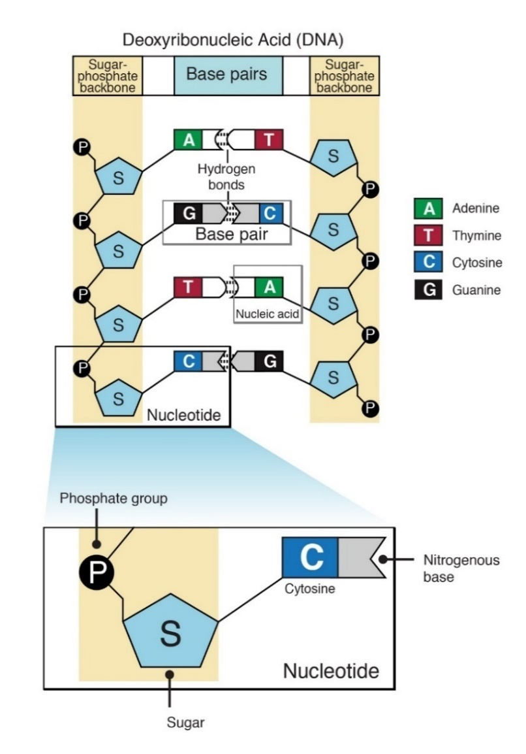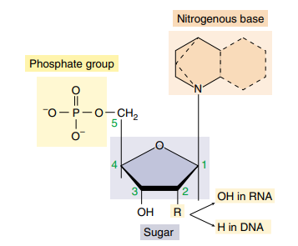Looking at Figure 1‑16 we have a closer look at an individual nucleotide. The carbon atoms in the deoxyribose molecules are marked with numbers 1-5 (Mason et al., 2020, p.47). When a new nucleotide is bound to the existing nucleotide, they can only be connected to the 3 carbon because they are able to chemically interact to create the phosphodiester bond (Mason et al., 2020, p.284).

Figure 1‑16. Three molecules making up a nucleotide. The positions of each carbon in the sugar molecule are marked by a number (Mason et al., 2020, p.47).

Figure 1‑17. Schematic of DNA double strand (Nucleotide, n.d.)

The DNA strands are twirled around its own axis to form a DNA double strand helix, then they are coiled around proteins known as histones to form a nucleosome. The nucleosomes are folded to produce fibers called chromatin. When a cell is preparing for cell division, the chromatin is tightly coiled into a supercoil (Mason et al., 2020, p.210). However, during interface (see 1.7.2) the DNA needs to be accessible for DNA replication and DNA transcription (Abbreviations and explanations). Therefore, the chromatin is a dynamic structure that condense and decondense according to the needs of the cell (Alberts et al., 2014, p.193).   
When chromatin is folded it forms a chromosome. The chromosome has a centromere which allows for linkage between chromosomes to create chromosome pairs. When chromosomes are connected, we refer to the individual chromosomes as a sister chromatids (*Centromere | Biology | Britannica*, 2012).

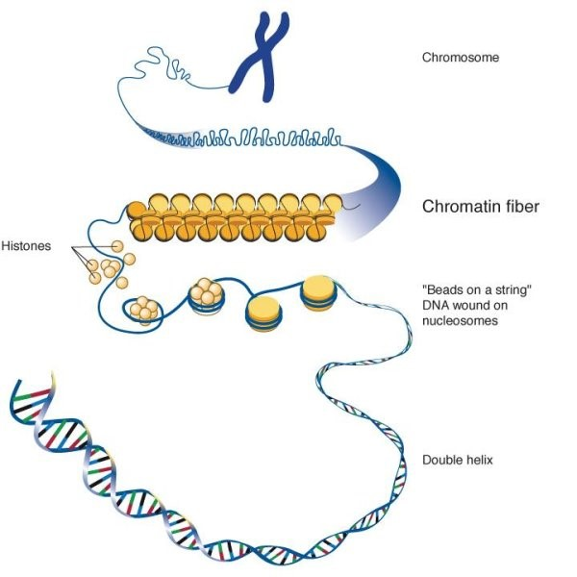

Figure 1‑18. Chromosome structure (The Structure and Function of Chromatin, 2017).

### Cell Cycle and Checkpoint

The cell cycle consists of four phases: G1, S, G2 and M (see Figure 1‑19). G1 and G2 are the gap phases where cell growth occurs. G2 is the last phase before cell division where all organelles, but the DNA, replicates. During S-phase DNA is replicated. This happens by a series of initiator proteins that open the DNA double helix, creating a replication fork (see Figure 1‑20) (Mason et al., 2020, p.293). An enzyme known as helicase separates the strands by disrupting the hydrogen bonds between the base pairs (Matson et al., 1994). Two DNA-polymerase enzymes are recruited to the DNA strands, with the purpose of generating two new complementary DNA strands. DNA-polymerase is only able to continue an existing complementary strand, therefore RNA-primers (Abbreviations and explanations) are created as a starting point for the DNA-polymerase (Mason et al., 2020, p.293). As mentioned in 1.7.1 new nucleotides can only attach to the 3 carbon. Since the two strands are antiparallel, the 5-3 strand is easy enough to replicate because the DNA-polymerase moves in the same direction as the helicase. This strand is known as the leading strand. But the complementary 3-5 strand must be replicated away from the replication fork. Therefore, the DNA-polymerase must jump back and forth, creating smaller bites of a DNA-strands called Okazaki fragments. Then the RNA primers are removed and the bites are glued together by an enzyme called ligase ­­(Mason et al., 2020, p.292). This strand is known as the lagging strand.

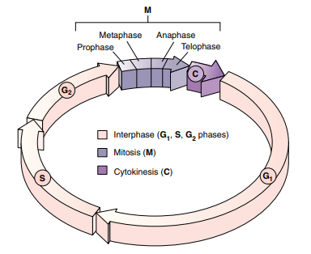

Figure 1‑19. Cell cycle schematic, G1, S and G2 phase is known as interphase, where the cell grows and replicates its organelles to prepare for cell division in Mitosis. In Mitosis the cell separates the chromosomes before the cytoplasm is separated, and we are left with two identical daughter cells (Mason et al., 2020, p.212).

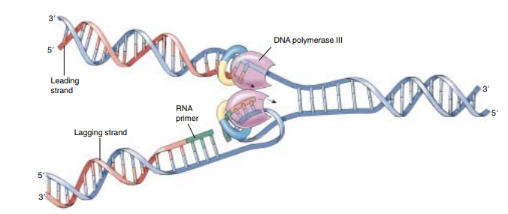

Figure 1‑20. DNA replication schematic, where DNA is opened, and two complementary strands are created. Nucleotides only binds on 3’-OH group, which affects how the DNA-polymerase connects new nucleotides, leading to a leading strand and a lagging strand (Mason et al., 2020)

M-phase is mitosis and the process of separating the replicated chromosomes before the cytoplasm (medium surrounding the organelles of the cell) is separated to create two identical daughter cells. The process is divided into **prophase:** where the chromosomes are condensed, and the mitotic spindle apparatus is assembled. **Metaphase:** where the centromeres of the chromosomes align at the center of the cell. **Anaphase:** centromeres separate and move towards each pole of the cell, splitting the chromosomes. **Telophase:** Then the spindle disassembles, and the daughter cells form individual nuclei (Mason et al., 2020, p.214-216). If the cell’s external environment isn’t favorable the cell might enter a resting phase known as G0, where it’s still able to perform its tasks, but does not prepare for cell division (Mason et al., 2020, p.212).

A cell’s progression through the cell cycle is highly regulated. The three checkpoints G1- G2- and M-checkpoint has the task of controlling that the associated phase has had enough time to complete its tasks (Alberts et al., 2014, p.967). If the cells were to enter cytokinesis before completely separating the chromosomes, or if the DNA weren’t replicated correctly before entering Mitosis, it would have disastrous consequences.

One very important enzyme in cell cycle progression (see protein in Abbreviations and explanations) is the cyclin dependent kinase (CDK). cdk’s are inactivated unless bound to another protein called cyclin. There are three main categories of cyclins: G1/S- S- and M- cyclins. Their levels rise and fall as the individual cyclins are needed (Mason et al., 2020, p.219). A cdk bound to a cyclin is called a cdk complex.   
  
For a cell to pass the G1-checkpoint there is a threshold of external and internal signaling levels that needs to be passed, for the cell to enter S-phase. A complex system of positive feedback loops drive the cell over a point called the restriction point (Pardee, 1974). E.g., when enough cdk’s are activated, they will phosphorylate (see Abbreviations and explanations) a protein called Rb (retinoblastoma). If the Rb protein receives two phosphors it will release itself from a protein called E2F, which in turn induce transcription of new cyclins (Alberts et al., 2014, p.1012-1013). E2F also targets a protein on the SCF protein complex, which is important in degradation of the p27 protein, a protein that binds to a cdk complex inhibiting phosphorylation (Yung et al., 2007).

The S-cyclin activated cdk’s phosphorylate proteins, such as activation of DNA helicases responsible for activation of the DNA replication process. The S-cdk is also responsible for the construction of a prereplicative complex (preRC), which ensures that the DNA is only replicated once per cycle (Alberts et al., 2014, p.974).

The G2-checkpoint makes sure that necessary proteins for mitosis are present and that the DNA, as well as all the organelles, has been correctly replicated in S-phase and G2-phase. Both G1- and G2-checkpoints can arrest the cell cycle if DNA-damage is spotted (Studzinski & Danilenko, 2005).

The M-checkpoint is the final checkpoint, and ensures correct separation of chromosomes before cytokinesis (Studzinski & Danilenko, 2005). Another set of positive feedback loops kicks in. A protein called Cdc25 activates M-cdk complexes, which was inactivated by another protein called wee1. These M-cdk complexes begins inhibiting the Wee1 protein, while also induce important events mitotic events (Alberts et al., 2014, p.978).

All checkpoints are controlled by genes that either promote or demote the cell cycle. Cell cycle promoting genes are called proto-oncogenes. If mutated, they become oncogenes and might lead to uncontrolled cell division and cancer (Weinstein, 2002). In the event of oncogene activation, tumor suppressors kick in. Tumor suppressors code for proteins responsible for inhibiting the cdk complexes from operating. Tumor suppressors are also responsible for cell cycle arrest when DNA-damages are detected (Alberts et al., 2014, p.1015), or if DNA-damage is unrepairable it might kill the cell through apoptosis (see Abbreviations and explanations) (Jeffers et al., 2003).

### DNA damage and repair

Ionizing radiation damage the DNA in two ways: Either directly depositing its energy in a biomolecule (see Abbreviations and explanations), or by ionizing molecules surrounding the biomolecules, creating highly reactive radicals that oxidize (loss of electrons) the biomolecules (*RADIATION BIOLOGY: A HANDBOOK FOR TEACHERS AND STUDENTS*, 2010).   
DNA is also damaged without being exposed to ionizing radiation. Especially during DNA replication and building of Okazaki fragments (see 1.7.2). About one mistake is made for every ${10}^{10}$ nucleotide (Alberts et al., 2014, p.242). The mistakes might also be spontaneous such as deamination (cytosine become uracil) and depurination (loss of either Adenine or Guanine) (Cooper, 2000a). Even UV-light might cause adjacent pyrimidines to glue together creating a pyrimidine dimer (Mason et al., 2020, p.364).  
  
The mentioned damages are discontinuities in the DNA strands and might be classified as either single strand breaks (SSB) or double strand breaks (DSB). A single strand break only occurs in one DNA strand. If two breaks happen, one on each strand and close in time and space, they are called double strand breaks (Hall & Giaccia, 2012, p.11).   
Damages might also be classified as sublethal, potentially lethal and lethal. Sublethal damages are not lethal, potentially lethal damages are lethal unless repaired and lethal damages are of course beyond repair.   
The cell has many DNA repair pathways, it can remove deaminated bases through base excision or remove whole nucleotides in a pyrimidine dimer with nucleotide excision repair (Hall & Giaccia, 2012, p.16). However, for more complicated damages like DSB’s, more intricate repair mechanisms are needed.   
  
Nonhomologous end-joining (NHEJ) is a repair mechanism activated in G1. The DNA is yet to be replicated so no sister chromatid is available. The solution is to simply reattach the strands as seen in Figure 1‑21. The result is loss of the damaged nucleotides, which might result in removing important exons (see 1.7.1) (Hall & Giaccia, 2012, p. 18).

Homologous recombination (HR) is another repair mechanism, but it is activated late S/G2 with available sister chromatid. The cell searches for a DNA segment on the unharmed sister chromatid, that is similar or identical to the damaged chromatid. This search is performed by one of the damaged strands by invading an unharmed strand and sampling base sequences. When homology is found DNA-polymerase is recruited to extend the damaged strand. The unharmed strand is released and the newly extended strand is used as a template to fix the other damaged strand (Alberts et al., 2014, p.278-279). Both repair mechanisms are illustrated in Figure 1‑21 . Compared to NHEJ, HR is less efficient, but no DNA is lost during HR (see Figure 1‑21) and DNA is accurately restored (Z. Mao et al., 2008). This underlines the importance of the G2 checkpoint.

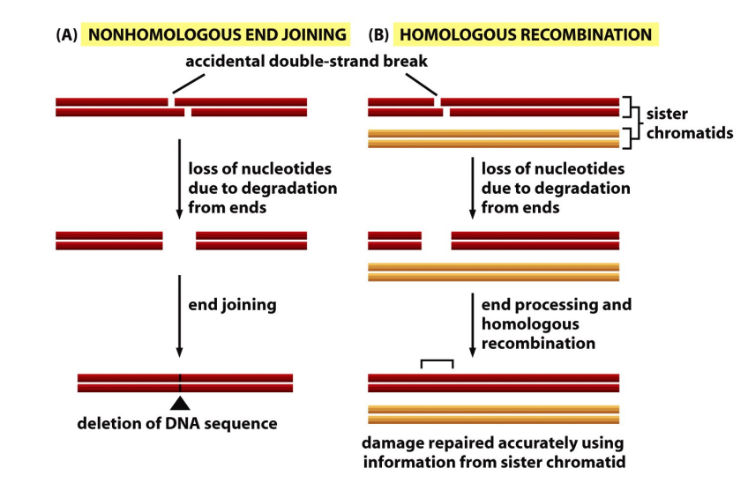

Figure 1‑21. (A) Nonhomologous end-joining is DNA repair happening in the G1-phase of the cell cycle, before DNA is replicated. The strands are connected, but the nucleotides that existed on the strand before damaged occurred, are gone. (B) Homologous Recombination during late G2/S phase where sister chromatid is available after DNA replication and completely restores the broken DNA (Alberts et al., 2014, p.275).

Failure of repairing DNA damage might result in severe consequences. An unbound base caused by a DSB easily forms new hydrogen bonds with unbound bases elsewhere on the strand where a DSB has occurred (Hall & Giaccia, 2012, p.25). If enough DSB’s are left unrepaired, or the cell isn’t arrested or the damage occur late in the cell cycle, they can cause severe abnormalities known as chromosomal aberrations (Grote & Revell, 1972). Lethal chromosomal aberrations result in chromosomes that are connected by more than the centromere. This leads to chromosomes not being fully separated during mitosis causing mitotic cell death (Hall & Giaccia, 2012, p.26). Worse is non-lethal chromosomal aberrations. Examples are symmetrical translocation and small deletions. Translocation is when a piece of chromosomes breaks and reattach to another chromosome, while deletion is removal of a piece of chromosome without reattaching. These aberrations are non-lethal because the chromosomes do not attach to each other when they are damaged, and they are able to separate successfully during mitosis (Hall & Giaccia, 2012, p.26-32). But the damages might lead to activation of oncogenes (Nambiar et al., 2008) or inactivation of a tumor suppressor gene (X. Mao et al., 2011), generating cancerous cells.

### Cell Survival Curves

A cell survival curve is a staple in radiobiology and explains the relationship between cell survival S and radiation dose D. If there is enough space and nutrients, a cancer cell will divide indefinitely. The cancer cell is therefore defined as dead if it has completely lost its ability to divide and form colonies, thereby the name clonogenic survival (Hall & Giaccia, 2012, p.35).   
Cancer cells response to irradiation is often studied by in vitro (in cell dish) cell survival experiments. The cells are seeded in monolayers at the bottom of a cell dish with a medium containing all necessary nutrients. The cells are kept in an incubator with ideal growth temperature, and after x number of days they are counted. The cells in a non-irradiated cell dish have a probability of growing into colonies, which is affected by the external environment as well as cell division errors (Hall & Giaccia, 2012, p.36). This efficiency is called the plating efficiency (PE) and is represented by the formula

|  |  |
| --- | --- |
| $$PE=\frac{\# colonies counted control flask}{\# cells seeded} .$$ | 1‑23 |

The ideal PE is 100% so that all cell death is explained by irradiation, but because of suboptimal growth medium handling or other external factors, optimal PE is around 50 % (personal communication, prof. Nina Edin). PE is used as a normalization factor to accurately compare different experiments with different conditions. The survival fraction (SF) of an irradiated cell dish is found using the formula

|  |  |
| --- | --- |
| $$SF=\frac{\# colonies counted irradiated flask}{\# cells seeded⋅PE} .$$ | 1‑24 |

In Figure 1‑22 we see a typical cell survival curve, with the natural log of survival as a function of radiation dose. However, it is worth noting that each irradiated dish’s survival constitutes a point on the curve, and the curve is a result of interpolation. The interpolation is decided by a model known as the linear-quadratic (LQ) model, which is discussed in 1.7.5.

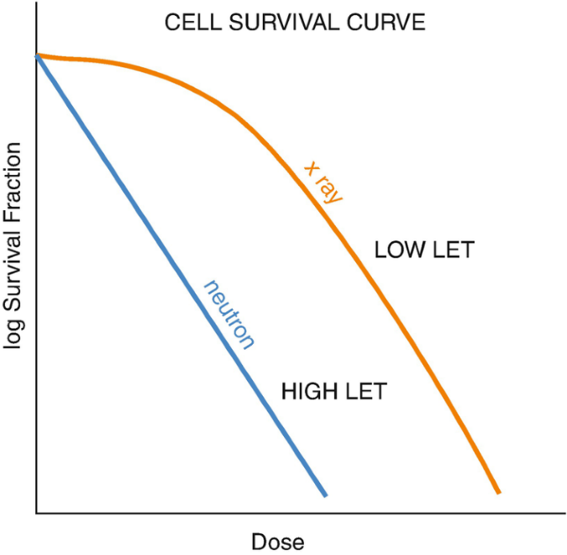

Figure 1‑22. Typical cell survival curve with low and high LET (see 1.1.2) which is typically expressed in the natural log of survival (Giridhar & Rath, 2020).

### LQ-model

This section is based on Chadwick & Leenhouts: A molecular theory of cell survival

The LQ-model tries to explain the shape of the cell survival curve as a function of increasing dose. From Figure 1‑22 we see that the survival curve becomes less linear as LET (see 1.1.2) decreases. The increased curvature of the low LET region is known as the “shoulder” of the survival curve. The formula explaining this shape is

|  |  |
| --- | --- |
| $$S= e^{-(αD+βD^{2})},$$ | 1‑25 |

where D is dose. $α$ and $β$ represents radiosensitivity of the cell (McMahon, 2018). The model assumes that there is a critical molecule crucial for a cell’s ability to divide, and that this molecule is the DNA. It also assumes that DSB is the critical damage type, but that the cell has repair mechanisms that might repair the damage. It accounts for two different DSB events (breakage of chemical bonds in the DNA molecule).

1. One event causing one DSB
2. Two SSB’s close enough in time and space to create one DSB

$α$ represents mode 1, and $β$ represents mode 2. In $α$ and $β$ we have the probability the chemical bonds, that received dose D, are broken. Represented by

$1-e^{-kDΔ}$

$1-e^{-kD(1-Δ)}$

where k is the probability per bond per unit dose that the bond is broken. $Δ$ is the proportion of dose that breaks the bonds with mode 1, and $(1-Δ)$ is the proportion of dose for mode 2. Chadwick & Leenhouts showed that the mean number of DSB’s from mode 1 was

$$A\left[1-e^{-kΔD}\right] ,$$

where A is the number of bonds on the DNA double helix, where mode 1 DSB’s occur.  
A first order Taylor approximation around 0 for $e^{-kΔD}$ gives

$$A⋅\left[1-\left(1-kΔD\right)\right]=AkΔD$$

For mode 2 they showed that mean number of DSB’s was

$$B{[1-e^{-k\left(1-Δ\right)D}]}^{2},$$

where B is number of SSB’s not repaired on both strands, that are also close enough in time and space to constitute a DSB. Doing the same Taylor expansion gives

$$B⋅\left[1-{\left(1-k\left(1-Δ\right)D\right)}^{2}\right]=Bk(1-Δ)D^{2} .$$

Combining the number of DSB’s from each mode and multiplying with the probability of the DSB’s being repaired f, we get

$$f⋅\left[AkΔD + Bk\left(1-Δ\right)D^{2}\right] .$$

From here they introduced a proportionality constant to relate number of DSBs to cell death and assumed Poisson distribution (see 1.6.2) to achieve probability of cell survival per dose. Which results in the equation 1‑25. This shows why we have a linear and a quadratic link in the LQ-model, which does fit well with the curves we see in Figure 1‑22, where the high LET radiation has a denser energy deposition, creating more mode 1 DSBs. And for low LET there is a shoulder caused by accumulation of SSBs for higher doses creating more mode 2 DSBs.

The $α/β$ ratio is a typical measurement of sensitivity to fractionation, where you find the dose of equal contribution between $α$ and $β$ (see Figure 1‑23). The ratio indicates whether it is reasonable to split the dose into fractions to allow time for repair, thereby extending the shoulder of the survival curve and increasing survival (van Leeuwen et al., 2018). The ratio is found like this (Hall & Giaccia, 2012, p.39)

$αD=βD^{2}→D=\frac{α}{β} .$

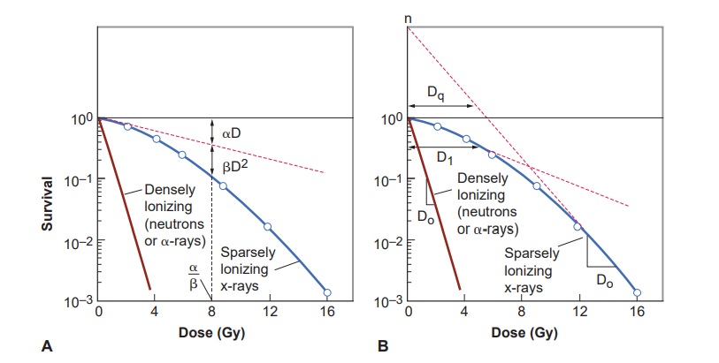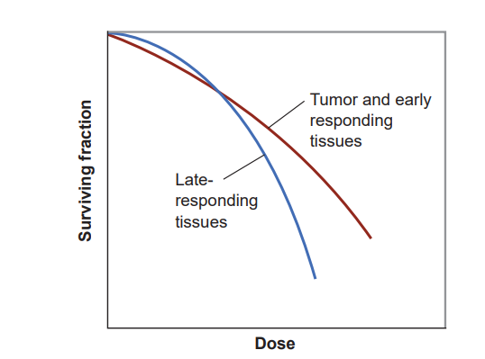

Figure 1‑23. Typical cell survival curves for low (blue) and high (red) LET, with $α/β$ ratio illustrated (Hall & Giaccia, 2012,p.39).

Figure 1‑24. Early (high $α/β$) vs late (low $α/β$) responding tissues. Early responding cells are typically cancer cells because they are always dividing, and (Hall & Giaccia, 2012, p. 395).

### Radiation Induced Bystander Effect

As mentioned in 1.7.3, cells are normally damaged either directly or indirectly. However, it has been showed that non-irradiated cells might exhibit the same biological endpoints (e.g. apoptosis, generation of micronuclei or DNA strand breaks) as irradiated cells. It was shown that 30% of analyzed cells expressed an increase in sister chromatid exchange, even though only 1% of cells were irradiated (SCE,Abbreviations and explanations) (Nagasawa & Little, 1992). This phenomenon is called the radiation induced bystander effect (RIBE). The theory is that irradiated cells signal to non-irradiated cells, either by intracellular communication trough protein channels (Gap junctions) between cells (Mesnil et al., 1996), or intercellular communication by excreting soluble factors into the surrounding medium (Luce et al., 2009). Although the existence of RIBE’s is indisputable, the characteristics of the biological parameters constituting an RIBE is not well defined (Blyth & Sykes, 2011).

It has been shown that a multitude of pathways are involved in RIBE’s, such as p53 (Koturbash et al., 2008), ATM (Ataxia telangiectasia mutated protein) (Ghosh et al., 2015), reactive oxygen species (ROS s) (D. Zhang et al., 2016) and various cytokines (Hu et al., 2014; Shareef et al., 2007).   
We will not discuss the various pathways in detail, but for shorter explanations see ***Abbreviations***.   
The bystander effect can either increase lethality or increase radio resistance. Mothersill & Seymour showed decreased clonogenic survival (see 1.7.4) when medium from irradiated cells were transferred to non-irradiated cells. However, Iyer & Lehnert showed increased clonogenic survival of cells that were irradiated after medium transfer.  
  
Which effect you’ll get is highly dependent on radiation quality (e.g., protons or photons), dose and which cell line is studied. A 2004 review on recent developments and implications of bystander effect concluded: For low-LET low dose radiation the protective effects were predominantly protective, but for high-LET it was less clear as both protective and detrimental was observed (Mitchel, 2004). Soleymanifard & Bahreyni found that QU-DB cancer cells had increased production of micronuclei (MN,see Abbreviations and explanations) , while number of MN for MRC5 fibroblasts remained constant.

Because of the bystander effect saturation for increasing dose, you neglect the effect for normal open field radiotherapy, but the effect has been established for SFRT (Spatially Fractionated Radiotherapy), where you have decreased toxicity in low-dose regions and increased survival in high-dose regions compared to open field (R. Asur et al., 2015).   
Better understanding of the biological mechanisms behind these results are important and has the potential of improving how SFRT (spatially fractionated radiotherapy) is used clinically.

### Spatially Fractionated Radiation Therapy

Spatially fractionated radiation therapy (SFRT) aims to achieve non-uniform dose distribution. It is a stark contrast to traditional radiotherapy where dose uniformity in the target is desirable. GRID therapy is a SFRT method where a photon beam is collimated into a specific pattern with low and high intensity areas, as is shown in Figure 1‑25. Traditionally a GRID block was used create high (peak) and low (valley) dose areas (Billena & Khan, 2019). GRID therapy arose from the need of treating deep seated or bulky tumors (W. Yan et al., 2019). The external beam therapy (EBT) machines of the early 20th century were typically X-ray tubes (1.2.1), and could not create photon beams with energies surpassing kV (Gianfaldoni et al., 2017). Therefore, few photons penetrated deep enough into the skin to reach the tumor. A GRID block was necessary to increase the dose but keep skin toxicity at a tolerable level. When MV photons were introduced with the linear accelerator (LINAC see Abbreviations and explanations) and photon ranges increased, the need for GRID decreased (W. Yan et al., 2019).  
Today there are many ways to apply SFRT. Linear accelerators have preinstalled MLC’s (see Abbreviations and explanations) which can modulate the GRID pattern in a way the static GRID block cannot (Billena & Khan, 2019). Tomotherapy is a treatment method, that combines a CT machine (see Abbreviations and explanations) with a linear accelerator to give radiation treatment in ${360}^{∘}$ degrees (Sterzing et al., 2009). The CT image is used to adjust the position of the patient to ensure that accurate dose is given. Modulation of beam intensity and direction can create a GRID shaped dose distribution (X. Zhang et al., 2016).   
3D SFRT methods have been developed, where the linear accelerator is rotated and the beam is modulated to create a sphere-like dose distribution (Wu et al., 2010).

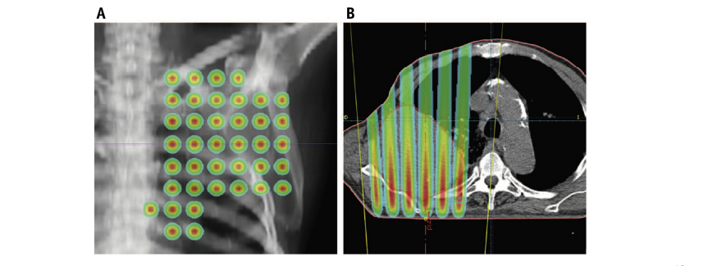

Figure 1‑25. (A) An example of a dose plan for GRID therapy from anteroposterior view of the lung area. The GRID pattern is clearly visible with dose gradients out from the center of the circles. (B) A transversal view of dose plan. Here we also see gradients in dose into the patient as the radiation attenuates into the body (Billena & Khan, 2019)

From the 1990’s to today, SFRT has primarily been used for palliative (treatment meant as pain relief rather than curing the patient) treatment of bulky (larger than 8 cm) tumors (W. Yan et al., 2019). However, (R. Asur et al., 2015) showed cells located in the valley region had overexpressed genes related to DNA-repair, cell cycle arrest and apoptosis. He also showed that cells located in peak areas had increased survival, leading it to believe that inter- and intracellular communication happen between cells (see 1.7.6). There is also evidence of immune system activation by recruitment of T-cells (a type of white blood cell) (Kanagavelu et al., 2014).  
These results indicate the potential of SFRT as a curative treatment.

# Materials and Methods

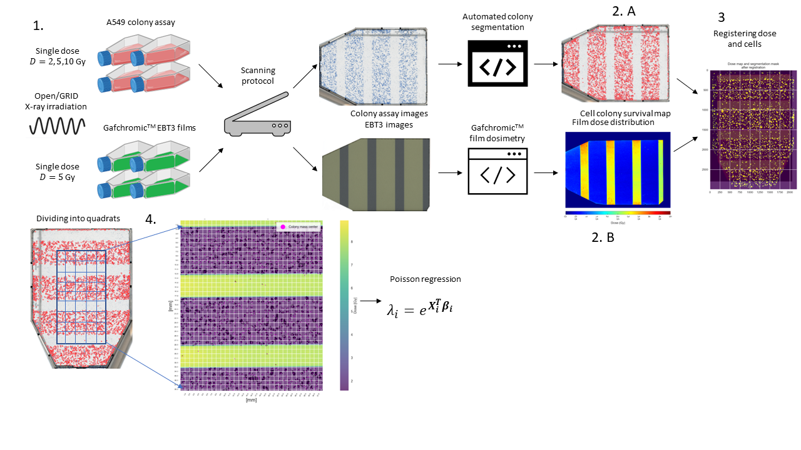

Figure 2‑1. A general overview of the pipeline 1. Irradiation and scanning of cell flasks with A549 cells or EBT3 films. 2.A. Segmentation of cells counting the number of colonies, 2.B. Calibration and fitting of dose model as a function of optical density of the irradiated EBT3 films. 3. Aligning dose map to a colony map with RIGID BODY registration. 4. Dividing an analysis area into equally sized quadrats, finding the total number of colonies within each quadrat and the mean dose, before passing the values to a Poisson Regression model.

## Dosimetry

We want to establish a 2D survival analysis method for X-ray irradiated A549 cells through a GRID block. It was therefore necessary to accurately measure how much dose was given to the cells. The dosimetry methodology was proposed by Bjørg Vårlig Håland in her master thesis (Bjørg Vårli Håland, 2020). Gafchromic EBT3 film (Ashland, USA) was chosen as dosimeter for reasons we’ll get into (see 2.1.2). We needed to establish the films’ dose response and generate a calibration curve. Therefore, X-ray dosimetry on an air-filled thimble ionization chamber (ion chamber) (FC65-G, IBA, Germany) was performed to give the films a known dose. Calibrations were made for striped and dotted GRID configurations, respectively. First on the 31.8.21 then on the 13.10.21.

### X-ray dosimetry

An X-ray beam was generated using a PMC 1000 X-ray unit (PANTAK, USA) operating at 10 mA and 220 kV for sufficient electron fluence from the cathode with high enough energy to generate photons of kV range. We used filtering of 0.7 mm Cu and 1.52 mm of Al. This is a standard in the X-ray lab at medical physics department at the University of Oslo to achieve a more homogeneous energy distribution. The X-ray beam was isolated to a cabinet lined with lead, which we will refer to as the irradiation cabinet. The cabinet has a platform made from Perspex, where cells can be placed a distance away from the X-ray source. A source to detector distance (SDD) of 60 cm was used to ensure the right beam divergence and high enough intensity. The experimental setup can be seen in Figure 2‑2.  
When cell flasks were irradiated, they were inserted into a cell flask holder made from polymethyl methacrylate (PMMA) holding four cell flasks in position A, B, C and D. To simulate the same conditions, the ion chamber was placed inside a T25 cell flask (Nunc, Denmark) and measurements were performed in all positions as seen in Figure 2‑3. Positioning of the cell flask holder on the Perspex platform inside the irradiation cabinet (see Figure 2‑2) was decided by field homogeneity measurements performed by Bjørg Vårli Håland.   
The protective cap of the ion chamber slightly lifts the sensitive volume above the bottom of the cell flask (see Figure 2‑1) closer to the radiation source, but the cells are seeded in monolayers at the bottom. It was therefore necessary to account for this height difference when prescribing radiation.

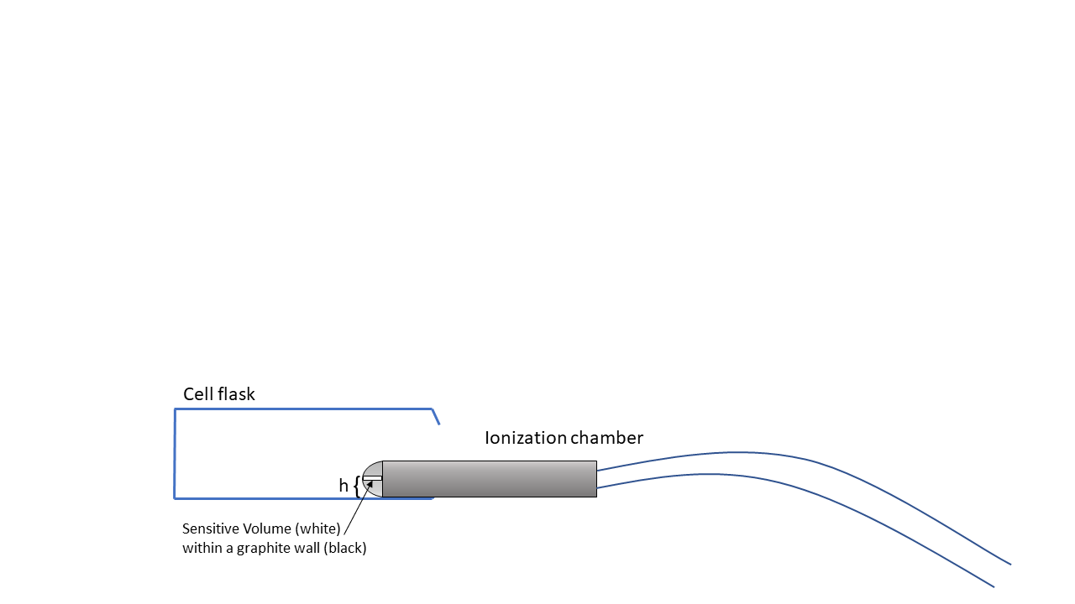

Figure 2‑2. Ion chamber inserted into a T25 cell flask, that has been cut open. The sensitive volume is surrounded by a graphite wall within the protective cap, and we observe the height difference between the bottom of the cell flask and the cell flask. During experiments efforts were made to position the ionization chamber as flat as possible inside the cell flask. Figure is only for illustration purposes.

Because intensity follows the inverse square law $I=α/r^{2}$ (see 1.2.1), the ratio between intensity at the sensitive volume of the ion chamber $I_{1}$ and the intensity at the bottom of the cell flask $I_{2}$ is

$$\frac{I_{1}}{I_{2}}=\frac{r_{2}^{2}}{r_{1}^{2}} .$$

Height measurements were made sing a caliper (FWP, Poland). We were unable to acquire a data sheet but based on the smallest measurement possible of 0.01 cm, we assumed an uncertainty of 0.001 cm. The thickness of the cell flask holder and the cell flask bottom were found to be $1.500±0.001$ cm and $0.200±0.001$ cm, respectfully. The diameter of the protective cap was $1.500±0.001$ cm, with a radius of $0.750±0.001$ cm. Uncertainty in $I_{1}/I_{2}$ was found with error propagation using equation 2‑3 assuming negligible uncertainty in SDD

|  |  |
| --- | --- |
| $$\frac{I_{1}}{I_{2}}=\frac{{\left(60-1.5-0.2\right)}^{2}}{{\left(60-1.5-0.2-0.75\right)}^{2}}=1.02600±0.00002 .$$ | 2‑1 |

Because of the low uncertainty we decided to neglect it, to not further complicate the uncertainty analysis. The intensity in the sensitive volume of the ion chamber is $2.6\%$ higher compared to the bottom of the cell flask, and we need to increase the dose accordingly when irradiating the EBT3 films.

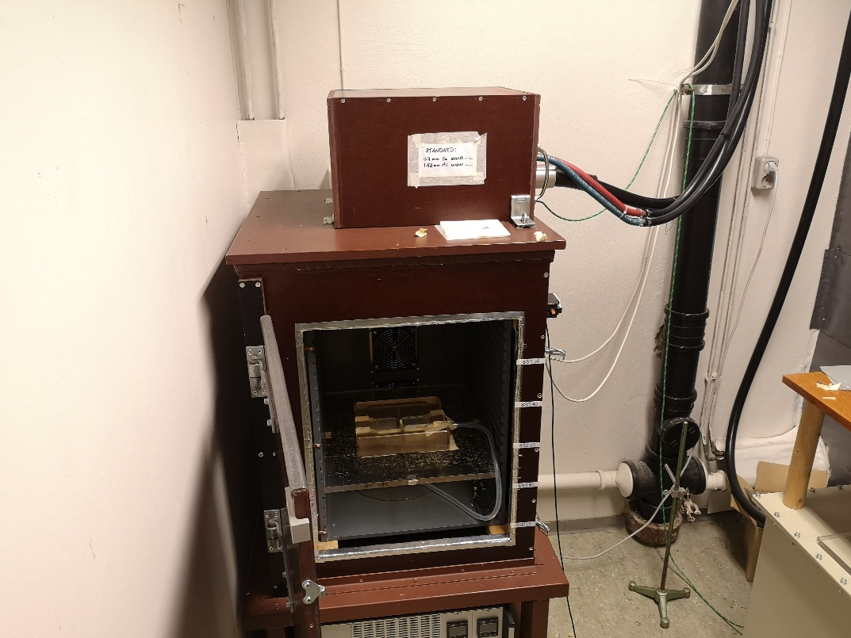

Figure 2‑3. An overlook of the experimental setup for X-ray dosimetry. The cell flask holder is placed inside an in-house made irradiation cabinet.

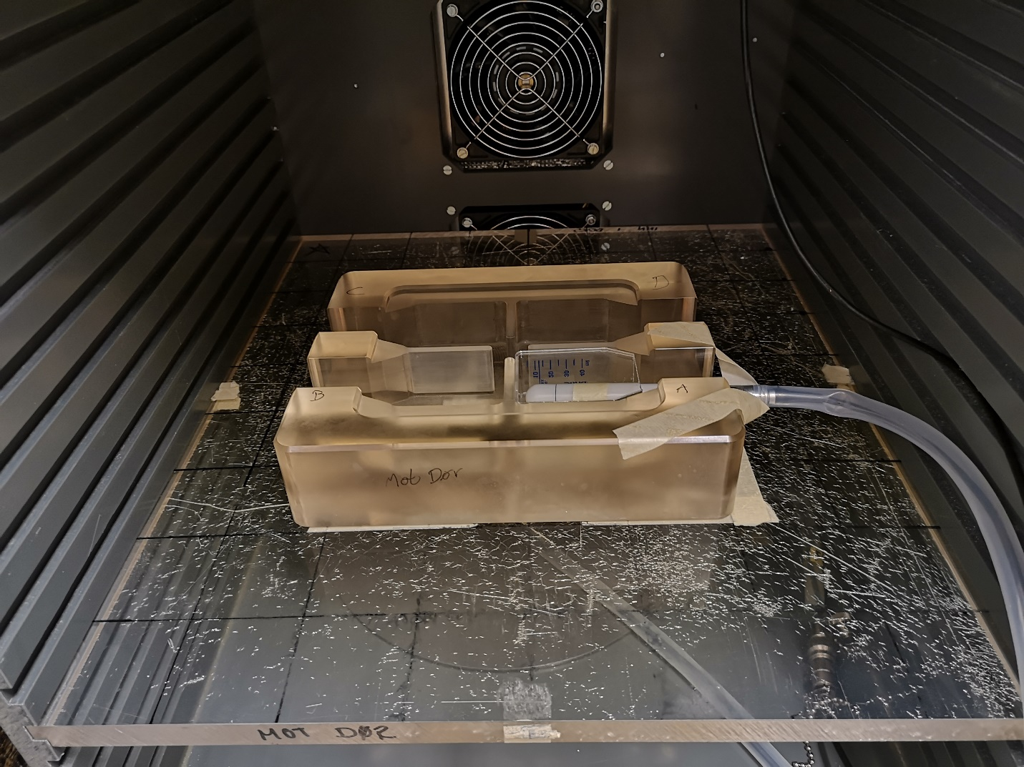

Figure 2‑4. A closer look at the experimental setup of X-ray dosimetry. The ionization chamber is inserted into the cell flask, which is placed into the cell flask holder. Ionizations is measured in all four positions.

A max 4000 electrometer (Standard Imaging, USA) was used to measure the ionization current from the ion chamber. Converting the output of the electrometer, from nC in air to $Gy$ [$J/kg$] in water, was done using the formalism established by the International IAEA explained in 1.5.2

|  |  |
| --- | --- |
| $$D_{w}=M_{u}N_{k}k_{u}p_{u}k_{TP}{\left(\frac{\overline{μ}}{ρ}\right)}_{w,air}=CM_{u}N_{k} .$$ | 2‑2 |

$D_{w}$ is dose to water, $N_{k} [mGy/nC]$ is the calibration factor relating ion chamber output to dose in water and is given by the calibration lab (Norwegian Radiation Protection Authority). $M_{u}$ is the output from the electrometer in nC, $k_{u}$ is correction factor accounting for change in ion chamber resulting in a shift in spectral distribution when moving from air to water. The correction factor is typically assumed to be 1, but it has been shown that $k_{u}$ is dependent on the angular distribution of photons (P.Andreo et al., 1996, p.54-55). However, for our experiments we assumed this to have a negligible effect. $p_{u}$ corrects for effects caused by the ion chamber displacing the water. ${\left(μ/ρ\right)}_{w,air}$ is mass energy absorption coefficient (see 1.3.1) ratio between water and air averaged over the photon energy spectrum during reference conditions, which can be found in Appendix A. $k_{TP}$ corrects for difference in air pressure and temperature conditions, compared to the reference conditions of the calibration lab. $k_{TP}$ was found using the formula

$$k_{TP}=\frac{273.15-T}{273.15+T_{0}}\frac{P_{0}}{P} ,$$

where $T$ and $P$ are temperature and air pressure during calibration with an assumed negligible uncertainty. $T_{0}$ and $P_{0}$ are reference temperature and air pressure. $T_{0}={20}^{∘}C$, $P_{0}=1013 Pa$. Updated Correction factors and mass energy absorption coefficient rates were found in (Waldeland et al., 2010) (see **Error! Reference source not found.**).

Table 2‑1. Calibration factor $N_{k}$ with correction factors and mass energy absorption coefficient ratio. Two experiments were performed using dotted and striped GRID configurations with different temperature and air pressure conditions.

|  |  |  |  |  |  |
| --- | --- | --- | --- | --- | --- |
| $$N_{k} [mGy/nC]$$ | $$p_{u}$$ | $$k_{u}$$ | $k_{TP}$ (310821, stripes) | $k_{TP}$ (131021, dots) | $${\left(μ/ρ\right)}_{air}^{w}$$ |
| $43.77±0.39$ | $$1.02$$ | $$1$$ | $$1.006745405$$ | $$1.021463$$ | $$1.075$$ |

The ionization chamber was irradiated 5, 10, 15, 20 and 60 seconds 3 (31.08.21) or 4 (13.10.21) times in each position. We wanted the calibration films to receive doses that correlated with doses the cells would receive during GRID irradiation. Hence, dose points of 0 (control), 0.1, 0.2, 0.5, 1, 2, 5, 10 Gy were chosen. Because of potential delay (ramp-up time) in beam production from the X-ray machine (Heales et al., 1998) we needed to make sure that there was a linear relationship between irradiation time and the lowest doses (0.1, 0.2, 0.5 Gy). A linear regression model (see 1.6.1) was found for each position using a function called *linregress* from the *scipy.v.1.6* library (Virtanen et al., 2020) in Python (v.3.8) (Guido van Rossum & and the Python development team, 2020). Then the estimated parameters were averaged to get a model independent of positioning in the cell flask holder. This would greatly decrease the duration of the experiment because we could irradiate in all positions at once.

$$\hat{D}=\overline{β_{0}}+\overline{β_{1}}t ,$$

where ${\overline{β}}_{0}, {\overline{β}}_{1}$ are mean coefficients and D is dose. Rearranging the equation, we could find the time needed to achieve the desired dose (0.1, 0.2, 0.5 Gy).

and multiplying desired dose with 1.026

$$\hat{t}=\frac{D⋅1.026-{\overline{β}}_{0}}{{\overline{β}}_{1}}$$

Dose was multiplied with 1.026 to compensate for the height difference between the sensitive volume of the ionization chamber and the bottom of the cell flask mentioned in 2.1.1  
With a nonzero intercept, we could account for the ramp-up in beam production. *Linregress* returns the standard error of the estimated coefficients. Because we found the average model the mean standard error of the model was found with $Δ\overline{β_{k}}= \sqrt{\sum_{i=0}^{n}{Δβ_{k,i}^{2}}}/n$, where k is either 0 or 1. The standard error of exposure time $Δ\hat{t}$ was found using the formula for error propagation of the multivariate function $f(x_{1}, x_{2}…x_{n})$ with independent variables

|  |  |
| --- | --- |
| $$df=\sqrt{ \sum_{1}^{n}{{\left(\frac{∂f}{∂x_{i}}Δx_{i}\right)}^{2} .}}$$ | 2‑3 |

The resulting error expression becomes

$$Δ\overline{\hat{t}}=\sqrt{{\left(-\frac{1}{{\overline{β}}_{1}}Δ{\overline{β}}_{0}\right)}^{2}+{\left(-\frac{D⋅1.026-{\overline{β}}_{0}}{{\overline{β}}_{1}^{2}} Δ{\overline{β}}_{1}\right)}^{2} .}$$

Because linear regression does not account for variability in the independent variable (see 1.6.1), $ΔD=0$. For doses above 0.5 Gy we assumed linearity. Therefore, we only made 60 second measurements to get dose rate (Gy/min) in all positions repeated 3 (31.08.21) or 4 (13.10.21) times. The measurements were averaged to obtain one dose rate. We assumed the uncertainties were connected to $N_{k}$ and $M_{u}$, respectively. With the error propagation we got

$$dD_{w}=C\sqrt{{\left(N_{k}⋅ΔM_{u}\right)}^{2}+{\left(M_{u}⋅ΔN_{k}\right)}^{2}} .$$

$ΔM_{u}$ was found from the nC measurements by averaging repeated measurements of each position, then finding the standard deviation of these averages and dividing it by $\sqrt{n},$ with n being number of positions. $ΔN_{k}$ was reported as $0.39 mGy/nC$ by the calibration lab (*Norwegian Radiation Protection Authority*).

Finding time required for 1, 2, 5 and 10 Gy, we divided the dose with the dose rate. Again, using error propagation we get uncertainty

$$Δt=\sqrt{{\left(-\frac{D}{doserate^{2}}⋅Δdoserate\right)}^{2}}.$$

To get standard error of the mean we divided with the square root of number of measurements.

### Gafchromic film dosimetry

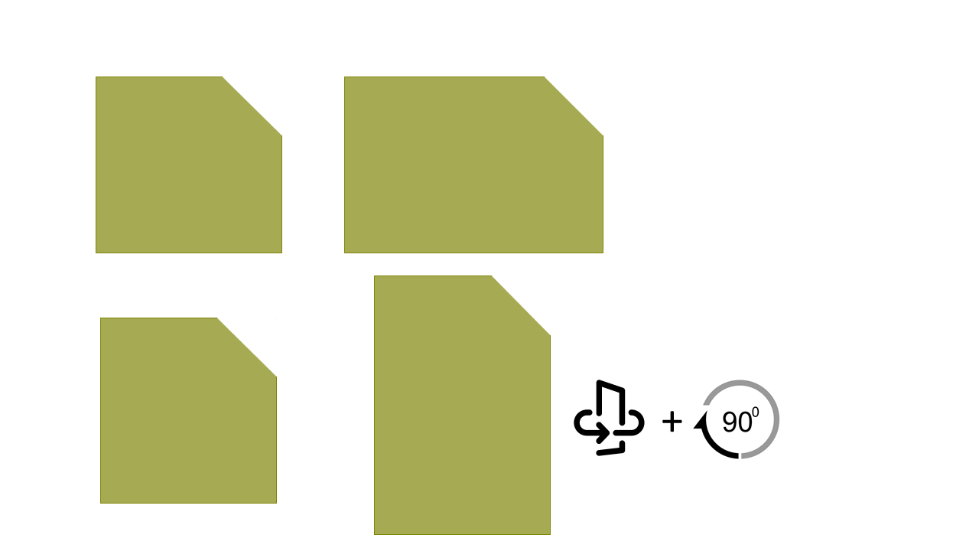The protocol for Gafchromic film calibration follows the protocol established by (Devic et al., 2016) in:   
“Reference radiochromic film dosimetry: Review of technical aspects”.   
  
The Gafchromic EBT3 films (lot #: 02122001) were chosen because they give a high spatial resolution, 2D dose distribution, and they can be neatly fitted to a cell flask. The near tissue equivalent property of the films offers comparative dose measurements to cells suspended in medium. The polymerization process (see 1.5.3) changes the color of the film post irradiation, and because of its low sensitivity to light, it’s unnecessary to develop the film (Niroomand-Rad et al., 1998).   
EBT3 was chosen because of its symmetric chemical configuration (see Figure 1‑15), with a 125 $μm$ protective matt polymer layer on both side of a 26 $μm$ active layer. The implementation of a matte polyester protective layer instead of the smooth layer found in EBT2 removes the generation of the newton ring artefacts when scanning the films (GafChromic, n.d.). The films have a dose range of 0.1 – 10 Gy. Their optical density is known to change from exposure to UV light, temperature and humidity (Girard et al., 2012; Park et al., 2012), the films were therefore handled using gloves in a room with dark curtains, and stored in a room tempered drawer. Because of the external influences in film response, it was important to have a set of control films, that received zero dose.

Figure 2‑5. Figure illustrating importance of having a rectangle with two clearly different sides. The left side has a small difference in height and width. When the film is flipped and rotated ${90}^{∘}$ it is hard to observe the rotation. But if the sides are clearly different, then it becomes clear that the film is oriented in the wrong direction.

#### Film irradiation

As mentioned in 1.5.3, we needed to establish a calibration curve before cell flask dose could be measured. Two calibrations were performed on two separate dates, one for striped and one for dotted GRID configurations on the 31.08.21 and the 13.10.21, respectively. The method was mostly the same on both occasions, but the size of the calibration films was different. The films came in 20 x 28 cm2 sheets and were cut with a Guillotine paper cutter, that was sanitized before use. The calibration films for striped GRID were cut to a size of 4.3 x 4.1 $cm^{2}$. It has been shown that the scan response is sensitive to the direction of the film (Borca et al., 2013). A cut was therefore made on the top right corner of the longest side. The chosen size made it hard to detect which side was the longest. If the film was not handled properly and the film was flipped to its opposite side, one could not trust that the orientation was correct based on the cut. The scenario is illustrated in Figure 2‑4. For dotted GRID, we increased the difference between width and height.   
The T25 cell flasks were cut horizontally, and one film was placed inside each flask. The films were then irradiated in all positions simultaneously, twice per dose point. Thus, giving each dose point eight calibration films.   
A thin slab of 2 mm nylon6 (polymer) was placed on top of the films to act as a buildup material. The material filters low energy electrons, ensuring CPE within the sensitive layer. Because the ionization chamber has a protective cap, the nylon6 slab will increase the similarity between the experimental setups of film- (see **Error! Reference source not found.**) and ionization chamber (see Figure 2‑2 and Figure 2‑3). The films were irradiated with the exposure times found in 2.1.1.

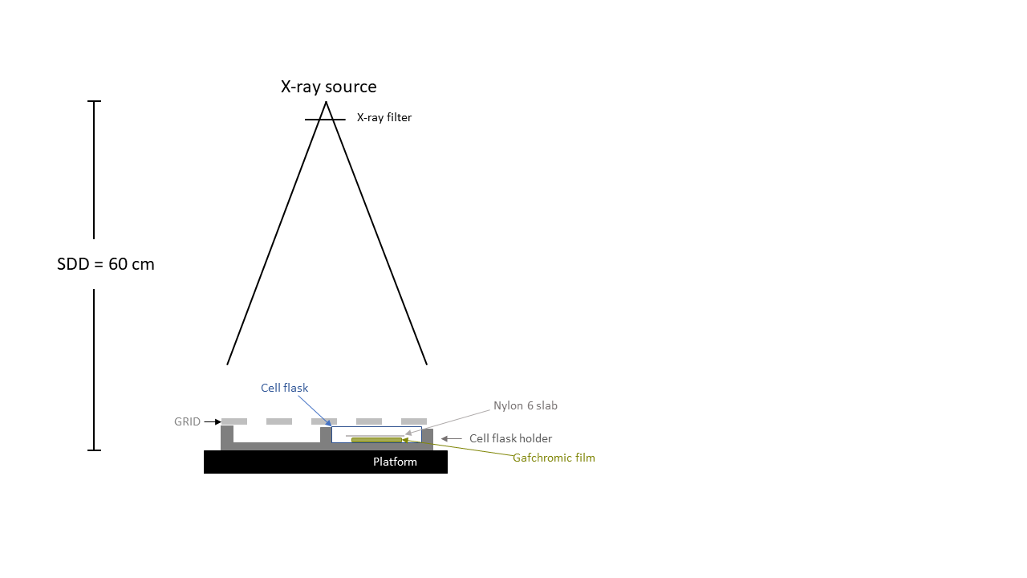

Figure 2‑6. The experimental setup for GRID irradiation of gafchromic films. For calibration, no GRID was used.

A new set of films were, to our best efforts, cut to match the shape of the bottom of the cell flasks. These will be called the measurement films. The films were given nominally 5 Gy. Then their response was mapped to the calibration curve. We irradiated films using the same experimental setup shown in **Error! Reference source not found.** On the first dosimetry experiment (31.08.21) we irradiated using both GRID and OPEN field. The OPEN field films were used to evaluate the accuracy of our dosimetry. However, on the second dosimetry experiment, only GRID irradiations were made to save time. Four films were irradiated simultaneously in all four positions. This was repeated four times for OPEN field and GRID. Thus, resulting in 16 films per configuration.

Two in-house 0.5 cm tungsten metal collimators with striped or dotted grid patterns were constructed to be placed on top of the cell flasks laying in the cell flask holder (see Figure 2‑6). The stripes had 5 mm wide slits and the diameter of the dots was also 5 mm. The GRID’s create high and low dose areas, called peak and valley. The high atomic number of tungsten (see 1.2.1) makes tungsten a great photon absorber. It is well known that collimating an X-ray beam results in increased scattering (Philip Mayes et al., 2007, p.377). The high density of tungsten allows for a thinner design, thereby mediating the scattering within the slits of the GRID. Because of poor cutting accuracy, the measurement films did not fit perfectly into the cell flask, causing them to have small variations in how they lay inside the flask. This resulted in slightly skewed response patterns after irradiations.

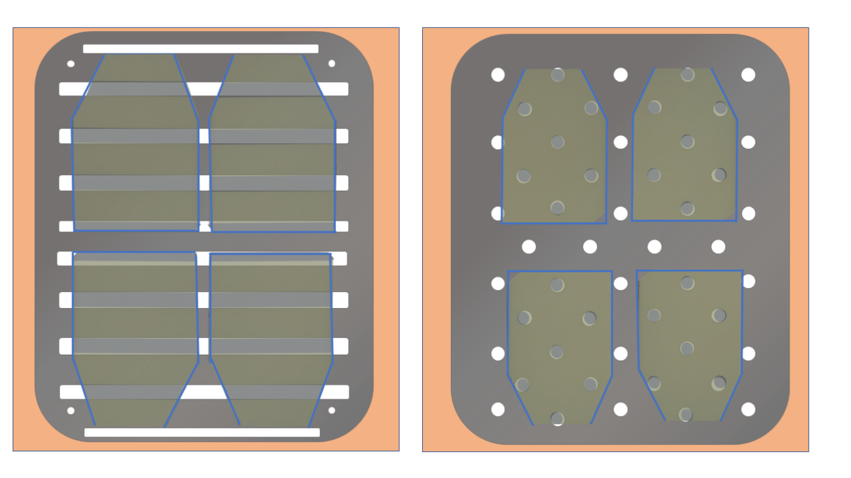

Figure 2‑7. Illustration of how the Gafchromic films were positioned underneath the different GRID configurations. The films were of equal size in both GRID configurations, but the size has been modified to fit the illustrations. The blue lines indicate the outline of the cell flasks, and the background represents the cell flask holder.

#### Scanning

To ensure a stable and saturated optical density of the films, we waited 48 hours after irradiation before scanning the films (Devic et al., 2005).

An Epson Perfection V850 Pro flatbed scanner was used to digitize the films’ radiation response. The films were placed in a central area of the scanner to minimize variations in scan readings (Lewis & Chan, 2015). Transmission mode was chosen, as recommended by (Aldelaijan & Devic, 2018). Using the Epson scan tool v.5.1 software we disabled automatic image corrections and adjustments to only extract raw data. Resolution of 300 dpi was chosen to achieve high enough spatial resolution while having a reasonable scanning time. A 16-bit color depth per channel (0 - $2^{16}$) RGB image was chosen for satisfactory intensity resolution. The scanner was allowed time to warm up for 30 minutes, then 10 dummy scans was performed to limit warm-up effects causing variations in response readings (Paelinck et al., 2006). Four scans were done per film to account for possible change in intensity readings caused by the scanner. We found the largest RPD between the mean pixel value of the fours scans for all films to be approximately $0.1\%$. Which was small enough for us to neglect the scanners effect on film response and only use the first scan in our dosimetry.   
For a complete opaque film, light transmission should be zero. However, there will always be background noise. Therefore, a black film was scanned, and its intensity was subtracted from all control and irradiated films.   
The images were saved as TIFF (Tag Image File Format) without compression to retain as much information as possible from the images.

#### Film calibration

Calculating netOD from the scanned images requires image processing using Python. First the raw data of the images were read and separated into a red, green, blue, and grey channel. Grey channel conversion follows rec 601 (*Recommendation ITU-R BT.601-7*, 2011) using the formula

$$I_{G}=0.299⋅I_{R}+0.587⋅I_{G}+0.114⋅I_{B} ,$$

where $I$ is pixel value. For 2D analysis of cell survival a mean dose map was generated using all 16 films (see explanation further down). It was therefore crucial that the GRID pattern aligned, so they could be stacked on top of each other. However, because of poor accuracy when cutting the measurement films, they were not equally positioned within the cell flask (see Figure 2‑7). We therefore had to spatially registe­r the films, which is the process of geometrically aligning two images. The calibration films were also registered. This ensured that the region of interest (ROI) was positioned equally in all calibration films. The only possible displacements during calibration were rotational and translational; hence a rigid body registration (preserving Euclidean distance) was performed.   
A python module called *pystackreg (version 0.2.5)* was used. The package is a port of the imageJ extension TurboReg/StackReg based on the paper:   
*“A Pyramid Approach to Subpixel Registration Based on Intensity”, by* Thevenaz et al.

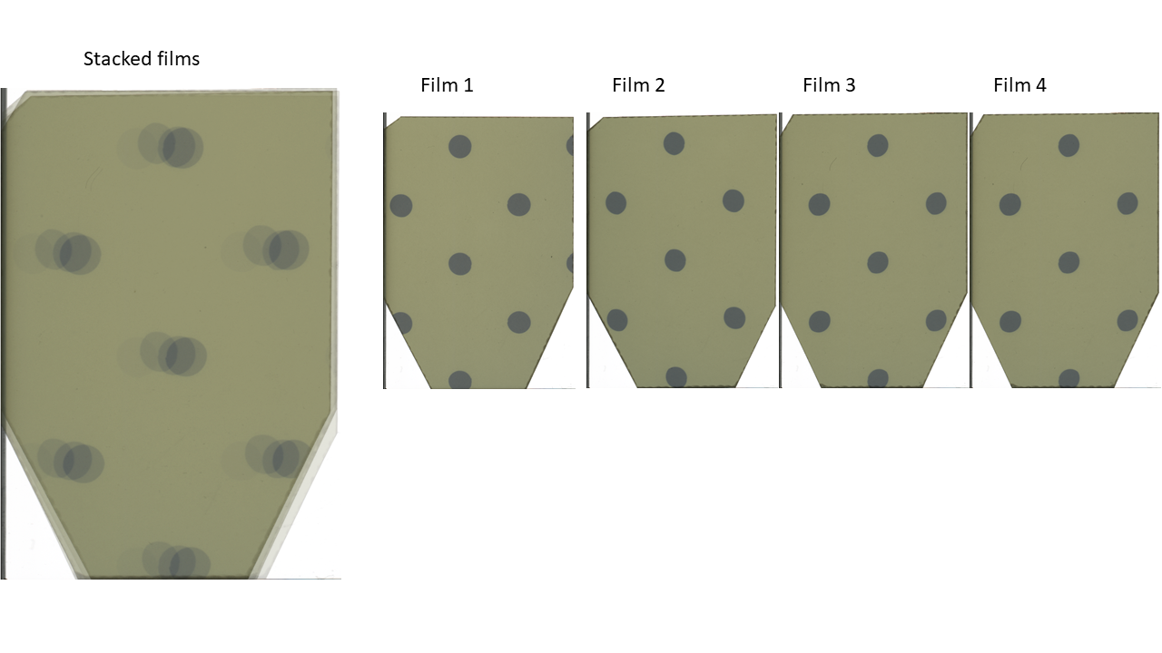Turboreg is a subpixel registration algorithm that aligns a source image $f_{S}$ to a reference image $f_{R}$, both with dimension M x N (rows, columns). Subpixel means that the algorithm has an error less than $± 1$ pixel. Turboreg uses the integrated square difference of the intensity values as a cost function denoted by $ϵ^{2}$

Figure 2‑8. Illustration of misalignment of measurement films underneath the GRID collimator, explaining the necessity for image registration.

$$ϵ^{2}=∫∫f_{R}\left(x,y\right)-Q_{P}\left\{f_{S}\left(x,y\right)\right\} dxdy ={\left\|f_{R}\left(x,y\right)-Q_{p}\left\{f_{S}\left(x,y\right)\right\}\right\|}^{2} ,$$

where $Q_{p}$ is a transformation of the source image (e.g., translation, rotation scaling etc.) parametrized by $P$. The goal is finding a transformation that minimizes the intensity difference, by tuning the parameters in $P$.

$$\frac{∂{ϵ\left(P\right)}^{2}}{∂P}=0$$

The algorithm uses a modified LM (see 1.6.1 for general LM) to find the optimal parameters. When a minimum is reached, or number of maximal iterations surpasses, it returns a 3 x 3 transformation matrix. To optimize the registration various degrees of preprocessing was necessary. *Pystackreg* tended to align the background of the image, rather than the object within. Therefore, a small crop of 20 pixels in each direction of the image was made. We wanted all images to be aligned to the first image in the folder, but the high intensity discrepancy of the calibration films originating from irradiating with doses ranging from 0 Gy to 10 Gy, caused large errors in the registration. We therefore registered each image to the neighboring image.  
This was not required when registering the measurement films, as they were all irradiated with 5 Gy. The background of the measurement films had to be dulled as well as cropping the image.   
We chose to use a package called *skimage.transform,* which includes a function called *warp*. *Warp* both applies the transformation matrix on an image and interpolates. Interpolation is necessary because when an image is transformed, each pixel is mapped into a new coordinate $P\left(x,y\right)→P'(x^{'},y^{'})$ (Ashburner & Friston, 2007). For instance, rotating an image is done by applying the rotational matrix $R$, with added translational elements $t_{x}$ and $t_{y}$,on each coordinate of the image

$$\left[\begin{matrix}x' \\ y'\end{matrix}\right]= \left[\begin{matrix}\cos{θ} & -sin θ & t_{x} \\ \sin{θ} & \cos{θ} & t_{y} \\ 0 & 0 & 1\end{matrix}\right] \left[\begin{matrix}x \\ y\end{matrix}\right].$$

It results in non-integer coordinates with unknown intensity values. The easiest solution is to round the coordinates to nearest integer and use the intensity values of these coordinates (called nearest neighbor interpolation). However, a more accurate interpolation called bi-cubic interpolation was used. We will not go into detail, but the method looks at the 16 neighboring pixels and estimates the unknown pixel’s intensity value from these (Han, 2013). The advantage of extracting the transformation matrix before applying it, is that you can make small tweaks to the registration by tuning the rotational and translational parameters.

In the cut area of the films a transparent white color appears. These areas are undesirable, as they indicate damage of the film’s layers. We therefore chose a Region of Interest (ROI) in a central area of the calibration film that balances the need for sufficient datapoints and capturing the variance of the radiation field, while avoiding the edges of the film. A suitable ROI was found retrospectively, by extracting the mean squared error (MSE) of the non-linear fit of equation 2‑6. Based on these calculations an ROI of 3 x 3 mm2 was chosen.

Measuring the darkening of the film we used the net optical density netOD. It describes the change in opacity compared to unirradiated films using the formula (Devic et al., 2004)

|  |  |
| --- | --- |
| $$netOD=ΔOD=\max\left[0,\log_{10}\left(\frac{{\overline{PV}}_{ctrl}-{\overline{PV}}_{bckg}}{PV_{irr}-{\overline{PV}}_{bckg}}\right)\right]$$ | 2‑4 |

If the log returns a negative number, then the PV value of the irradiated film is larger than that of the control film, which in theory should not be possible. We therefore set netOD of that film to 0.

where ${\overline{PV}}_{ctrl}$ and ${\overline{PV}}_{bckg}$ was found by finding the mean pixel value within the ROI of each control and background image, then finding a weighted average of these means (see Figure 2‑8). The weights are based on the standard deviations of each mean following the relationship (Devic et al., 2004) $w_{i}=\frac{{1/σ}_{PV}^{2}}{\sum_{i=1 }^{n}{1/σ_{PV}^{2}}}$. $PV_{irr}$ is the mean pixel value of the ROIs of all irradiated films, a weighted average was not found for $PV_{irr}$, because we wanted each dose point to have 8 accompanying films for increased accuracy when fitting the calibration curve. Using equation 2‑3 we estimate the error in $netOD$ as

|  |  |
| --- | --- |
| $$σ_{netOD}=\sqrt{{\frac{∂ΔOD}{∂PV_{ctrl}}}^{2}⋅{σ_{PV}^{2}}_{ctrl }+ {\frac{∂ΔOD}{∂PV_{bckg}}}^{2}{{⋅σ}_{PV}^{2}}_{bckg}+{\frac{∂ΔOD}{∂PV_{irr}}}^{2}⋅{σ_{PV}^{2}}_{irr}} \\ =\frac{1}{ln10}\sqrt{{\left(\frac{σ_{{\overline{PV}}_{ctrl}}}{{\overline{PV}}_{ctrl}-{\overline{PV}}_{bckg}}\right)}^{2}+{\left(\frac{σ_{PV_{irr}}}{PV_{irr}-{\overline{PV}}_{bckg}}\right)}^{2}+{\left[\frac{{\overline{PV}}_{ctrl}-{\overline{PV}}_{bckg}}{\left(PV_{irr}-{\overline{PV}}_{bckg}\right)\left({\overline{PV}}_{ctrl}-{\overline{PV}}_{bckg}\right)}\right]}^{2}σ_{{\overline{PV}}_{bckg}}^{2} }$$ | 2‑5 |

For measurement films, all pixels were converted to netOD, hence no mean pixel value was found and $σ_{PV_{irr}}=0$. We found ${σ_{\overline{PV}}}_{ctrl}$ and $σ_{{\overline{PV}}_{bckg}}$ using (Devic et al., 2004)

$$σ_{{\overline{PV}}_{ctrl}}=\frac{1}{\sqrt{\sum_{i=0}^{n}{\frac{1}{σ_{i,PV_{ctrl}}^{2}}}}} , σ_{{\overline{PV}}_{bckg}}=\frac{1}{\sqrt{\sum_{i=0}^{m}{\frac{1}{σ_{i,PV_{bckg}}^{2}}}}} ,$$

where $n$ and m was the number of control and background films respectively. ${σ_{PV}}_{ctrl}$ and $σ_{PV_{bckg}}$ represents the standard error of the weighted mean pixel value within the ROIs of the control and background images.

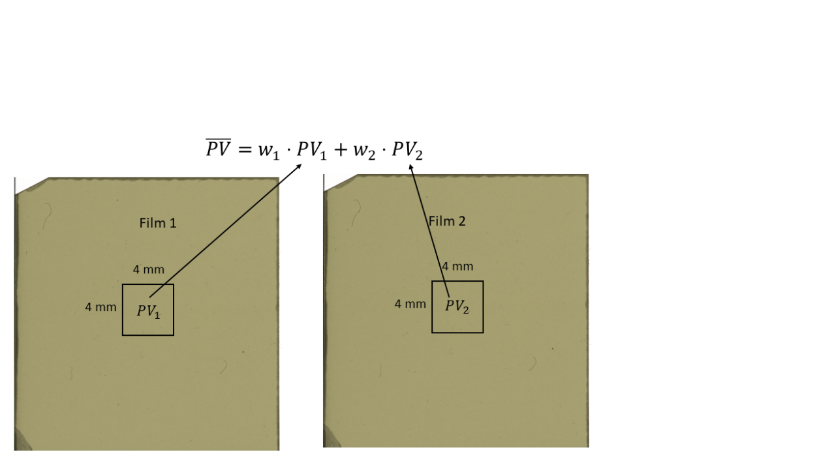

Figure 2‑9. Illustration explaining the notation behind calculating weighted average pixel values $\overline{PV}$**.** Both $PV_{1}$ and $PV_{2}$ are mean pixel values within the 4 x 4 mm2.

When plotting netOD against dose it became apparent that the calibration films had a split response, which can be seen in Figure 2‑10. This was not the case for the second calibration, which complicated the process of converting from netOD to dose (explained further down). But for striped GRID we were able to separate the datapoints into low and high response using Kernel Density Estimation (KDE). KDE estimates the probability density function (PDF) of the data (Silverman, 1998, p.1). The method sorts the data in increasing order, before centering a kernel over all the datapoints. The kernel is a known PDF with a specified smoothing parameter called bandwidth. For our netOD data we used a Gaussian kernel, where the bandwidth acts as the standard deviation in the Gaussian PDF. The kernels are summed together, and the sum increases if many kernels are within each other’s bandwidths, as seen in Figure 2‑9. We used a python package called *sklearn.neighbors* (Pedregosa et al., 2011) with the module *KernelDensity.* This function is slightly different, in that it finds the log likelihood of the kernels, which resulted in a negative curve. We know that we have two groups: high and low response, we can therefore identify the global minimum of the log likelihood curve to obtain the index separating the netOD values into high or low response. This method was also used for the measurement films.

Following separation of high and low response, we could fit the data to a model explaining the relationship between dose given and netOD measured $D(netOD)$. Bjørg Vårli Håland evaluated models using corrected Akaike Information criteria (AICc). We will come back to the concept of AIC in 2.4.3.5 , but we will not perform the same analysis. Based on the results of Bjørg Vårli Håland, we chose the model

|  |  |
| --- | --- |
| $$D=a⋅netOD+b⋅netOD^{n} ,$$ | 2‑6 |

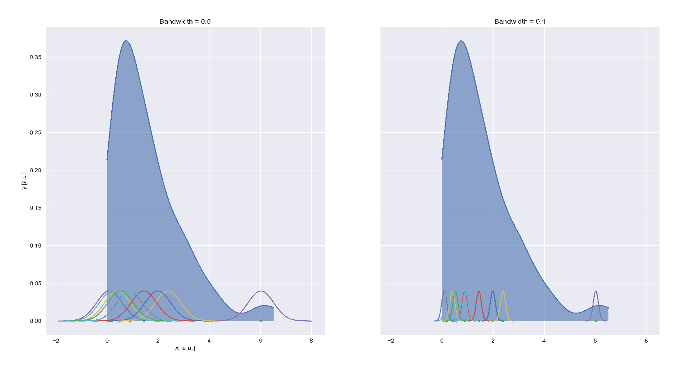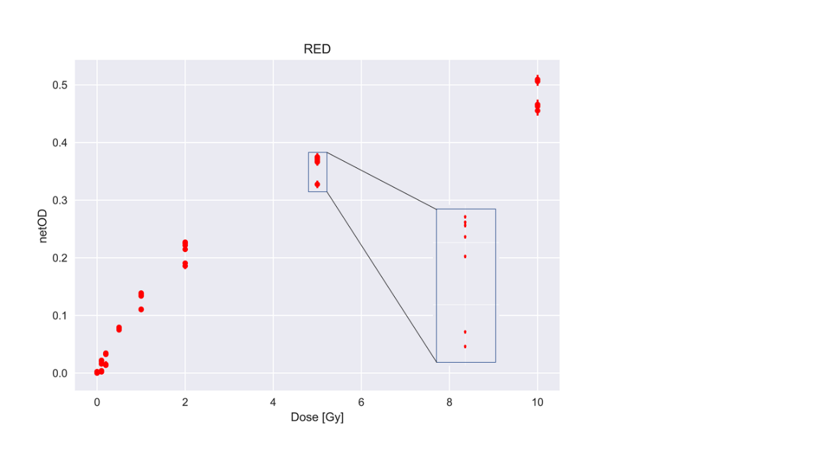where $a, b,$ and $n$ are unknown parameters. The python package *scipy.optimize* with the module $least_squares$ estimates the parameters using the LM method. It also returns necessary goodness of fit values to evaluate the model. Extracting the uncertainty of the estimated parameters is not trivial, as it is not returned by the function. However, it does return the Jacobian (see 1.6.1), which can be used to find the variances of each parameter.

Figure 2‑10. KDE schematic. Kernels are drawn over each datapoint and summed together. When more datapoints are clustered together, the kernel sum increases to form the shape seen in the image.

Figure 2‑11. Illustration of the split response in netOD. This was apparent in all color channels.

Using the relationship (Niclas Börlin, 2007, slide 12)

$$Σ=σ^{2}H^{-1} ,$$

where $Σ$ is the covariance matrix, a p x p matrix explaining how the parameters in $p$ vary following the expression

$$Cov \left(p_{x},p_{y}\right)=\frac{1}{n-1}\sum_{i=1}^{n}{(p_{x_{i} }-{\overline{p}}_{x_{i}} )(p_{y_{i}}-{\overline{p}}_{y_{i}})}$$

The diagonal elements of this matrix are $Cov (p_{x},p_{x})$, which reduces to $Var \left(p_{x}\right)$. $H^{-1}$ is the inverted hessian matrix. From 1.6.1 we saw that the hessian matrix could be approximated to $J^{T}J$, without the weights $W$. $σ^{2}$ is the standard error of the residuals. Combining these elements, we found the variances of each estimated parameter.

The LM method demands an initial guess of parameters. We evaluated the robustness of the algorithm by initializing random guesses for a,b and n, where the guesses came from a standard normal distribution, the output parameters were recorded to observe if the algorithm converged to the same parameters every time. The only criterion was that $n>0$.

All color channels were fitted, but only one channels was chosen for dosimetry. Which one was decided based the channels sensitivity to dose (Stevens et al., 1996) and the mean squared error (MSE) of the fit. The red color channel proved to have highest sensitivity and lowest MSE

With an established response between dose and netOD, we could perform netOD calculations on the measurement films. The pixel values of the films were first converted to netOD before they were classified as either high or low response using the KDE method. Then these pixel values were converted to dose using the newly fitted equation 2‑6. No ROIs were used because we wanted each pixel in the image to correspond to a dose measurement. This made it possible to determine peak and valley doses in the GRID irradiated films. Uncertainty in dose measurements were calculated using error propagation of the fitted function in equation 2‑6.

|  |  |
| --- | --- |
| $$σ_{D_{fit}}=\sqrt{{\frac{∂D}{∂a}}^{2}⋅{σ_{a}^{2}}_{ }+ {\frac{∂D}{∂b}}^{2}{⋅σ}_{b}^{2}+{\frac{∂D}{∂netOD}}^{2}⋅σ_{netOD}^{2}+{\frac{∂D}{∂n}}^{2}⋅σ_{n}^{2}} \\ =\sqrt{netOD^{2}σ_{a}^{2}+{\left(netOD^{n}\right)}^{2}σ_{b}^{2}+{\left(a+bn⋅netOD^{n-1}\right)}^{2}σ_{netOD}^{2}+{\left(b\ln{netOD}⋅netOD^{n}\right)}^{2}σ_{n}^{2}}$$ | 2‑7 |

One mean dose map was generated for OPEN field and both GRID configurations based on the 16 irradiated films following the formula

|  |  |
| --- | --- |
| $$\frac{1}{\# films}\sum_{i=0}^{\# films}{D_{i},}$$ | 2‑8 |

where $D_{i}$ is the ith dose map.The steps taken to generate the mean dose map is illustrated in Figure 2‑11. The estimated uncertainty in the mean dose map was a combination of fitting uncertainty found from equation 2‑7 and the standard error in the pixels across the 16 measurement films. Each pixel has a standard error from the fit $σ_{D_{fit}}$. Because our mean dose was calculated using equation 2‑8 we can find the corresponding error using

$\frac{1}{\#films} \sum_{i=0}^{\#films}{σ_{i}^{2}}$, where $σ_{i}=\left[{σ_{D}}_{fit,0}, {σ_{D}}_{fit,1},…,{σ_{D}}_{fit,n}\right].$ As a consequence of the split response, the uncertainty of high and low response was found separately following

$${\overline{σ}}_{low}= \frac{\sqrt{\sum_{i=0}{σ_{D_{fit,low,i}}^{2}}}}{low} , {\overline{σ}}_{high} \frac{\sqrt{\sum_{i=0}{σ_{D_{fit,high}}^{2}}}}{high} ,$$

before being combined to total standard error of fit $σ_{fit,tot}=\sqrt{{\overline{σ}}_{low}^{2}+{{\overline{σ}}^{2}}_{high}}$.

The standard error of each pixel was also found separately before being combined to the total standard error $σ_{\overline{D}}$.   
Finally, we combined all the errors to get the total standard error of the mean dose map $σ_{tot}=\sqrt{σ_{fit,tot}^{2}+σ_{\overline{D},tot}^{2} }$.

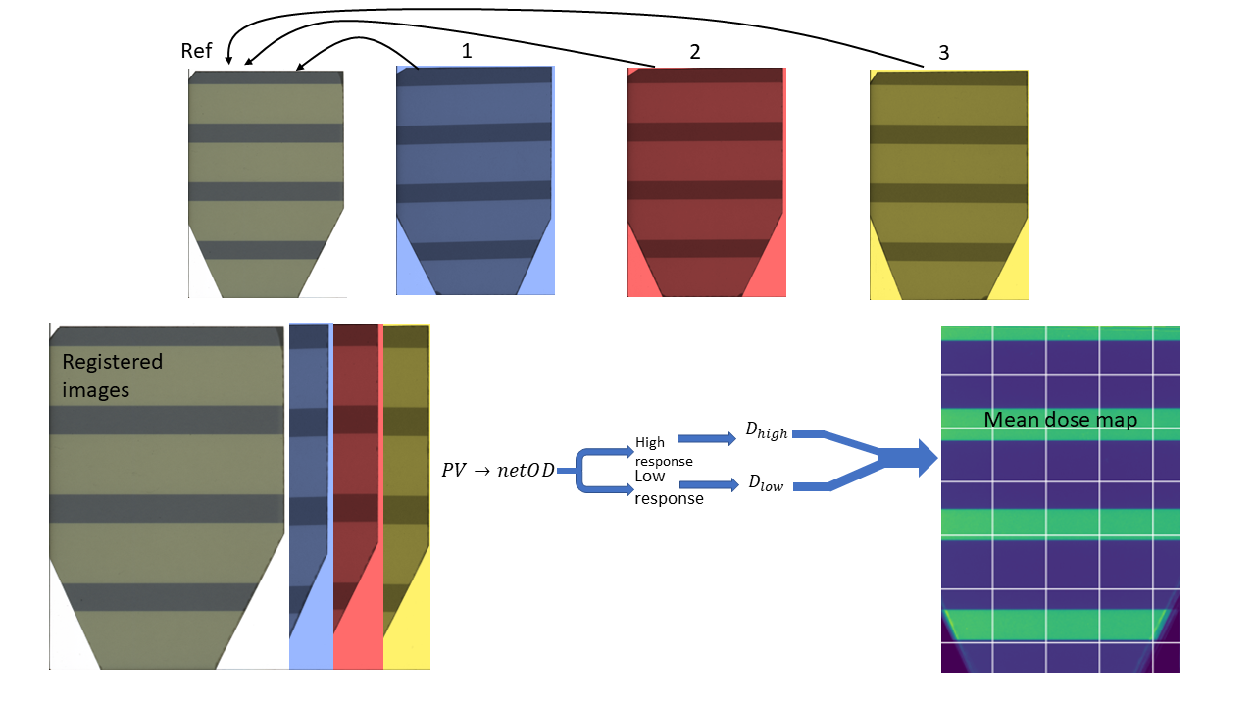

Figure 2‑12. An overview of registration process to generate a mean dose map from the measurement films. First all films are registered to the first film in the folder (reference image), then each image pixel value is converted to netOD using equation 2‑4, before being converted to dose via equation 2‑6. Then all dose films are averaged to generate a mean dose map. This process is equal for all irradiation configurations: OPEN field or GRID.

Dose profiles were made by calculating the mean dose in each pixel row within a limited area. The upper and lower limit was chosen to remove variations in the mean caused by areas where the GRID openings were of unequal length. In Figure 1‑10 we see an example of this, where the film narrows at the bottom, causing a decrease in mean dose for the rows located here. From the dose profiles we estimated the dose prescribed with OPEN field and GRID, in the peak and valley areas. For OPEN filed, mean dose was found from all 16 dose profiles generated from the irradiated measurement films. The dose profiles for GRID irradiated measurement films were separated into datapoints that were within the peak or valley dose category. Peak and valley doses were defined as being **above** 95% of maximum dose, and **below** 105% of the minimum dose, respectively. Then the mean dose of all these datapoints was found. Uncertainty was estimated by combining the total uncertainty of all films, both high and low response.   
As mentioned, the lack of high and low response in the calibration films for dotted GRID complicated the fitting of equation 2‑6. When plotting the netOD from these films together with the data from the first calibration, we saw that some films exhibited **only** low or high response, not both (see Figure 2‑13). As a solution, we tried two approaches: First, the calibration films were fitted ignoring the possibility of high and low responses. The fit was subsequently used on the measurement films, converting their netOD values to dose. Secondly, we did not ignore the possibility of high and low response and used the fitting parameters from the first calibration on the high and low response measurement films, respectively.

Converting pixels to mm in a 300 dpi or a 1200 dpi image was done by finding the pixels per mm conversion factor. Assuming a one-to-one relationship between dots and pixels we have 25.4 mm per inch, resulting in

|  |  |
| --- | --- |
| $$\frac{300\frac{dots}{inch}}{25.4\frac{mm}{inch}}≈11.8 pixels/mm , \frac{1200\frac{dots}{inch}}{25.4\frac{mm}{inch}}≈47 pixel/mm$$ | 2‑9 |

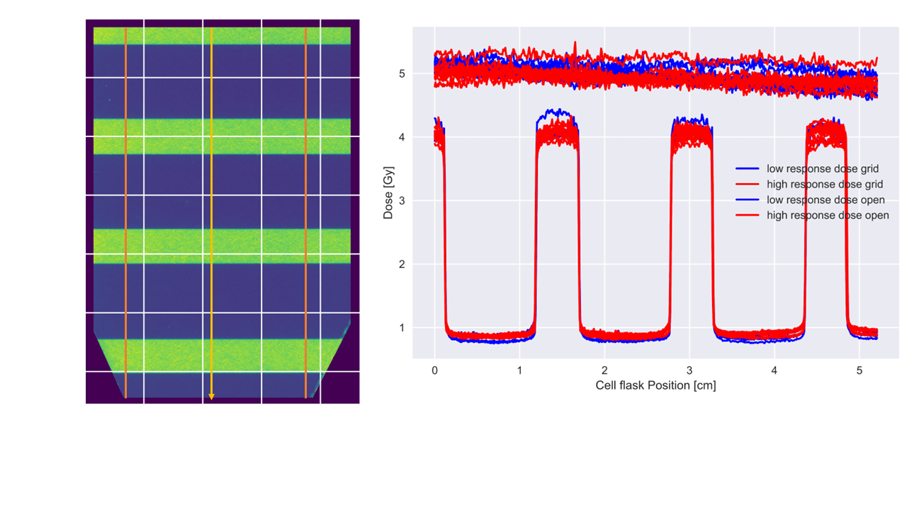

Figure 2‑13. Dose profile for striped GRID measured by calculating mean dose for each pixel row in the image. The image was cropped before making a dose profile to remove variations in mean dose caused by areas where the GRID pattern was not of equal length (see bottom of image to the left).

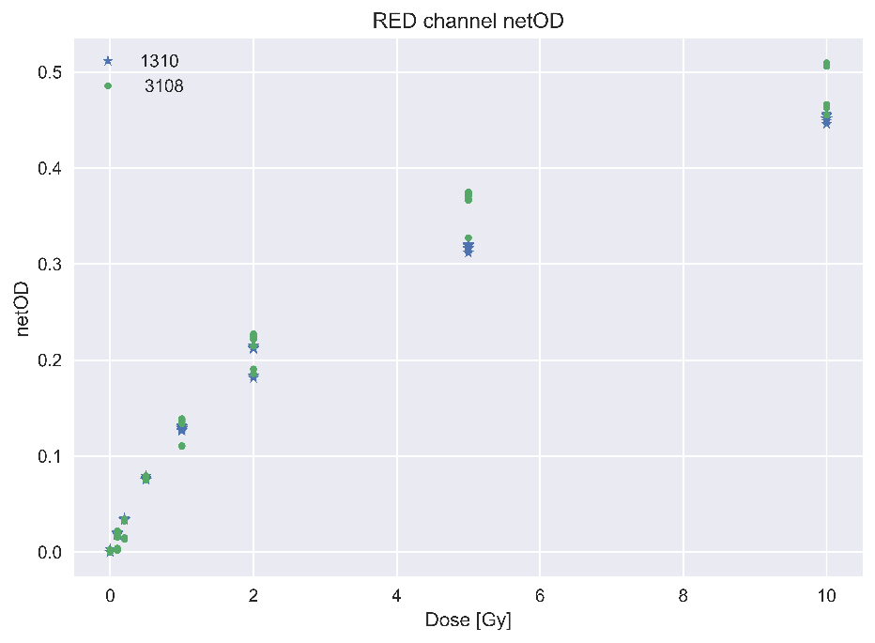

Figure 2‑14. netOD of red channel for both sets of calibration films 3108 and 1310. We see a clear separation for the first set, but for the second there are some films with high and some with low response.

#### Dose evaluation

To have a point of reference, the dosimetry for GRID was validated with Monte Carlo simulations performed by Delmon Arous, PhD-student. He used FLUKA version 4-2.1 (Battistoni et al., 2015; Böhlen et al., 2014), a particle physics Monte Carlo simulation package to simulate how the photons would interact in our experimental setup, including chemical composition of EBT3 films, the T25 cell flasks, the 220 kV photon energy spectrum filtered through 0.7 mm Cu and 1.52 mm Al and the collimation of the beam through the GRIDs. The algorithm follows the photons’ interactions until a specified cutoff energy has been reached, and the remaining energy is deposited locally (N. Reynaert et.al, 2006). Cutoff energy of 1 keV was chosen for photons and secondary electrons (Jabbari, 2011), and a total of $2⋅{10}^{7}$ primary X-rays were simulated. With these Monte Carlo simulations, the absorbed dose within the EBT3 films was found.

## Cell Experiments

Cell experiments were performed by Magnus Børsting in his master thesis:   
*“GRID irradiation and bystander effect in lung cancer cells”*(Magnus Børsting, 2020, 45-56)*.*  
  
A549 cells were chosen for in vitro GRID irradiation. The cell line is an alveolar basal epithelial cancer cell originating from the study of 200 human tumors, where the goal was to establish cell lines (Giard et al., 1973). An alveolar cell originates from the alveoli of the lungs, which are small cavities that exchange oxygen for carbon dioxide. Epithelial cells are cells that covers the surface areas of the body (*Epithelium | Anatomy | Britannica*, 2009). Basal means that the cell is found in the lower parts of the epithelium (Morgenroth & Ebsen, 2008, p.70).   
30 000 cells were seeded with 6 ml growth medium in a T25 cell flask (Nunclon, Denmark) with 25 cm2 cell culture area. The cells were incubated in an incubator (Thermo, USA) holding ${37}^{∘}$ C with a CO2 percentage of 5%. The number of 30 000 was found by Magnus Børsting after performing a pilot experiment where different cell densities were used. All experiments used 30 000 cells to remove variability in survival that occurs for different cell densities. The number was chosen because it best balances the need of having high enough cell density to measure the effect of high doses while being close enough to observe the effects of introducing a dose gradient (caused by GRID block), but small enough that it was possible to identify individual colonies. It should also be noted that seeding too many cells might result in an artificially low plating efficiency (Pomp et al., 1996).

The irradiations of the cells were done using the same experimental setup as shown in Figure 2‑6, and the same X-ray beam settings were chosen, with the same filtration. The differences were that no Gafchromic film or nylon6 slab was used. The cells are as mentioned seeded at the bottom of the cell flask, with medium covering the cells acting as the buildup material. The irradiation cabinet seen in Figure 2‑2 has a heater, ensuring the ideal temperature of ${37}^{∘}$ C.   
Nominal doses of 2, 5 and 10 Gy were chosen. Four flasks were used per dose point, including control flasks. The irradiation was done for OPEN field, GRID stripes and GRID dots.

A colony is a cluster of more than 50 cells (Franken et al., 2006). Number of colonies formed after irradiation was our metric of survival. It was chosen to wait six days before fixating the cells, seeing that a typical doubling times for A549 cells is 22 h (*A549 Cell Subculture Protocol – A549 Cell Line*, n.d.). Fixation of cells is the process of fixing the cells in their position and terminating all ongoing biological mechanisms, essentially killing them and disabling their natural degradation mechanisms so they can be viewed in a microscope (Panzacchi et al., 2019).  
3 ml of Ethanol was used to fixate. Ethanol was chosen because it is fast and has optimal preservation of cell structure (Rahman et al., 2022).  
The number of surviving colonies (SC) was counted using a segmentation algorithm, it was therefore necessary to stain the cells to make it easier for the algorithm to separate individual colonies. 3 ml of methylene blue dye was added. Because of a specific chemical reaction that only occurs in living cells, only dead cells are colored by the dye (O’Connor-Cox et al., 1997).

After fixation and staining the cell flasks with cells were scanned by Bjørg Vårli Håland the same way as the EBT3 films (see 2.1.2.2), except for a dpi of 1200 with the resolution of 2220 x 2976 x 3. The cell flasks have a height making it impossible to close the scanner completely. The scans of the cell flasks will therefore have a slight angle, causing a sharp dark shadow on the image.

## Segmentation

Segmentation of cells was performed by Delmon Arous in the article:   
*“Principal component-based image segmentation: a new approach to outline in vitro cell colonies”.* (Arous et al., 2022).   
  
This section uses the same notation found in (Strang, 2006, p.425-427).  
The scanned cell flask images were segmented using a combination of PCA, GLCM, k-means and topological multi-threshold watershed. The segmentation was performed with MATLAB. PCA is principal component analysis and aims to reduce the dimensionality of the image while retaining most of its variation (Jolliffe, 2002, p. IX). For easier understanding one scanned image of a cell flasks is used as an example. The dimension of the image is M x N x 3. By collapsing the first two dimensions and transposing the matrix, you get the matrix $X ϵ R^{3 x MN}$. Each column represents the RGB values ${\left[r_{i}, g_{i}, b_{i}\right]}^{T}$. The data is centered around the origin by subtracting the mean $μ ϵ R^{3 x 1}$ of each row of $X$ from the $r_{i}$, $g_{i}$ and $b_{i}$ values, to generate $\hat{X}=X-μ$. The covariance matrix $C ϵ R^{3 x 3}$ is generated from $\hat{X}$ and explains how the color channel intensity values r, g and b vary among themselves.

Through Singular Value Decomposition (SVD), which will not be elaborated further, the eigenvectors of $C$ is found and represented by the matrix $P=[u_{1}, u_{2}, u_{3}] {ϵ R}^{3 x 3}$.The eigenvectors are ordered in descending order, from highest to lowest variance. The important thing to note is that the eigenvectors are per definition uncorrelated, so they represent different parts of the image. It is therefore possible to isolate the eigenvector that represents the variance of the clusters of cell colonies in the image. Using the eigenvectors, you can transform the data in $\hat{X}$ into the PCA space using the transformation

$$\hat{Y}=P\hat{X}=\left[\begin{matrix}u_{1}^{T}{ \hat{X}}_{i} \\ u_{2}^{T}{ \hat{X}}_{i} \\ u_{3}^{T} {\hat{X}}_{i}\end{matrix}\right] ,$$

where $\hat{Y}$ are the new pixel values in the transformed data. $\hat{Y}$ is divided into three parts $I_{PCA1},I_{PCA2}$ and $I_{PCA3}$**,** which is named the PCA images with dimension 1 x MN. Deciding which image that contains cell colony variance was decided using the Grey-level co-occurrence matrix (GLCM) (Haralick et al., 1973), assuming that the suitable $I_{PCA}$ is composed of pixel values that are insensitive to and suppress the presence of various high-contrast artefacts, such as contaminants or residue in the suspension medium, shadow artefacts or background noise from the scan acquisition and the cell container boundary.

With a suitable $I_{CPA}$ it was necessary to distinguish background from foreground. I.e., cell colonies from black background. Using k-means on clusters of 9 pixels (one central pixel, with eight surrounding pixels), the pixels were assigned to either foreground or background (Lloyd, 1982). The resulting matrix is a binary mask (only two intensity values) with foreground objects named Binary Large Objects or BLOBs.

Topological multi-threshold watershed segmentation is applied to separate the BLOBs (see Figure 2‑14 into individual colonies (Khan et al., 2016). The watershed works by identifying parts of an image with local intensity minima known as catchment basins. These areas are filled with colors to identify different objects within the image (Preim & Botha, 2014, p.130). If watershed was used on the original scanned images, which does contain noise, dust etc. it would see all these artefacts as cell colonies. But because the BLOB’s coordinates were extracted using PCA, they are independent from the mentioned artefacts. Each BLOB was searched for local minima in intensity, but watershed has a tendency to over-segment an image caused by naturally occurring variations in intensity (Preim & Botha, 2014, p.130), therefore minima with depth less than a threshold value h was suppressed.   
After segmentation, the program returned information about individual colonies’ centroid coordinates, area, circularity, mean and standard deviation of intensity, as well as delineated cell flask images (see Figure 2‑14)

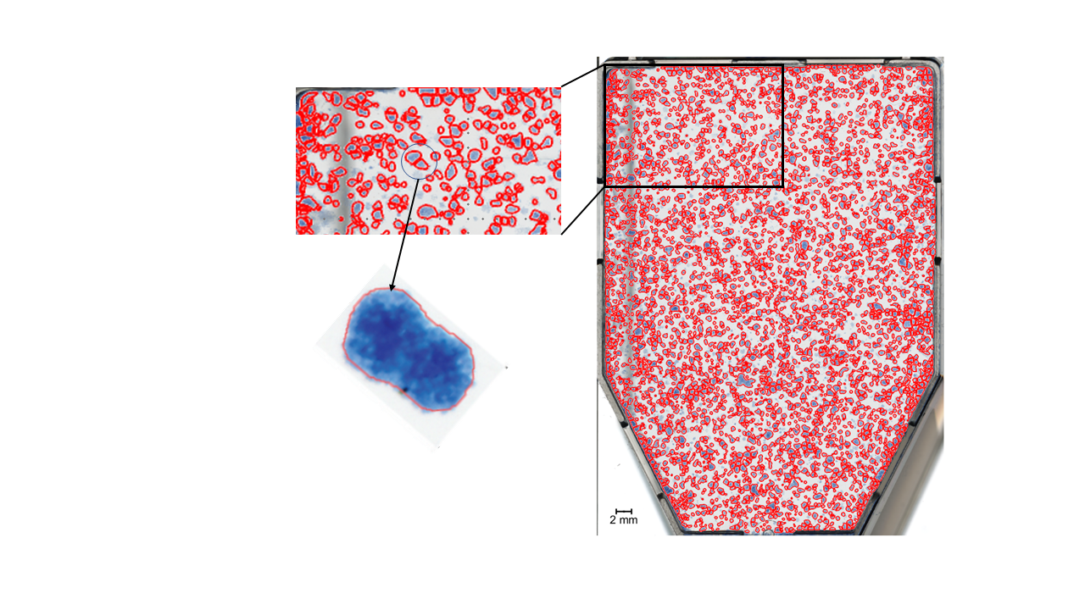

Figure 2‑15. An example of a BLOB that is difficult to classify. The red circles are delineations of colonies stained with blue dye. Here we see a successful delineation of two separate colonies within a BLOB.

## Cell Survival Analysis

With an established dosimetry for the cells, we could analyze the survival data from Delmon Arous’ segmentation program. Magnus Børsting performed four different single fractionation experiments. The irradiation configurations used in these experiments are summarized in Table 2‑2. An LQ model was fitted for analysis of OPEN field survival data, while a band analysis proposed by Bjørg Vårli Håland was employed on striped GRID data to have a basis of comparison for the novel 2D approach.

Table 2‑2.Segmentation data generated by Delmon Arous, PhD student, from experiments performed by Magnus Børsting, former Msc student.

|  |  |  |  |  |
| --- | --- | --- | --- | --- |
|  | **Experiments** |  |  |  |
| **Configurations** | 18.11.2019 | 20.11.2019 | 03.01.2020 | 17.12.2020 |
| OPEN | ✓ | ✓ |  | ✓ |
| GRID Stripes | ✓ | ✓ |  | ✓ |
| GRID Dots |  | ✓ | ✓ | ✓ |

### Data acquisition and image registration

**The scanned cell flask images will from here on out, be referred to as cell flasks, and the scanned dosimetry films will be referred to as dosimetry films or simply films**.

For our 2D survival analysis we used Poisson regression, which models counting data. This limited how much data we could use. As mentioned in 1.7.4, one might normalize survival data using the plating efficiency to compare experiments performed under different conditions, but as Poisson regression demands counts, this is not possible. We still wanted to use as much data as possible. We therefore used Analysis of Variances (ANOVA, explained in 2.1.2.2) to evaluate the differences in mean number of colonies found in the four control cell flasks per experiments. There was no significant difference between experiments performed on the 18.11.2019 and the 20.11.2019. We therefore chose to combine these results for increased statistical significance in our calculations. Another point was to choose data with the highest PE, for more viable results (see 1.7.4).   
Using the centroid coordinates of the cell colonies we created a colony map (binary), where intensity value 1 indicated a cell colony. The coordinates were in decimals, it was therefore necessary to round to nearest neighboring whole number pixel to place the colony in the colony map. In our 2D analysis we divided the cell flasks into quadrats of different sizes. The smallest size of our quadrats will be 0.5 mm2, which for a 1200 dpi image assuming 25.4 pixels per mm and a one-to-one relationship between dots and pixels, corresponds to a 24 x 24 matrix. We therefore chose to neglect the round off error.

The mean dose map was registered to the segmented cell flasks. Because the dose map was based on EBT3 films registered to the first film of the folder (reference film) (see Figure 2‑11), and cell flasks were registered to each other by Delmon Arous, it was only necessary to register the reference film to one of the cell flasks. Then use the obtained transformation matrix on the mean dose map. Final tuning of said transformation matrix was made to achieve ideal match between the dose map and the cell flask. As mentioned, the different irradiation configurations (GRID or OPEN field, Stripes or Dots) needed various degrees of image processing, but the common modification was to match the resolution of the images. We either had to downscale the resolution of the cell flasks (1200 to 300 dpi), or upscale the resolution of the films (300 to 1200 dpi). The latter was chosen to retain as much accuracy as possible when pinpointing the positions of the cell colonies. Downscaling an image may result in valuable information being lost, and the centroid position of the colonies would be spread out onto four pixels with 0.25 intensity.

The films and the cell flasks are different images, we therefore needed to create binary maps to enhance the similarity of the images. E.g., for striped GRID we see dark striped patches in the peak area matched by a decrease in survival in the same area of the cell flasks (see Figure 2‑15). Changing the intensity to match these patterns helped to improve the registration. This approach was also used for OPEN field and dotted GRID. We still used a rigid body registration because the main displacements were still translational and rotational. However, assuming no influence on the scanning by the cell flask other than not properly closing the cover (see 2.2), the cell flask bottom has small feet that slightly raises the cells above the glass plate of the scanner. Because the films were scanned directly on the glass plate, there is a slight height difference of about $0.250±0.001$ cm, accounting for the feet and the thickness of the cell flask bottom. This led to a small error in registration, but not large enough for us to use scaled rotation (translation, rotation, scaling). This scaling is not increasing number of pixels using interpolation, but the process of increasing or decreasing the size of the image without changing the number of pixels.

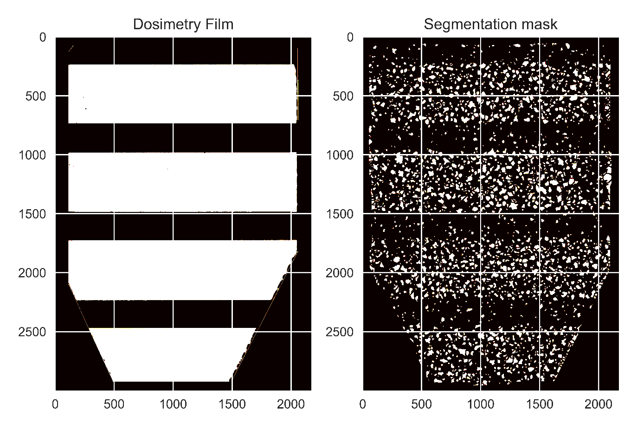.

Figure 2‑16. How the patterns of the segmentation mask and the dosimetry films were matches for better registration. One of the 16 dosimetry films for striped GRID can be seen on the left, and the segmentation mask of counted colonies can be seen on the right.

### 1D survival analysis

A 1D analysis of survival was performed to have a basis of comparison to our novel 2D analysis. For OPEN field data all colonies within an area of the films with reliable data (discarding colonies near the edges) were summed. The number of colonies for control and irradiated flasks were normalized to control before being log transformed. They were then fitted using the traditional LQ model. Log transforming equation 1‑25 we get the quadratic expression

$$\log{S=}-αD-βD^{2} ,$$

that we could fit using ordinary least square (OLS) fitting from the *statsmodels* package (Seabold & Perktold, 2010) in Python. It finds the optimal parameters, with uncertainty, using the closed form solution of least squares (see 1.6.1). The OLS function takes the response variables $y$ and the explanatory values $X$. It demands $X$ tohave the shape m x n, with m datapoints and n explanatory variables. With dose and dose squared as explanatory variables you get the matrix

$$X= \left[\begin{matrix}1 & d_{0,1} & d_{0,2}^{2} \\ 1 & d_{1,1} & d_{1,2}^{2} \\ 1 & d_{2,1} & d_{2,2}^{2} \\ ⋮ & ⋮ & ⋮ \\ 1 & d_{n,1} & d_{n,2}^{2} \end{matrix}\right] ,$$

where the first column was added so statsmodels fits an intercept as well as $α$ and $β$. We only used data from 2 and 5 Gy, because the segmentation algorithm did not work for 10 Gy OPEN field. We therefore had to extrapolate the curve to cover 10 Gy. Because all flasks were seeded with 30 000 cells, we normalized the data using mean survival of the control flasks across all experiment included in the analysis to obtain SF. The 95% confidence interval of estimated survival was found using *statsmodels’* own method.

Striped GRID data was analyzed by iterating over the rows of the colony map and summing up number of SC within each row. As seen in (Figure 2‑15), not all rows have an equal area to grow cells. Using a binary template image of the cell flask (0 is background 1 is cell flask), provided by Delmon Arous, we found a weighting factor for each row-sum based on the ratio of zeros and one $w=1+\frac{zeros}{ones}$. We divided the rows into survival bands of specified widths and summed up the colonies within the bands. Survival profiles were made by finding the mean survival within the bands for all cell flasks (see Figure 2‑16). The observed survival was compared to the survival predicted by the LQ model. Because of the heterogeneous dose distribution of GRID irradiated cell flasks, predicting survival was done by dividing the mean dose map into bands of specified equal widths, and finding the mean dose within the bands to be inserted into the LQ model.

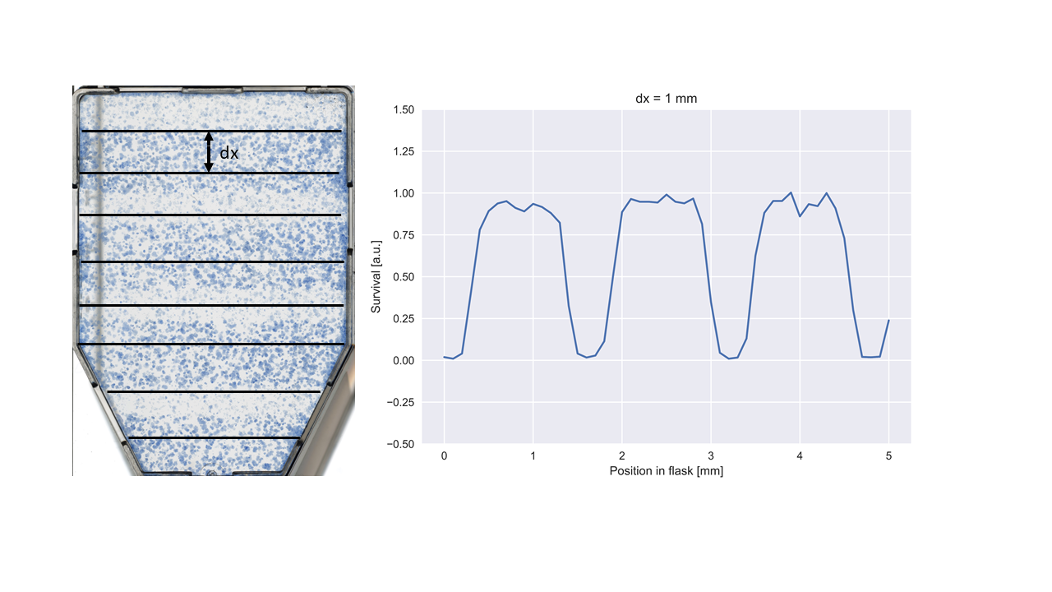

Figure 2‑17. Illustration of 1D analysis of striped GRID irradiated cell flask.

### 2D survival analysis

The 1D method of analysis was best suited for striped GRID as the survival naturally separated into high and low survival bands following the shape of the GRID. But we wanted the analysis to be independent from GRID configuration, and therefore introduced a 2D analysis method using Poisson regression (see 1.6.2).

#### Pooling

We started by dividing the registered cell flasks and dosimetry films into equally sized quadrats. Because of the geometrical displacement mentioned in 2.1.2.3, after registration, the GRID patterns would match nicely but the edges of the image would not. This limited the area where we had accurate dose measurements, thereby limiting the amount of survival data we could include.   
The number of colonies within each quadrat was summed using a *python* function called *LPPOOL2D* from the *pytorch* library (*LPPool2d — PyTorch 1.11.0 Documentation*, n.d.). The function lets a n x n kernel move in strides across the image, computing the power-average within the kernel

$$f\left(X\right)=\sqrt[p]{\sum_{x ∈X}{x^{p}}} .$$

Setting $p$ to 1, it simply finds the sum of the pixels within each kernel. We talk about kernels as being dynamic, while the quadrats are fixed in place. The process of sum pooling is visualized in Figure 2‑17.Choosing a kernel and a stride with the same size as the quadrats, will let the kernel jump from quadrat to quadrat extracting the desired quantity from the pixel values within the quadrat.Because we had generated dose maps where each pixel constituted a dose value, we had to find the mean dose of all pixels within the quadrat. The mean dose was found in a process very similar to sum pooling called average pooling using the *AvgPool2D* (*AvgPool2d — PyTorch 1.11.0 Documentation*, n.d.), which finds the average pixel value within the kernel. Choosing the right size of the quadrats is important, because you want to cover enough pixels to get a significant number of colonies within the quadrat. A 1 x 1 pixel sized quadrat would greatly inflate the number of quadrats not containing any colonies (zero inflation), making the dta deviate from the Poisson distribution (Harrison, 2014). But the quadrats must be small enough, so that the number of quadrats is large enough to have sufficient data for Poisson regression. Also, choosing quadrats too large leads to smoothing of quadrat doses because the quadrats might cover an area between a peak and a valley.  
  
We examined the striped GRID survival data within the quadrats using sizes of 0.5 x 0.5, 1 x 1, 2 x 2, 3 x 3 and 4 x 4 mm2. Evaluations of each size were made using a set of measurements: zero inflation, reduction in dose variance (smoothing), relative percentage difference (RPD) between variance and mean for peak and valley survival and a chi-squared ($χ^{2}$)-test. We assumed that optimal quadrat size was the same for both GRID configurations. This assumption becomes less true for larger quadrat sizes, caused by the scenario mentioned above where quadrats are placed between peak and valley areas. Looking at Figure 6‑5 and Figure 6‑6 we see the cells with their associated dose for 0.5- and 4-mm quadrat sizes. The striped GRID lends itself much better to a larger quadrat size compared to dotted GRID. Making the quadrats smaller will reduce the error caused by dividing the analysis area into quadrats.   
Zero inflation was found by sum pooling the control cell flasks and finding the number of quadrats with zero colonies. Reduction in dose variance was found by finding the variance of the average pooled dose maps. RPDs were found by separating the mean dose map for GRID into peak and valley doses, where peak and valley doses were defined as greater than 70% of maximum, and smaller than 115% of minimum dose, respectively. We increased the definition of peak and valley doses to ensure enough data within each category for statistical significance. Quadrats outside these dose ranges were not included. Because the Poisson regression assumes Poisson distributed data with equal variance and mean, we calculated the RPD between these quantities for peak and valley quadrats following the formula

$$RPD=\frac{\left|Var-Mean\right|}{(Var+Mean)/2} .$$

The $χ^{2}$-test is a significance test, to test whether the difference between observed and expected values are significantly different (Heiberger & Holland, 2015, p.149). We used the test to evaluate if our peak and valley survival data was Poisson distributed. The null hypothesis $H_{0}$ is that the data follows the Poisson distribution, and the alternative hypothesis $H_{a}$ is that the data does not follow the Poisson distribution. The number of colonies in all kernels was recorded and binned. These were our observed values. The expected values were found from a theoretical Poisson distribution generated using the mean number of colonies from the observed values. $χ^{2}$ is found using the sum

$$χ^{2}=\sum_{i=0}^{k}{\frac{{\left(E_{i}{ }-O_{i}\right)}^{2}}{E_{i}}} ,$$

with k being number of possible categories (1 colony, 2 colonies etc.) E being expected values and O being the observed values. From the $χ^{2}$ distribution with degrees of freedom k - 1 we found the p-value.

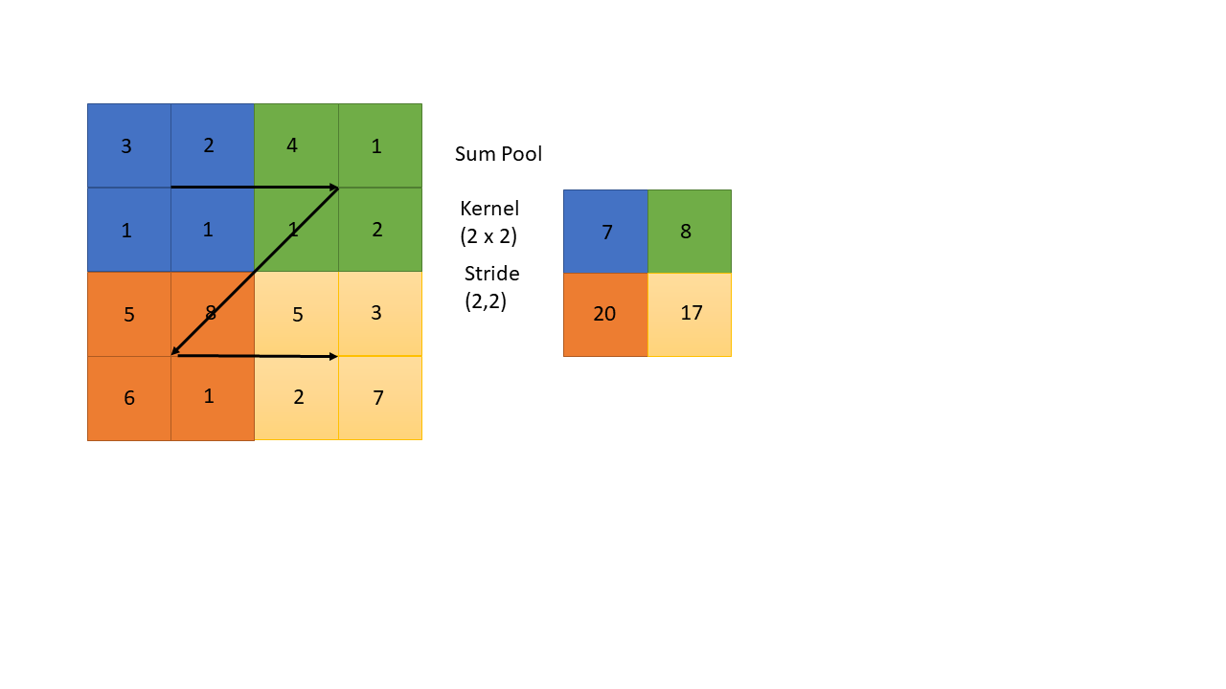

Figure 2‑18. Sum pooling, with a 2 x 2 kernel moving in 2 x 2 strides across the image, summing up the pixel values within the kernel. The arrows indicate the movement of the kernel.

#### Poisson Regression

For the Poisson regression itself, we chose the Generalized Linear Models (GLM) from the *statsmodels* module (Seabold & Perktold, 2010). GLM takes the response data $y$ and the explanatory data $X$**.** We chose to split the data into training and test (80/20 split). The training data was stacked together, to generate a model suitable for all irradiation scenarios: control, OPEN field, GRID stripes and GRID dots survival data. The test data was kept separate for model evaluation, which we will explain further in 2.4.3.5. Input data passed to GLM needs to have the same shape as for OLS in 1D survival 3.3.1. GLM also takes a family class. The family class provides the link function and the mean-variance relationship. We will of course use the Poisson family for our Poisson regression. After fitting the data, the GLM returns the estimated coefficients for our explanatory variables, and numerous statistical quantities. Comparing the 2D analysis to the 1D band analysis was not straightforward, because band analysis draws survival profiles along the length of the cell flask and compares the profile with predicted survival from a LQ model fitted to OPEN field survival data, while the 2D analysis splits the flask into quadrats where the positions of said quadrats within the cell flask are unknown. We therefore found a way to compare the peak and valley survival with predicted survival from a Poisson regression model fitted to the OPEN field survival data with dose and dose squared as explanatory variables. It was yet again necessary to define the peak and valley doses. The definition was increased to allow natural occurring variation. Peak was now defined as being doses above 70% of maximum, while valley was defined as doses being below 130% of minimum. The quadrats were separated into their respective category, before the mean SC was found with standard error. These would act as the observed data, to be compared to the predicted data.

We wanted to expand the model and include explanatory variables that could possibly explain difference in survival of GRID compared to OPEN field irradiated cells. We first incorporated the peak area ratio. The hope was that the ratios could describe degree of cell killing caused by changing GRID configurations. Secondly, we tried to incorporate the distance from a quadrat to nearest peak. This distance might explain the bystander effects occurring between the cells. When introducing new explanatory variables, we needed to test for collinearity. Multicollinearity is significant correlation between the explanatory variables making them incapable of independently predicting the dependent variable (*Collinearity | Statistics | Britannica*, 2013). Multicollinearity also has a tendency of increasing the estimated coefficients’ standard error, thereby decreasing the precision of the estimates (Alin, 2010).

#### Peak area ratio

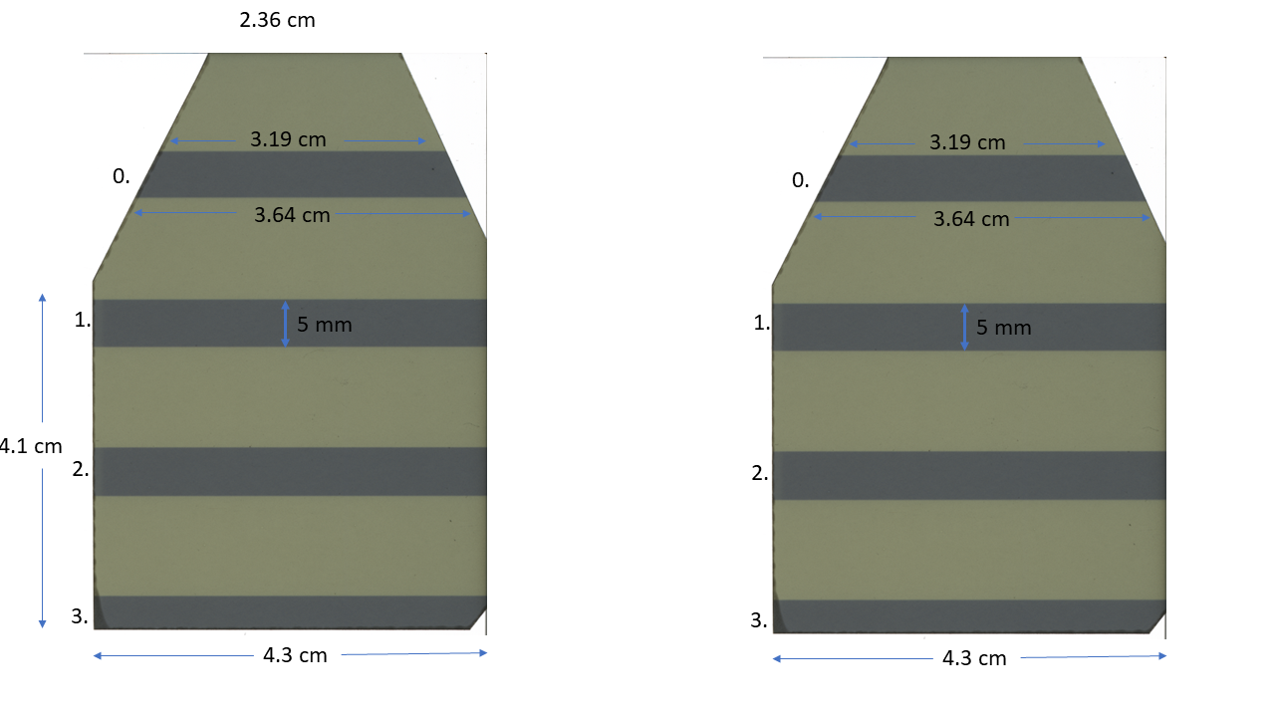For both striped and dotted GRID we measured the area positioned underneath the grid opening, called peak area. Using a caliper and one irradiated EBT3 film, we were able to measure the area of the stripes appearing in the films following the irradiation to calculate the peak area (see measurements in Figure 2‑18). However, poor cutting accuracy causes this area to be slightly different for all films and does not perfectly represent the peak area of the irradiated cells. The length measurements of the chosen film can be seen in Figure 2‑18. For peak 3 we assumed the same area as peak 1 and 2 of $4.3⋅0.5=2.15 cm^{2}$. Which results in the total area for peak 1, 2 and 3 of $3⋅2.15=6.45±0.01 cm^{2}$. Peak 0 had a trapezoidal shape, with the area of $\frac{3.19+3.64}{2}⋅0.5=1.7075±0.0004 cm^{2}$, which results in a total peak area of approximately $8.16 ±0.01 cm^{2}$. The total peak area was divided by the total area of the bottom of the cell flask (25 cm2) to obtain peak area ratio (PAR). Uncertainties were found using the error propagation in equation 2‑3, with the assumption of no uncertainty in the width of the grid slits and the uncertainty of the caliper being 0.001 cm.   
For dotted GRID the peak area ratio was found by multiplying the number of holes within the irradiated films, of which there was 7, with the area of the holes. The holes have a diameter of 5 mm, resulting in a peak area of $7⋅π{\left(\frac{0.5}{2}\right)}^{2}=1.37 cm^{2}$ No uncertainties were estimated because no caliper measurements were needed. For OPEN field all area would be within a “peak”, and PAR was therefore 1. The control films were not irradiated; hence they are neither peak nor valley and the PAR was set to 0.   
In Table 2‑3 we see the PARs for all irradiation configurations.

Figure 2‑19. Caliper measurements on irradiated EBT3 film. Every peak is marked with a number.

Table 2‑3. PAR and valley area ratios for dotted and striped GRID. The area measurements for striped GRID were found using an irradiated EBT3 film.

|  |  |  |  |  |
| --- | --- | --- | --- | --- |
|  | Dots | Stripes | Open | Control |
| Peak area ratio | $$0.05498$$ | $$0.32640±0.0005$$ | $$1$$ | $$0$$ |

#### Nearest Peak estimation

An algorithm was made to loop over each quadrat and find the distance to the nearest peak. The code can be found in Appendix A. Note that $\text{kernel_size}$ is the length of the sides of the quadrats converted to pixels.

Identification of peaks was done by generating contour lines at 85% of maximum dose. To exclude sporadically occurring high intensity pixels, which did not constitute peak doses, we only included lines surpassing 500 pixels. The two loops are looping over rows and columns in the pooled image, jumping from quadrat center to quadrat center. For all centers, the algorithm finds the smallest Euclidean distance between the center and each peak contour lines. It then saves the smallest distance, i.e., it finds the distance to all the peaks and stores the smallest one in a matrix. If the quadrat is positioned within a peak, then the distance should be set to 0. An if-test handles this scenario.   
When looping over the quadrat centers in the pooled image, index *i* is not 0,1,2 etc., but will follow $\sum_{k=0}{\frac{\text{kernel_size}}{2}+\text{kernel_size}⋅k},$ where k represents the iteration we are currently on. In the case of a 3 x 3 mm2 quadrat, converted to 141 x 141 pixels using the 47 pixels per mm conversion from equation 2‑9, *i* becomes 70,211,352 etc. One cannot index the distance matrix using these values.  
It was therefore necessary to find a general expression to downscale the indexes, so they become 0,1,2 etc. For the case of odd quadrat pixel size, we used the formula

$$i-\frac{\text{kernel_size}}{2}⋅\text{odd_i} ,$$

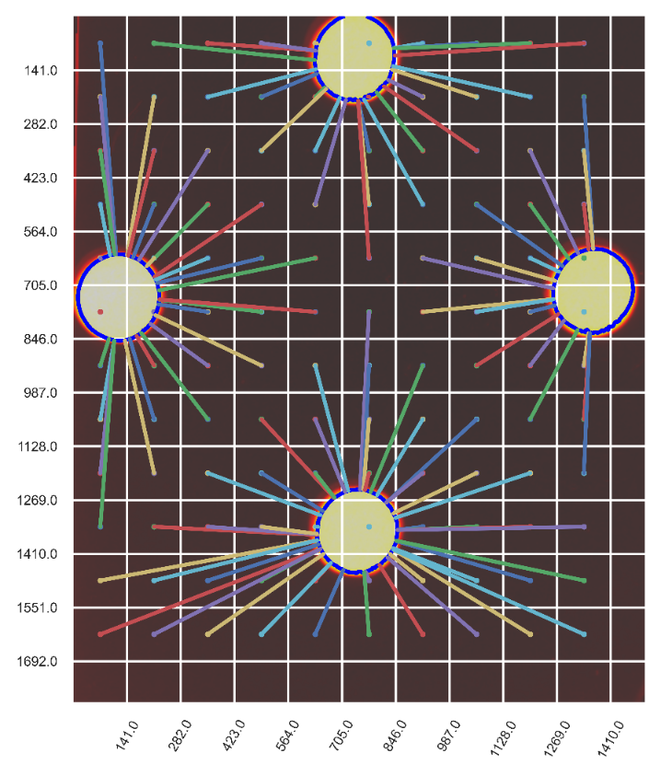where odd_i is 1,3,5 etc. The formula is equivalent for i and j. The resulting distance measurement are illustrated in Figure 2‑19.

Figure 2‑20. Illustration of nearest peak distance for all quadrats of size 3 x 3 mm2 with dotted GRID configuration. The distances of quadrats with center located inside a peak, are not found.

#### Model Evaluation

A $χ^{2}$ test was performed to be the first indicator of goodness of fit. *Statsmodels* provide the $χ^{2}$ value, and we could use the cumulative distribution function from the *scipy.stats* library to calculate the p-value. Introducing more explanatory variables might lead to a better result but making a more complex model might lead to overfitting. The opposite problem occurs if not enough complexity is introduced.   
Overfitting and underfitting is illustrated using polynomial fitting in Figure 2‑20.   
Akaike information criteria (AIC) is a model selection metric that represents the tradeoff between overfitting and underfitting, and is found using the expression (Burnham & Anderson, 1998, p.47)

$$AIC=2k-2\ln{\hat{L}} ,$$

where $\hat{L}$ is the likelihood (see maximum likelihood function 1.6.2) when the algorithm reaches convergence (or maximum iterations have been reached). $-2\ln{\hat{L}}$ tends to shrink when introducing more explanatory variables. *k* is the number of estimated parameters making AIC increase when adding more explanatory variables to your model. A small AIC is desired, but evaluating a model using AIC alone is not fruitful, as AIC increase with sample size (Burnham & Anderson, 1998, p.55). However, if two models are curated from the same dataset, we can use AIC to find the model that strikes the best balance between complexity and generality.   
AIC values were extracted from the GLM model.   
The model was also evaluated based on how well it predicted survival $\hat{y}$ of the test data. For all irradiation configurations, including control, we found the MSE. This way we could test if the model predicted certain categories better than others, and which explanatory variables were responsible for potential improvements or declines in MSE. Separation of training and test data is a highly used method of mediating overfitting in machine learning. The fitting parameters are found for the training data, before testing the model on the test data. This ensures that the model works even when being exposed to unknown data.

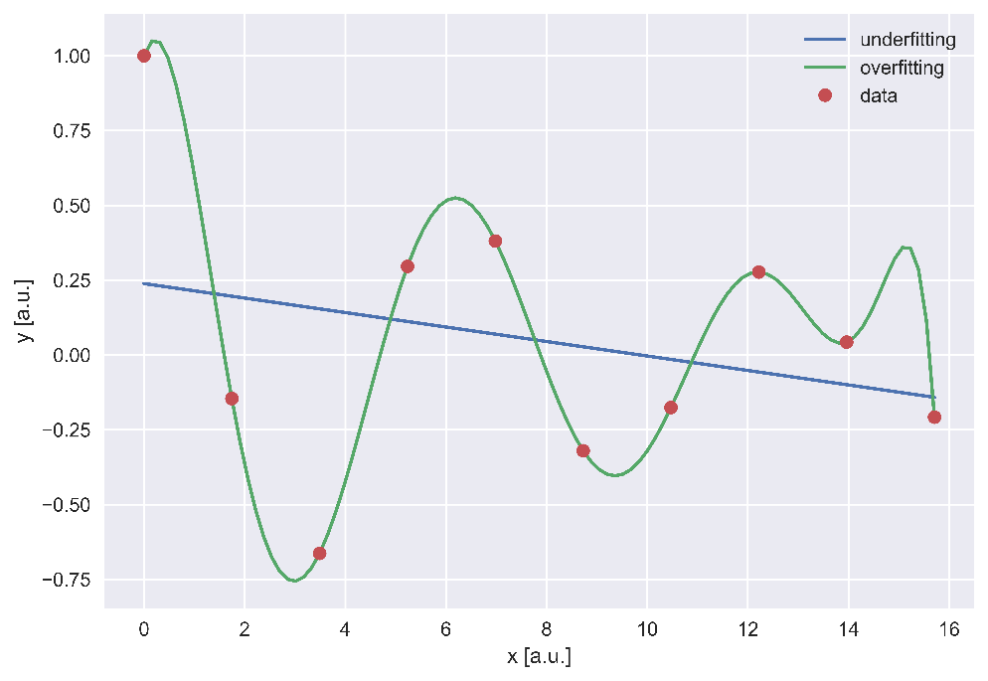

Figure 2‑21. Overfitting vs underfitting of data. The Straight blue line fits the data using a one-degree polynomial, while the green line fits the data using a tenth-degree polynomial.

# Results

## X-ray dosimetry

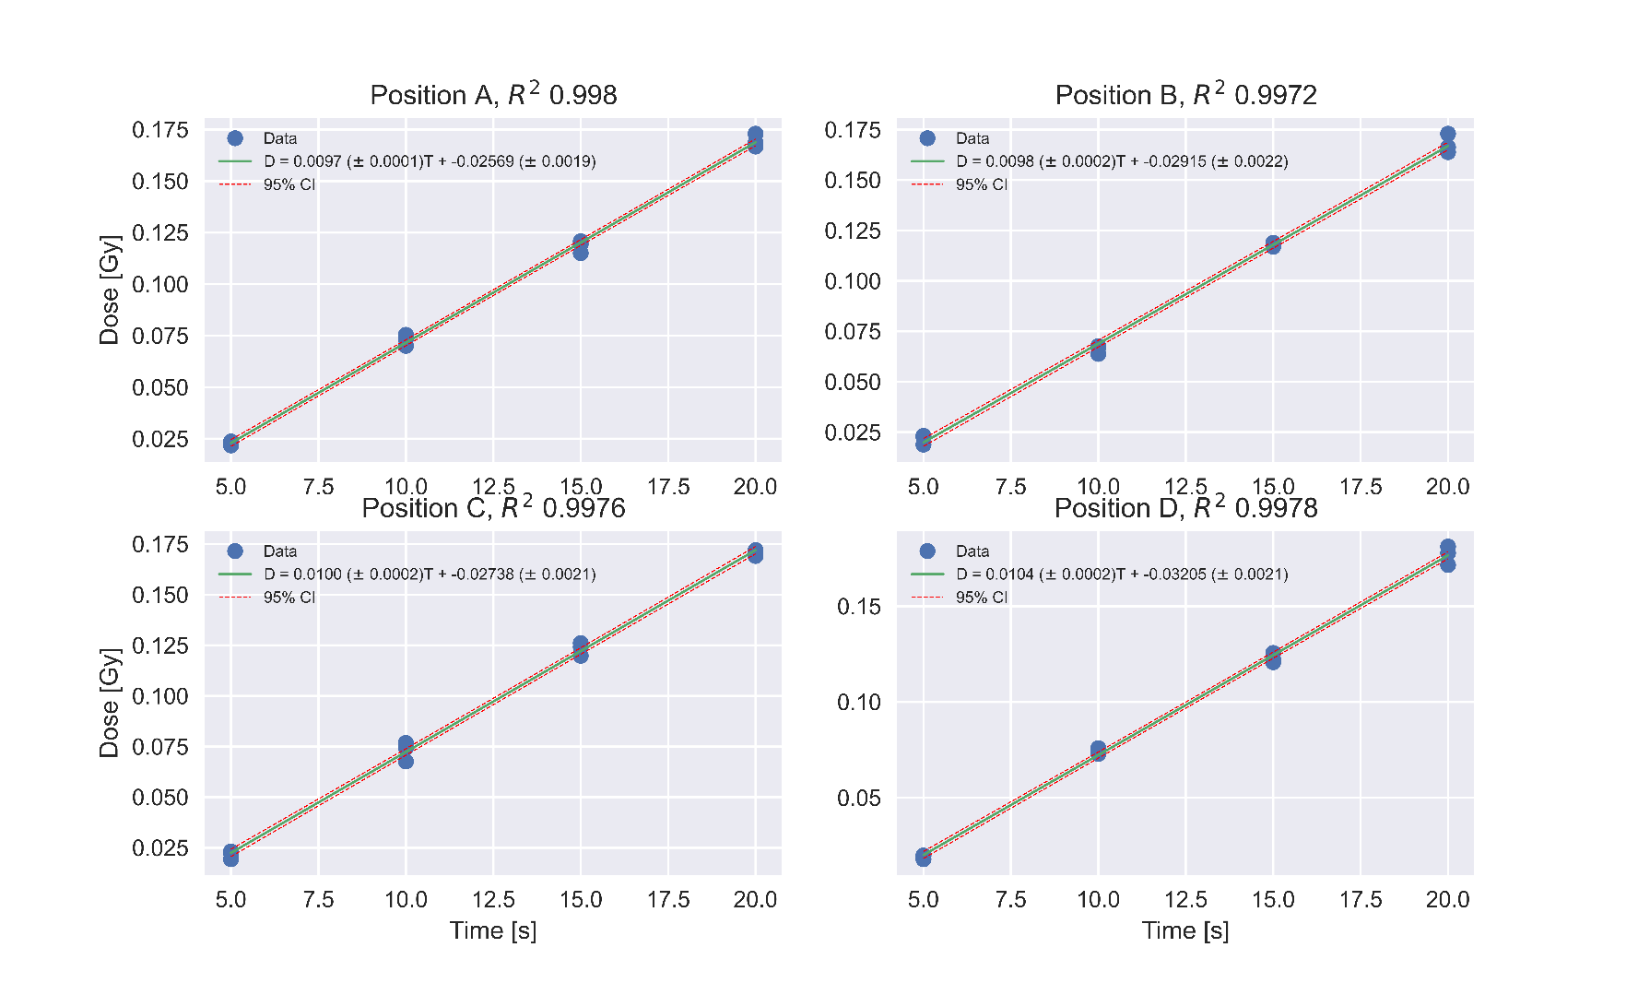X-ray dosimetry was necessary to have a known radiation field to calibrate the EBT3 films. As mentioned, two calibrations were performed one for striped GRID and one for dotted GRID. The methodology was the same, expect that three repeated measurements were taken in the first calibration versus four in the second. We therefore decided to only include the most important results from the second calibration. Table 6‑1 shows the charge output (nC) from all four positions for both calibrations. The low dose regression plots for 5, 10, 15 and 20 second exposure times can be seen in Figure 3‑1 with the associated $R^{2}$.

Figure 3‑1. Regression lines generated from the ionization chamber output irradiated in all positions of the cell flasks holder, with $R^{2}$.

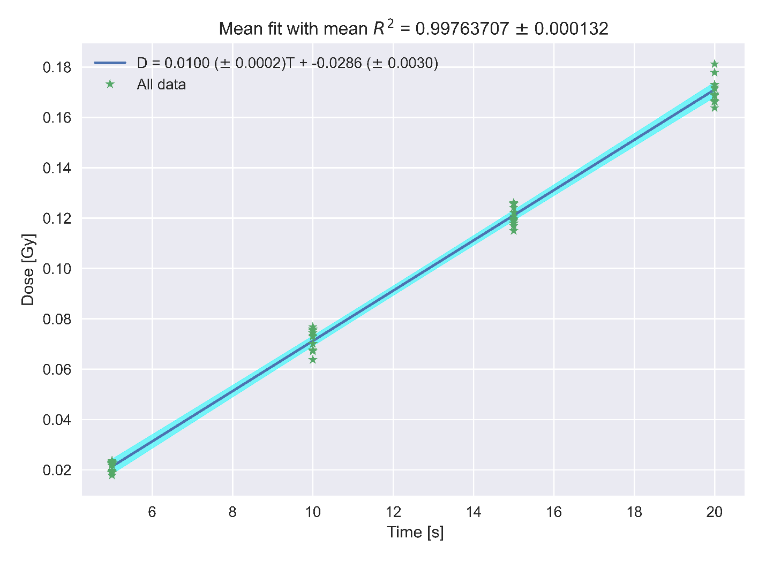

Figure 3‑2. Mean fit generated from four regression lines (see previous plot) for all positions (A,B,C,D) of the cell flask holder.

The mean fit in equation 3‑1 represented the linear relationship between exposure time T [s] and dose [Gy] for low doses, with a measured $R^{2}$ of $0.9976±0.0001$

|  |  |
| --- | --- |
| $$\hat{D}=0.0010±0.0002 \left[Gy/s\right]⋅T \left[s\right]-0.029±0.003 \left[Gy\right].$$ | 3‑1 |

The negative intercept of -0.029 showed a slight delay after starting the X-ray unit before dose was received in the ionization chamber. Converting the dose rate from [Gy/s] to [Gy/min] we got

$$\dot{D}=0.60±0.01 Gy/min$$

For doses higher than 0.5 it was assumed that a steady production of X-ray was reached, and the negative intercept’s impact on dose was neglected. From 60 second measurements found the same way as for low dose a dose rate of $\dot{D}= 0.59±0.02 Gy/min$.

On the second calibration we obtained a mean fit of

$$\hat{D}=0.0102±0.0002 \left[Gy/s\right]⋅T \left[s\right]-0.031±0.002 \left[Gy\right] .$$

The 60 second measurements resulted in a dose rate of $\dot{D}= 0.60±0.02 Gy/min$.

Exposure times necessary to achieve 0.1, 0.2, 0.5 Gy was found using the mean fit equations, while doses above 0.5 Gy was found using the dose rate. All doses were multiplied with the correction factor 1.026, correcting for the height difference between the ionization chamber’s sensitive volume and the EBT3 films positioned on the bottom of the cell flasks. The exposure times for both calibrations can be found in Table 6‑2.

## Gafchromic film dosimetry

Calibration of EBT3 films were necessary to know what dose GRID irradiated cells received. The calibration films were given 0.1, 0.2, 0.5, 1, 2, 5 and 10 Gy using the exposure times from Table 6‑2. We wanted to evaluate if the light from the scanner affected the response of the films. Therefore, four scans were made and the RPD between the pixel values of all four scans was found. The mean RPD for all films is shown in Figure 3‑3. The maximum difference was $≈0.1\%$, with the majority being in the 0.01 – 0.03 % range.

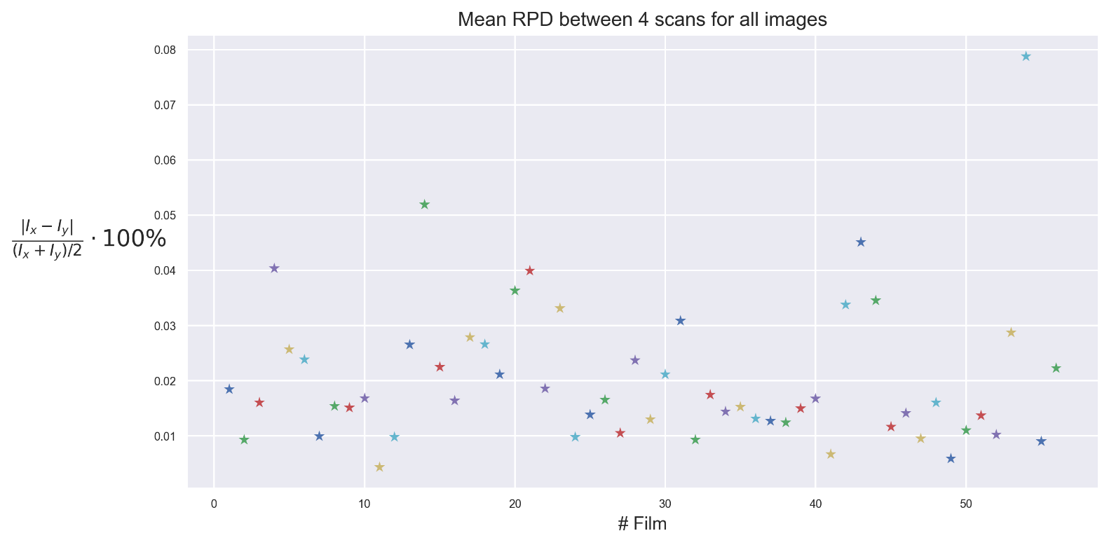

Figure 3‑3. Mean RPD (relative percentage difference) between the pixel values of 4 scans of the same EBT3 film, to evaluate if the scanner affected the response of the films.

The pixel values of all the calibration films were converted to netOD using the equation 2‑4. Measurement films cut to fit the cell flasks were used as a proxy for the cells to give a 2D dose distribution. Even though all color channels were calibrated, and their dose response was established, only one color channel was chosen to measure the dose received by the measurement films. Sensitivity to irradiation was one of the criteria, and Figure 3‑4 showed that GREEN and RED channel exhibited the highest sensitivity, however it was hard to detect the difference. Figure 3‑5 was made to for easier comparison between the channels. Both GREEN and RED channel exhibit superior separation of the netOD values for different doses, but RED color channel had a slightly higher sensitivity.

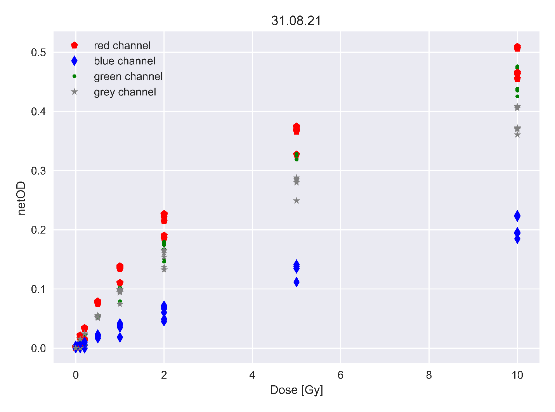

Figure 3‑4. NetOD of all EBT3 calibration films for all color channels calculated using equation 2‑4. One color channel was to be chosen for fitting of the dose model D(netOD). Two different responses were found within one batch of films, which can clearly be seen for doses above 0.5 Gy.

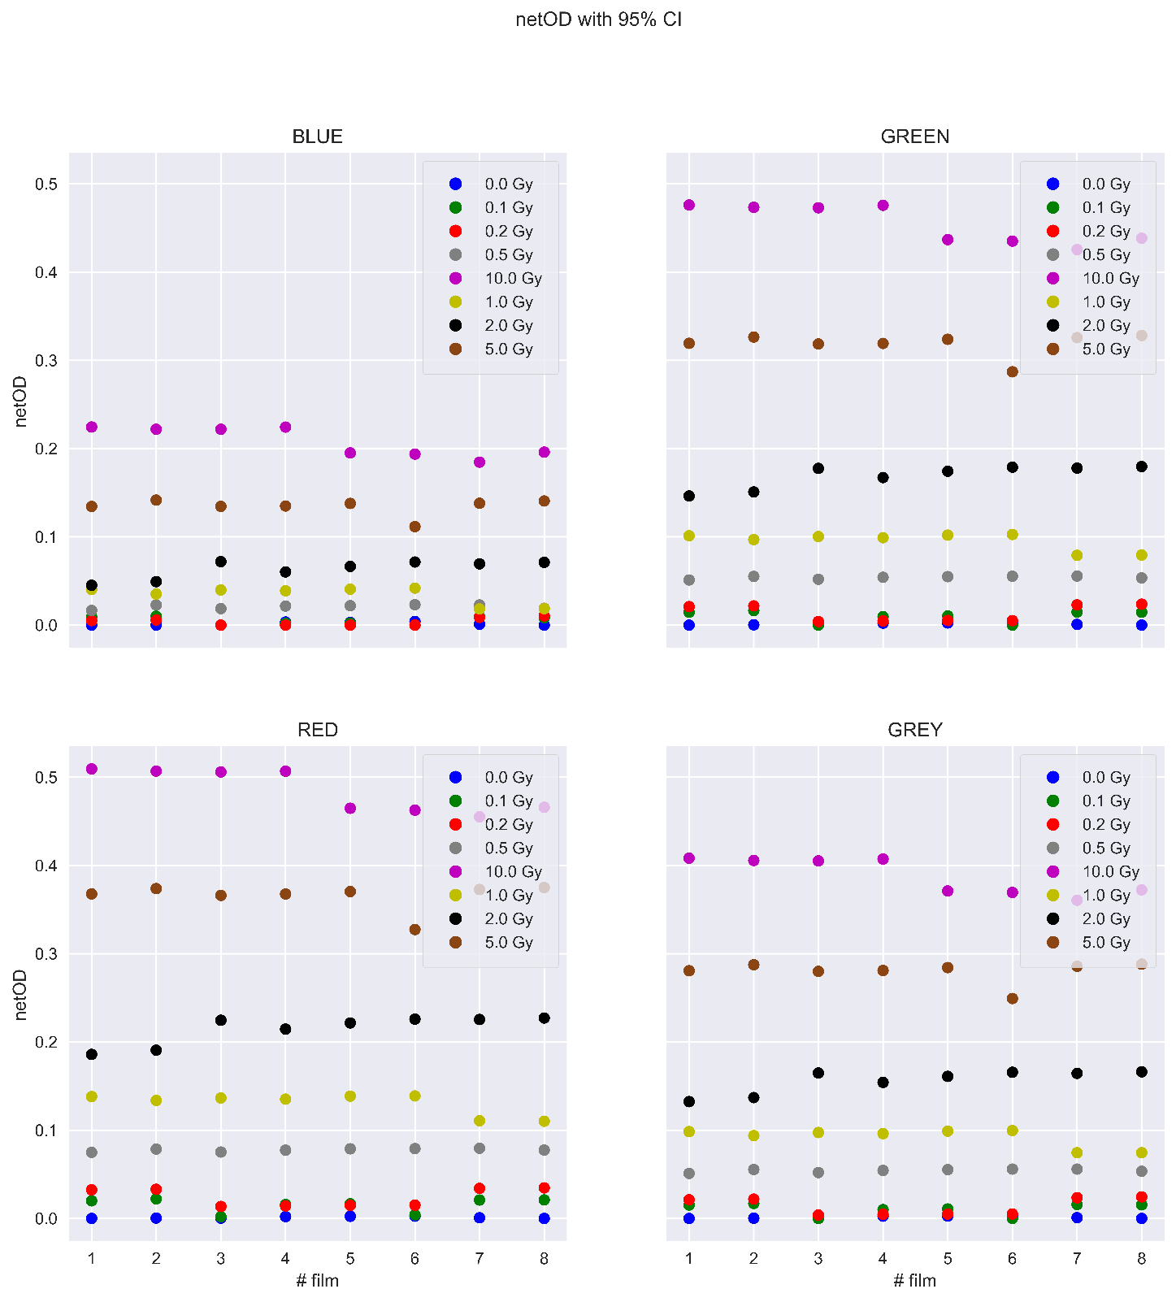The last criterium for choosing color channel was the goodness of fit quantity MSE found after fitting equation 2‑6 with non-linear regression algorithm. MSE was also used to find the optimal ROI size. The results can be seen in Table 3‑1. Because of a split in film response, the films were separated into low and high responding films before being fitted, and the MSE of high and low response films was summed. Then the optimal combination of ROI and color was RED color channel accompanied by an ROI of 3 x 3 mm2.

Figure 3‑5. NetOD found using equation 2‑4 of all films for all doses and all color channels. There were eight films per dose.

Table 3‑1. MSE found after non-linear fitting of equation 2‑6 for different color channels and ROI’s. The values are separated into high and low, because of the film-to-film variation. The combination of color channel and ROI size giving the lowest total MSE is marked in orange.

|  |  |  |  |
| --- | --- | --- | --- |
| MSE (Low, High, Sum) | ROI (mm2) |  |  |
| Color Channel | 2 x 2 | 3 x 3 | 4 x 4 |
| BLUE | 0.03189,0.01090,  0.04279 | 0.03407,0.01001,  0.04407 | 0.03319,0.00994,  0.04313 |
| GREEN | 0.01334,0.00294,  0.01628 | 0.01329,0.00273,  0.01602 | 0.01367,0.00266,  0.01632 |
| RED | 0.01013,0.00254,  0.01267 | 0.00974,0.00243,  0.01216 | 0.01004,0.00236,  0.01239 |
| GREY | 0.01593,0.00347,  0.01940 | 0.01565,0.00330,  0.01895 | 0.01617,0.00313,  0.01930 |

Figure 3‑6 shows the RED channel netOD data for high and low response with the associated regression line. The fit was based on 42 high response films and 22 low response films and resulted in the following dose models

|  |  |
| --- | --- |
| $${\hat{D}}_{high}=6.2±0.2⋅netOD+51±1⋅netOD^{2.96±0.05} \\ {\hat{D}}_{low}=7.3±0.9⋅netOD+51±6⋅netOD^{2.6±0.2}$$ | 3‑2 |

The high uncertainty of ${\hat{D}}_{low}$ stemmed from there being only 22 low response films. An evaluation of the robustness of the model was done by giving the non-linear regression algorithm a set of random starting points as initial guesses for the fitting parameters $a$, b and n. The numbers were drawn from a normal distribution with $μ=0$ and $σ^{2}=1$. *n* had to be a positive value. Table 6‑4 shows the resulting parameters after fitting. Only once did the algorithm return a nonsensical result.

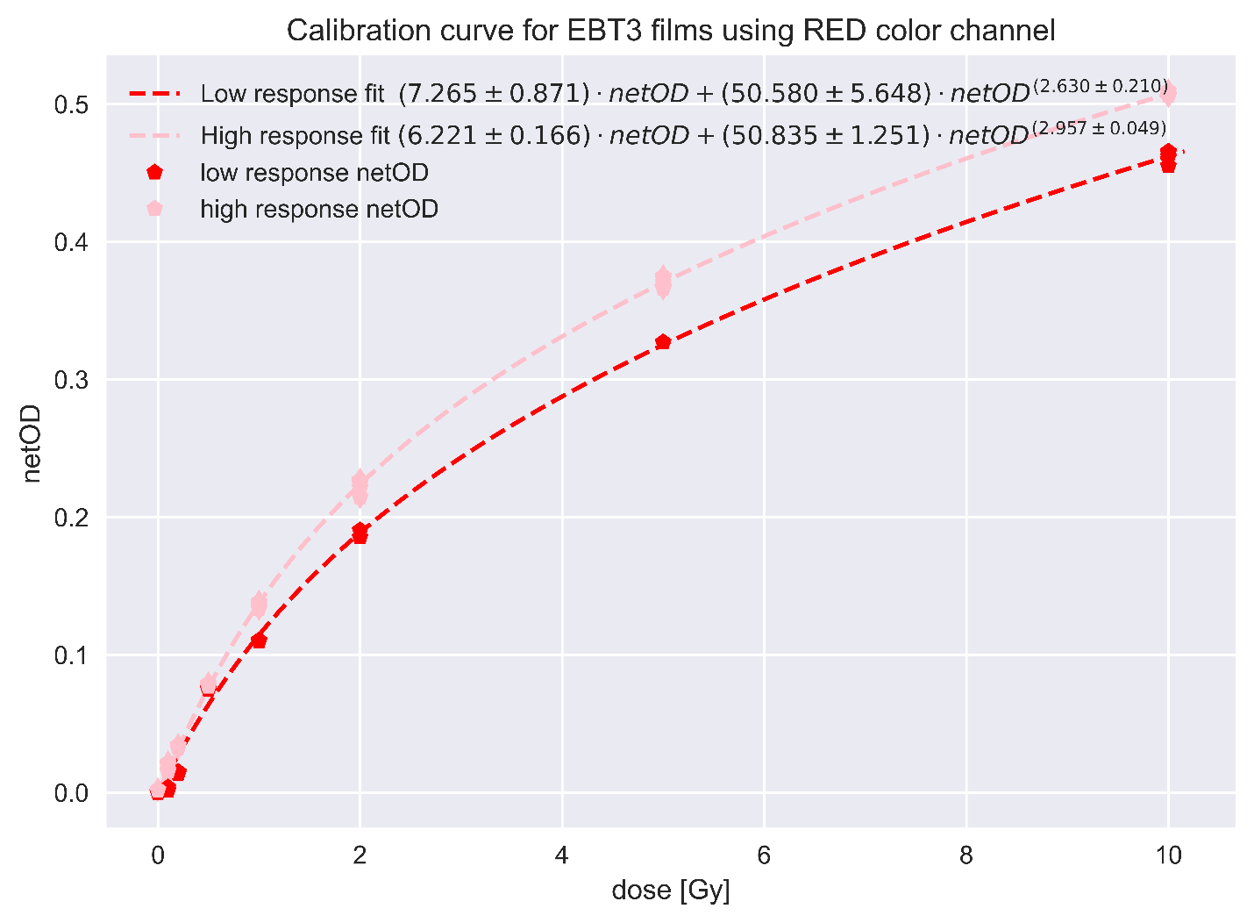

Figure 3‑6. netOD data from the first calibration for RED color channel. Two non-linear regression line was generated from equation 2‑6, for high and low response EBT3 films, respectively.

The second calibration, with a lack of high and low response films for all doses, was not trivial. First the films were calibrated ignoring high and low split using the same ROI and color channel as the first calibration. The resulting fit can be seen in Figure 3‑7 with a dose model of

|  |  |
| --- | --- |
| $$\hat{D}=4.2±0.6⋅netOD+52±2⋅netOD^{2.34±0.09}.$$ | 3‑3 |

With an established model for dose as a function of netOD for both calibrations we measured the received dose in each pixel of the measurement films, generating dose maps. For OPEN field irradiated measurement films, there were 8 high and 8 low response films. For striped GRID irradiated films, the number was 11 high and 5 low response films, respectively. As mentioned, there was no clear separation for the dotted GRID calibration films, and all measurement films were converted to dose using equation 6‑3. One dose profile was generated for each dose map and can be seen in Figure 3‑9 and Figure 3‑8, for striped and dotted GRID respectively.

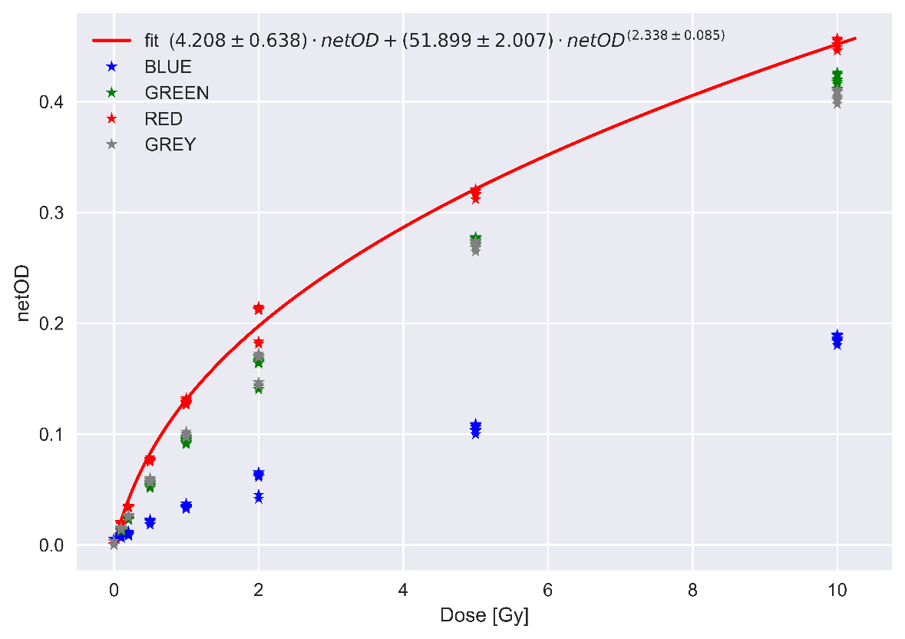

Figure 3‑7. Data from the second calibration. netOD data with regression line for the RED color channel fitted using non-linear regression of equation 2‑6. A split response can be seen for some doses, but not all.

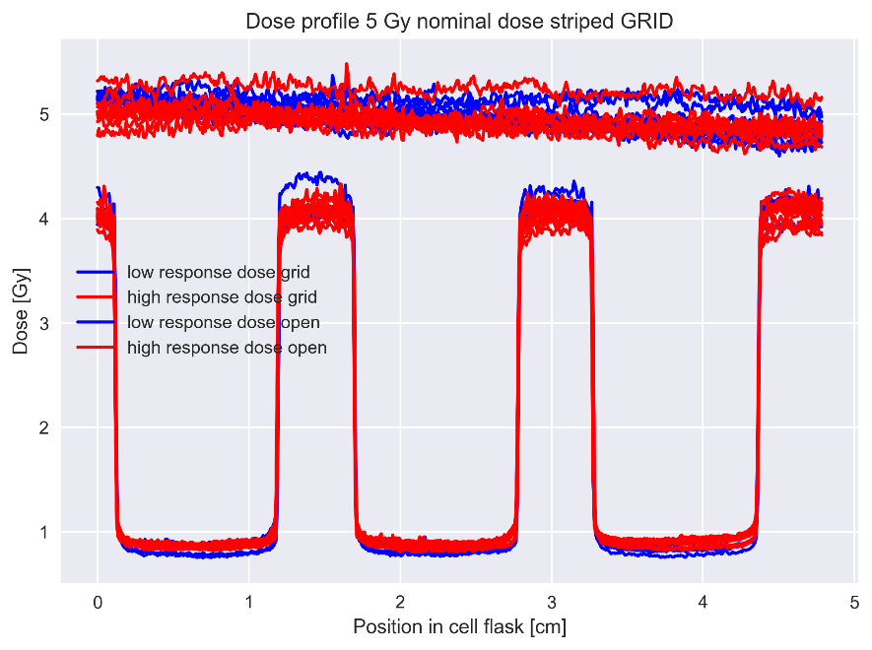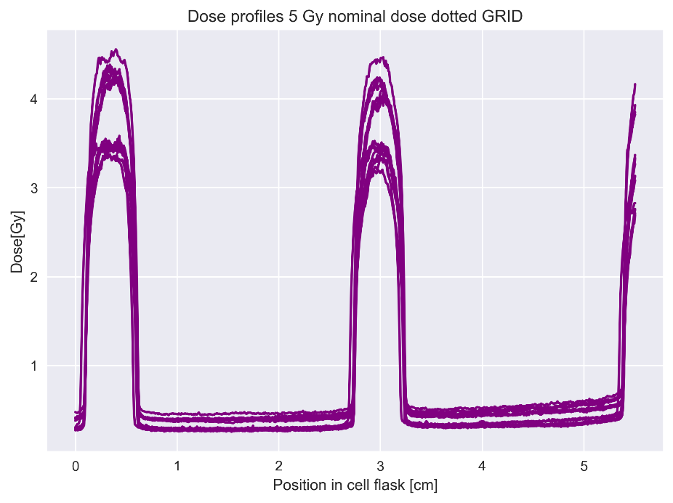

Figure 3‑8. Dose profiles generated by finding the mean dose on each row in a mean dose map for OPEN field and striped GRID irradiated EBT3 films. Blue profiles were low response films, while red profiles were high response films.

Figure 3‑9. Dose profiles generated by finding the mean dose on each row in a mean dose map for dotted GRID. The profiles were found with no regard for possible split film response.

Ignoring the split response resulted in split dose profiles. The second approach was therefore again to separate the measurement films into high and low response, before converting the pixels into dose using fitting parameters from equation 3‑2. A new set of dose profiles were generated, which can be seen in Figure 3‑10. This time there was a better match between the profiles.

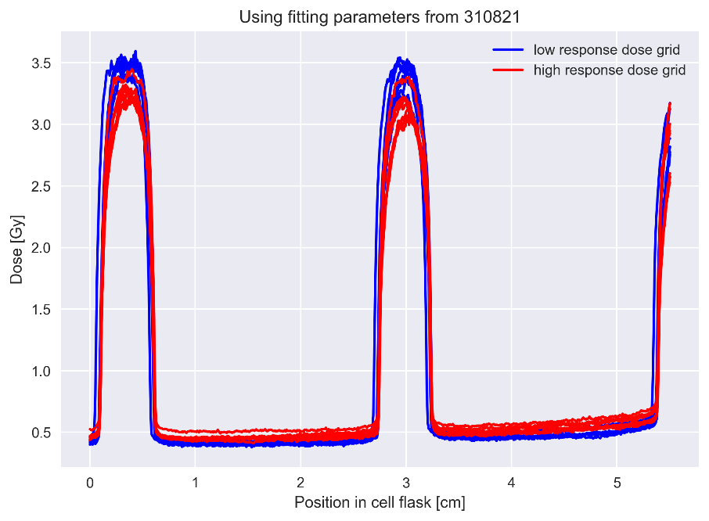

Figure 3‑10. Dose profiles generated by finding the mean dose on each row in a mean dose map for dotted GRID irradiated EBT3 films. Blue profiles were low response films, while red profiles were high response films.

With an established model for dose as a function of netOD for both calibrations we measured the received dose in each pixel of the measurement films, generating dose maps. For OPEN field irradiated measurement films, there were 8 high and 8 low response films. For striped GRID irradiated films, the number was 11 high and 5 low response films, respectively. As mentioned, there was no clear separation for the dotted GRID calibration films, and all measurement films were converted to dose using equation 6‑3. One dose profile was generated for each dose map and can be seen in Figure 3‑9 and Figure 3‑8, for striped and dotted GRID respectively. Ignoring the split response resulted in split dose profiles. The second approach was therefore again to separate the measurement films into high and low response, before converting the pixels into dose using fitting parameters from equation 3‑2. A new set of dose profiles were generated, which can be seen in Figure 3‑10. This time there was a better match between the profiles. One mean dose map was generated for OPEN field by combining all high and low response dose maps. This meant that one pixel in the mean dose map represented the mean dose map represented the mean of 16 pixels. Similar mean dose maps were generated for both GRID configurations. The dose maps can be seen in Figure 3‑11.

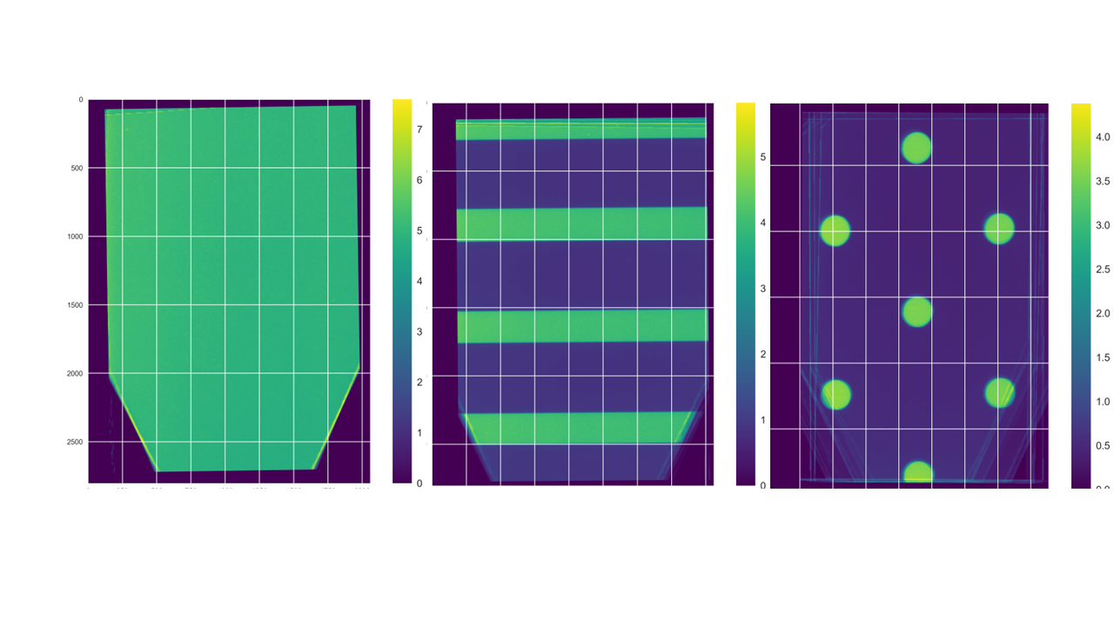

Figure 3‑11. Mean dose maps for all irradiation configurations. The dose maps were generated by combining the high and low response measurement film that were registered to each other and converted to dose. The color bar represents the dose. The dose spikes near the edges of the films where the films were cut.

From these mean dose maps, one dose profile was generated for each irradiation configuration. These profiles can be seen in Figure 3‑12 and Figure 3‑13. The OPEN field profile was around 5 Gy, which was the expected dose. The peak dose in striped GRID was slightly higher than the peak dose of dotted GRID, which was also the case for the valley doses. All GRID doses were lower than OPEN field doses.

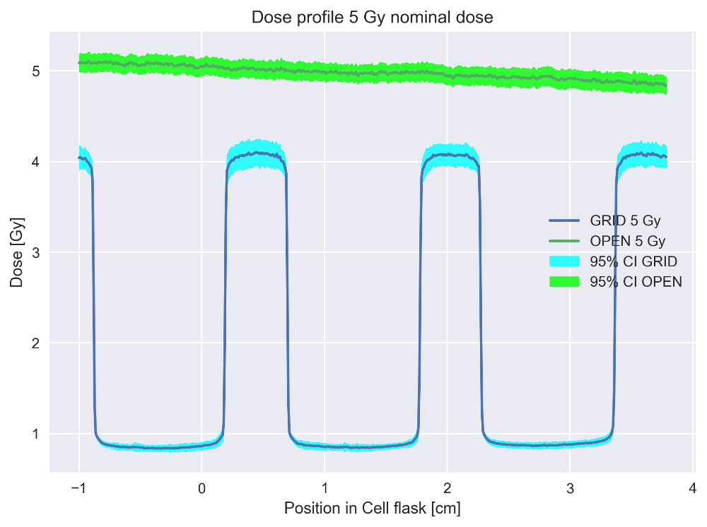

Figure 3‑12. One mean dose profile found from the mean dose map generated from all 16 high or low response dose maps for OPEN field (green) and striped GRID (blue).

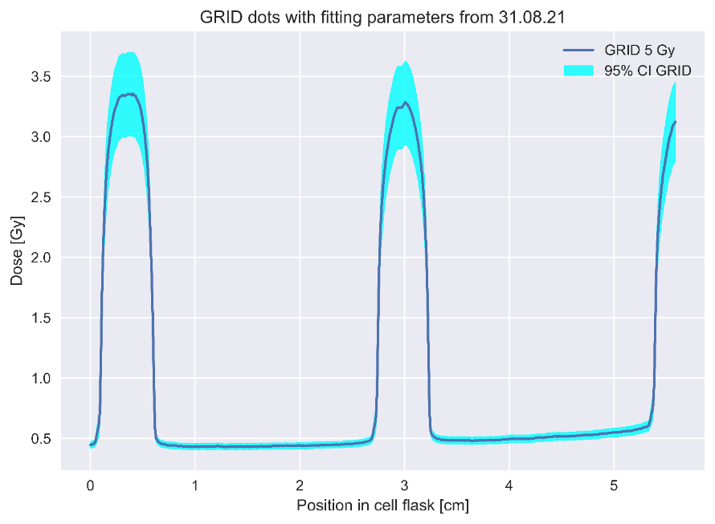

Figure 3‑13. One mean dose profile found from the mean dose map generated from all 16 high or low response dose maps for dotted GRID irradiated EBT3 measurement films.

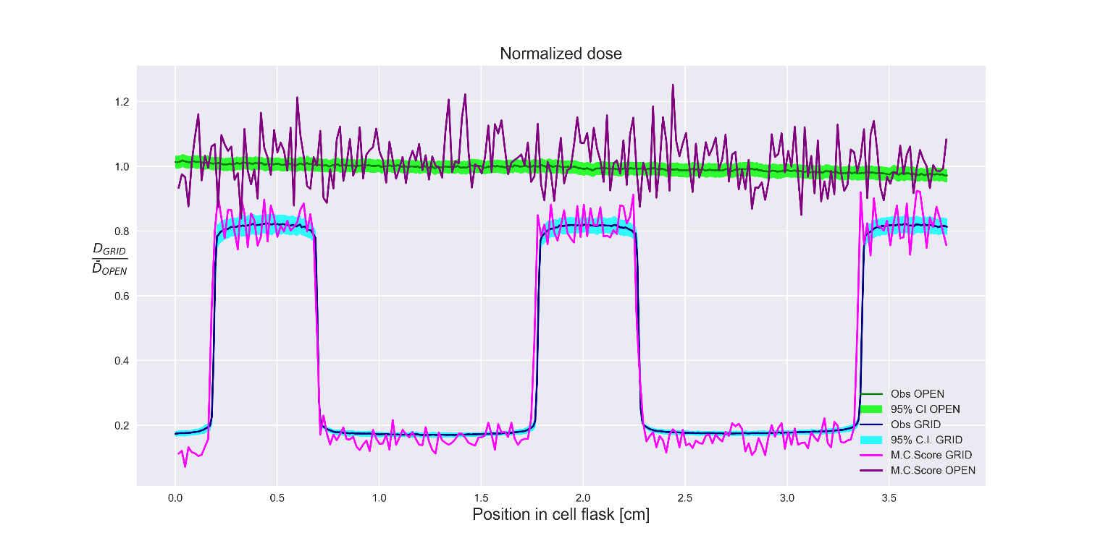Further evaluation of the dose profiles was done, by a comparison with MC simulated data. The MC data was normalized to an OPEN field. The comparison of MC and striped GRID can be seen in Figure 3‑14. For OPEN field the MC data was relatively noisy with larger oscillations around the OPEN field dose profile. Smaller oscillations were found for the striped GRID MC data.

Figure 3‑14. Mean dose profiles for GRID and OPEN field (from Figure 3‑12) normalized to OPEN field dose. Monte Carlo simulated data was plotted over each profile for dosimetry validation.

One value of estimated dose was found for OPEN field, striped and dotted GRID in peak and valley areas. The values were found by averaging the relevant parts of the mean dose profile per irradiation configuration. As mentioned, peak was defined as doses above 95% of maximum dose, while valley was defined as doses below 115% of minimum dose. The results can be seen in Table 3‑2.

Table 3‑2. Mean dose values for OPEN field, striped and dotted GRID with 95% confidence intervals. Peak dose was defined as values above 95% of maximum dose. Valley was defined as values under 115% of minimum dose. The values were found as a mean of 16 dose profiles, both high and low response.

|  |  |  |  |  |
| --- | --- | --- | --- | --- |
| Open Field (95%,C.I) | Striped GRID (95%,C.I) |  | Dotted GRID (95%,C.I) |  |
|  | Peak | Valley | Peak | Valley |
| $$4.98(4.93,5.03)$$ | $$4.044(3.98,4.16)$$ | $$0.8579(0.80, 0.87)$$ | $$3.367(3.28, 3.45)$$ | $$0.4386 (0.41, 0.45)$$ |

## Cell survival

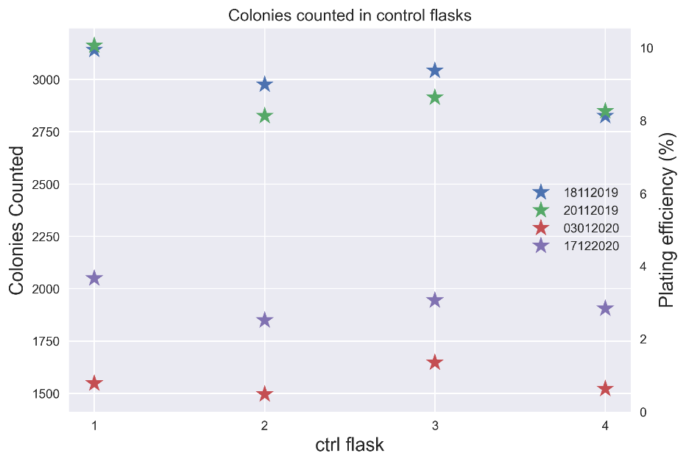What data to use for survival analysis was chosen based on the similarity between the control flasks across the performed cell experiments. Figure 3‑15 shows number of colonies counted as well as PE. The experiments performed on the 18.11 and 20.11 yielded the highest PE in the range of 8-10% and Table 3‑3 shows that the control flasks from these two experiments were not significantly different (p-value 0.581).

Figure 3‑15. Number of colonies counted from scanned control flasks, delineated by a segmentation algorithm. Plating efficiency was found by dividing number of colonies with number of seeded cells 30 000.

Table 3‑3. Based on the number of colonies found in segmented control flasks, an ANOVA test was performed between the groups of data that appeared to be closest. The P-values from this test is seen in the third row.

|  |  |  |  |  |
| --- | --- | --- | --- | --- |
|  | 18.11.2019 | 20.11.2019 | 03.01.2019 | 17.12.2020 |
| Ctrl flask counted colonies | 3142 | 2976 | 3042 | 2825 |
| Anova p-value | 0.581 | | 0.0004 | |

Following data acquisition, image registration was necessary to align the cell flasks to the dosimetry map. Preprocessing steps were made to increase the similarity between these images before the RIGID BODY registration was performed. Following registration, the transformation matrix was applied to the mean dose map. Figure 3‑16 shows all steps taken under registration. The top images show alteration of the films for increased similarities between reference cell flask and dosimetry film. The bottom images show the match between the mean dose map and the reference cell flask before and after registration.

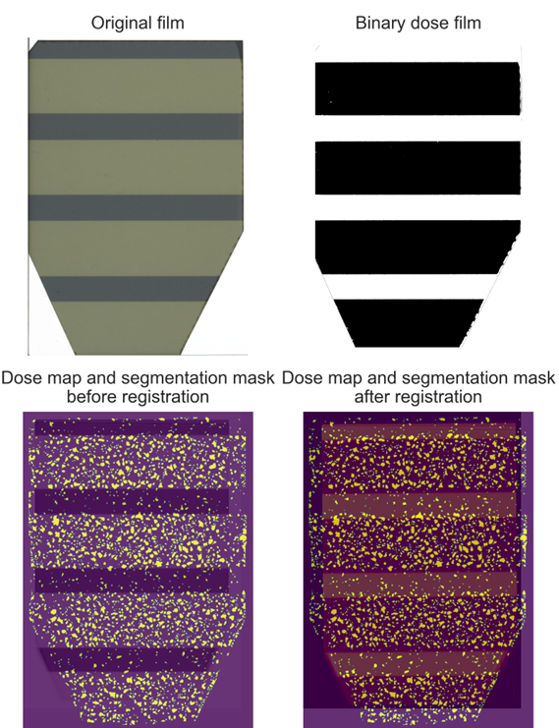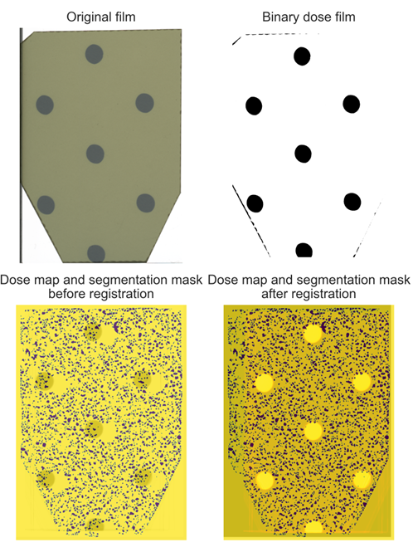

Figure 3‑16. Preprocessing steps taken to match cell flasks and dosimetry films. 1. Edges were removed. 2. Intensity values were changed to enhance similarities. 3. Rigid Body registration. 4. Small adjustments to transformation matrix for optimal alignment. All objects in this figure were irradiated with 5 Gy nominally.

### 1D survival analysis

#### LQ modelling

Fitting the OPEN field survival data resulted in the estimated $α$ and $β$ parameters represented in Table 3‑4, yielding a LQ model of $\log{SF}= -0.06D-0.01D^{2}$, which we would use to estimate predicted survival when comparing OPEN field and GRID for equal dose. The $α/β$-ratio was $6±5 Gy$. Figure 3‑17 shows the log transformed SF data observed from the OPEN field irradiated cell flasks with a regression line. The reason for the large confidence interval for 10 Gy, was that the 10 Gy data was not included in the analysis and the regression line had to be extrapolated.

Table 3‑4. Estimated fitting parameters from statsmodels OLS model, after fitting the log transformed LQ model to survival data normalized to control and log transformed.

|  |  |  |  |
| --- | --- | --- | --- |
|  | Estimate | Standard error | p-value |
| $$α$$ | $$0.06$$ | $$0.04$$ | 0.061 |
| $$β$$ | $$0.01$$ | $$0.01$$ | 0.143 |

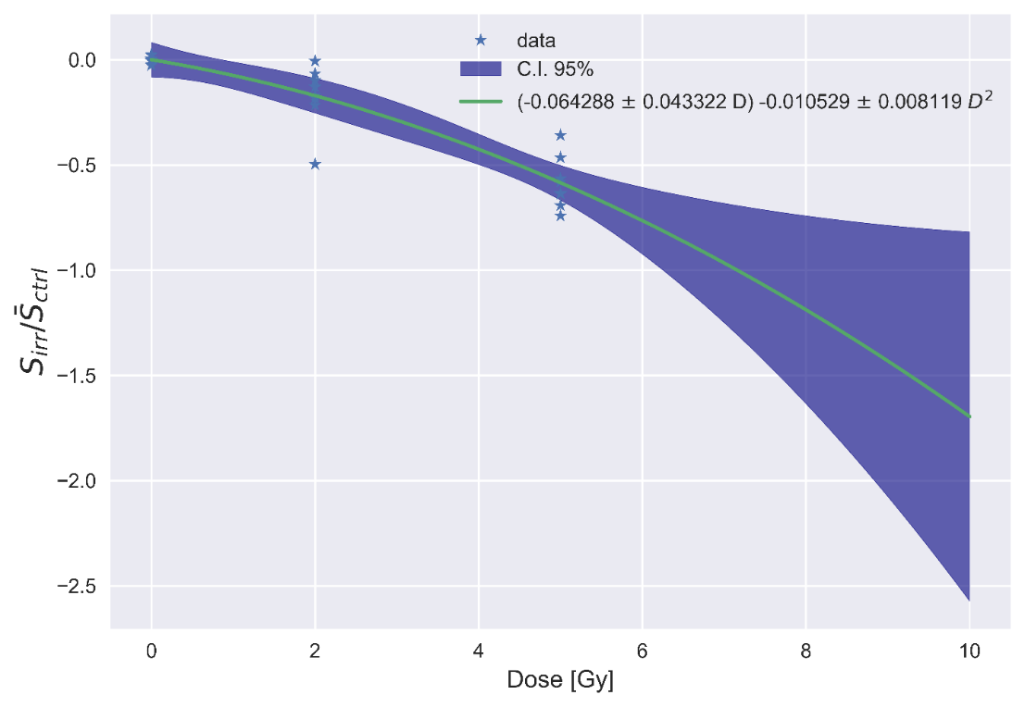

Figure 3‑17. Fitting OPEN field survival data from segmented cell flasks to generate $α$ and $β$ values for the LQ-model. The large confidence band seen for doses above 5 Gy stem from the lack of 10 Gy survival data.

#### Band analysis

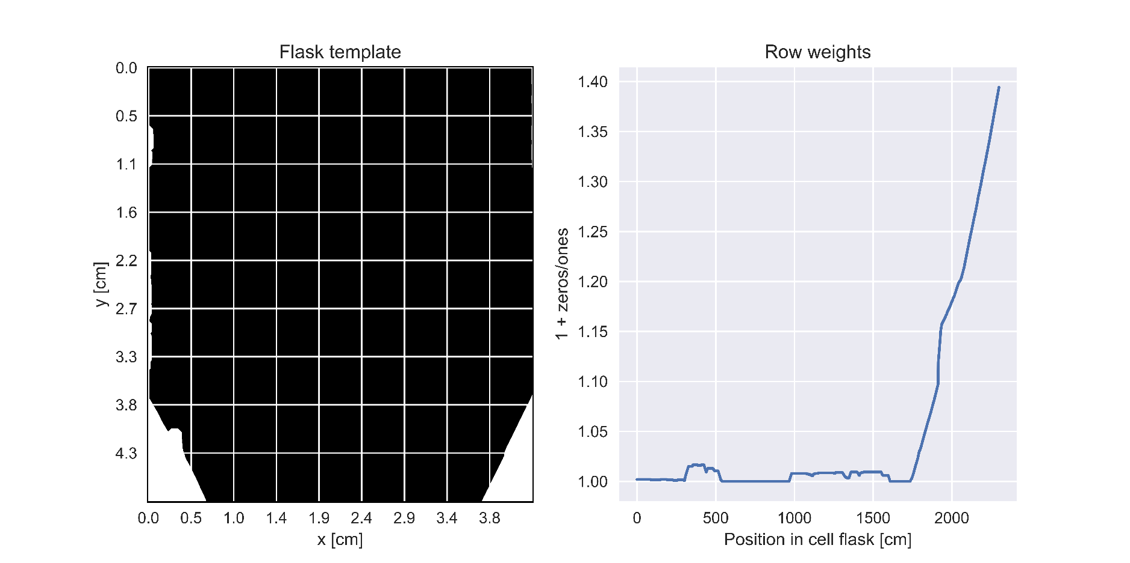Analysis of survival in GRID irradiated cell flasks was performed by dividing the analysis area into bands of equal width and summing number of colonies within each band. Before dividing the cell flasks into bands, the number of colonies on each pixel row (y-axis) was found. All pixel rows did not have the same width, it was therefore necessary to weight them differently. Figure 3‑18 shows how the weights were calculated based on the number of zeros on the binary image of the cell flask.

Figure 3‑18. How each pixel row (y-axis) was weighted based on how many zeros there were on the row in the flask template (left) image. More zeros meant less area to grow colonies, hence increased weight. As seen in the right image, as you move down vertically in the cell flask, the weight increase.

The analysis was only performed for 1 mm bandwidth on cell irradiated 2 and 5 Gy nominally to have comparative results to the 2D analysis, where 1 x 1 mm2 was deemed the optimal quadrat size (see 3.3.2). The sums represented the observed data in Figure 3‑19. The predicted data was found by inserting the doses from the dose profiles into the fitted LQ model, to get predicted survival. Predicted survival and the RPD between observed and predicted can be seen in Figure 3‑19 and Figure 3‑20 for 2 and 5 Gy respectively. Both plots show a decreased observed survival in the peak areas, albeit the pattern was clearer and less noisy for the 5 Gy irradiated cells. The survival in valley was more or less the same as predicted.

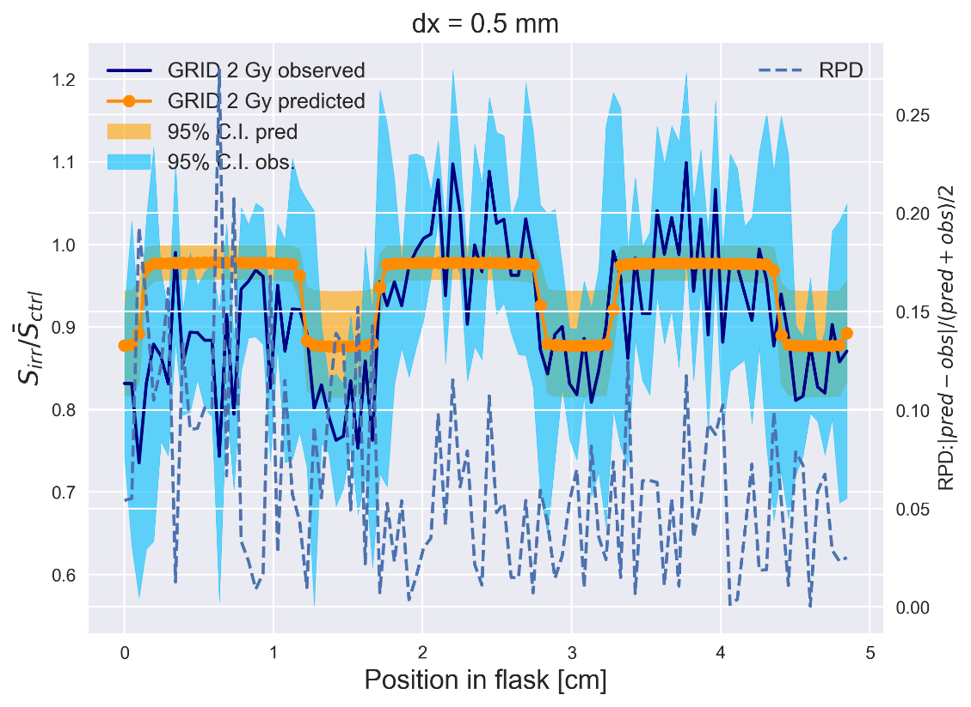

Figure 3‑19. 2 Gy survival band analysis using 0.5 mm wide bands. Predicted data was obtained using LQ model fitted to SF data from OPEN field irradiated cell flasks in orange vs observed in blue. Striped line is relative percentage difference between predicted and observed.

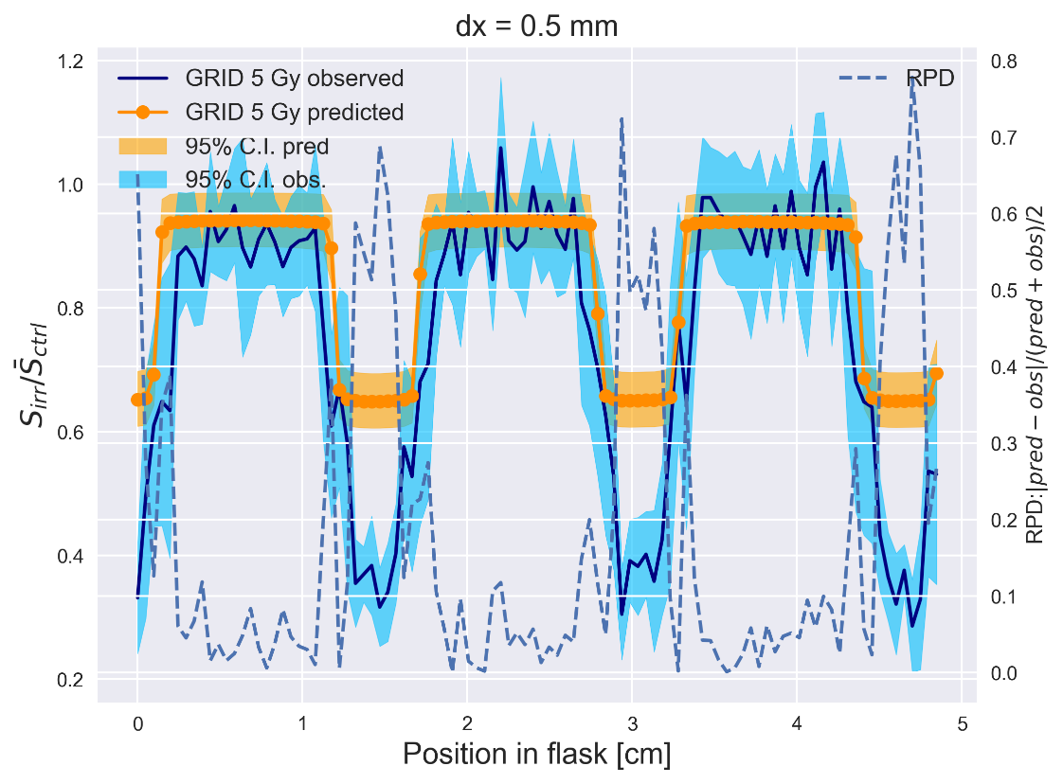

Figure 3‑20. 5 Gy survival band analysis using 0.5 mm wide bands. Predicted data was obtained using LQ model fitted to SF data from OPEN field irradiated cell flasks in orange vs observed survival within the bands in blue. Striped line is relative percentage difference between predicted and observed.

### 2D analysis

For the 2D analysis of the cell survival, we moved away from the band analysis, and divided the whole cell flask into quadrats of equal size. The number of colonies and the mean dose within each quadrat was found and passed to the Poisson regression.

#### Poisson evaluation

Before performing the Poisson regression, we evaluated the performance of different quadrat sizes. The first criterium was that the survival data in the peak and valley areas were Poisson distributed. RPD’s between mean and variance were found for all quadrat sizes and all doses. Additionally, a $χ^{2}$-test was performed to compare a theoretical Poisson distribution with the observed peak and valley survival data. The histograms generated from the observed survival can be seen in Appendix A with a theoretical distribution. RPD and p-values can be seen in Table 3‑5. A p-value > 0.05 means that there was no evidence that the observed values did not follow the Poisson distribution. Quadrat sizes was also evaluated based on number of quadrats containing no colonies in the control flasks, as well as variance between quadrat doses. Figure 3‑21 shows how all quadrat sizes performed for nominally 5 Gy irradiated cells.

Table 3‑5. Relative percentage difference between mean and variance of survival data in either peak or valley dose category. Cells receiving dose above 70% maximum and dose below 115% minimum for all kernel sizes and doses. P-values were found by performing a $χ^{2}$ test between observed occurrences and expected occurrences of counted colonies within an X x X mm2 quadrat, with null hypothesis being that there was no significant difference between the theoretical Poisson distribution and the observed.

|  |  |  |  |  |  |  |  |  |  |  |  |  |
| --- | --- | --- | --- | --- | --- | --- | --- | --- | --- | --- | --- | --- |
|  | 2 Gy | | | | 5 Gy | | | | 10 Gy | | | |
|  | Peak | | Valley | | Peak | | Valley | | Peak | | Valley | |
| Quadrat sizes | RPD | p-value | RPD | p-value | RPD | p-value | RPD | p-value | RPD | p-value | RPD | p-value |
| 0.5 | 0.058 | 0.987 | 0.070 | 0.998 | 0.030 | 0.996 | 0.080 | 0.984 | 0.006 | 0.997 | 0.099 | 0.986 |
| 1 | 0.120 | 0.9998 | 0.135 | 0.9998 | 0.049 | 0.99996 | 0.159 | 0.9995 | 0.054 | 0.999 | 0.178 | 0.99997 |
| 2 | 0.123 | 1 | 0.141 | 1 | 0.020 | 1 | 0.173 | 1 | 0.149 | $≈$ 0 | 0.185 | 1 |
| 3 | 0.102 | 1 | 0.130 | 1 | 0.005 | 1 | 0.168 | 1 | 0.226 | $≈$ 0 | 0.169 | 1 |
| 4 | 0.116 | 1 | 0.141 | 1 | 0.026 | 1 | 0.138 | 1 | 0.142 | 0.999 | 0.076 | 1 |

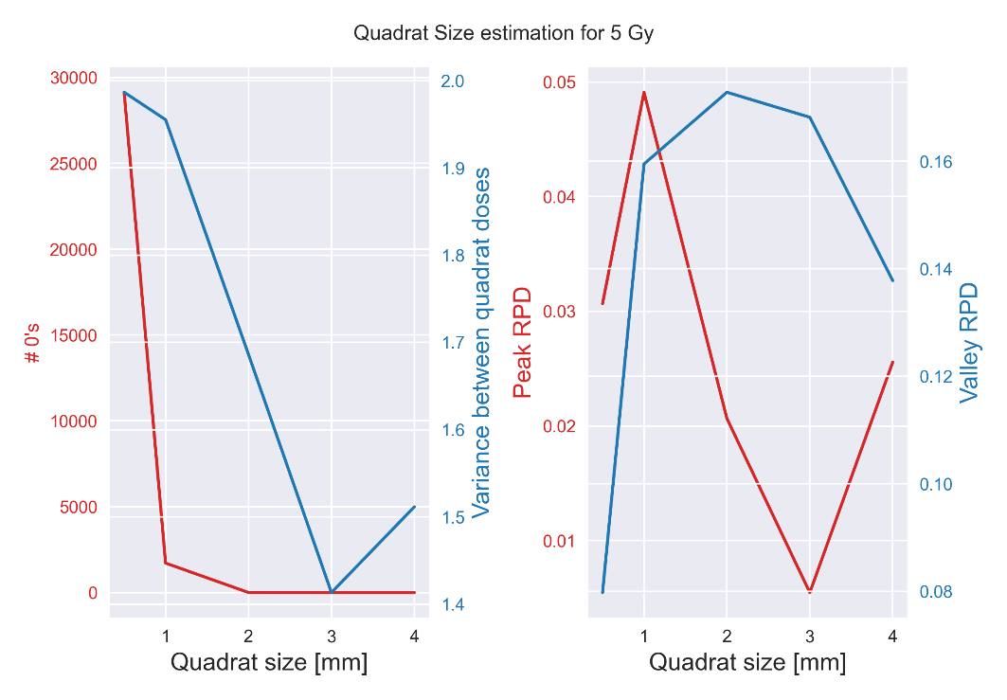Figure 3‑21.2D analysis of survival was performed by dividing a colony map into equally sized quadrats. Evaluation of all quadrat sizes. Quality criteria were number of quadrats in the control flasks containing 0 colonies to mediate zero inflation, variance between the doses of each quadrat to mediate smoothing of doses and RPD between variance and mean for peak and valley survival data to ensure Poisson distributed data.

#### Poisson regression

As mentioned in 2.4.3.2 we wanted to make a model suitable for all irradiation configurations. But we also wanted to see if we could get comparable results to the traditional LQ model fitted for OPEN field irradiated data. Using dose and dose squared as explanatory variables, we fitted the OPEN field data once more, only now we used the Poisson regression. This time we could not normalize with control. The result can be seen in Table 3‑6. The output was generated by the *statsmodels* package and contains the coefficients for all fitted parameters, their standard error, z-score, p-values and 95% confidence interval. Additionally, a $χ^{2}$-test was performed to estimate the goodness of fit between the model and the observed data. The $α$ and $β$ coefficients became $0.057±0.1$ and $0.014±0.002$, respectively. This yielded an $α/β$-ratio of $4±1$.

Table 3‑6. Poisson regression output for 1 x 1 mm2 with two explanatory variables. The fitting parameters are const, x1 and x2. Const is the intercept, x1 and x2 is dose and dose squared, respectively. The p-value of the coefficients show if there is a significant correlation between the explanatory variable and the independent variable. The p-value in the right column was calculated from the output gathered from the regression result, indicating a goodness of fit between the observed data and the model.

|  |  |  |
| --- | --- | --- |
| # Explanatory variables | Poisson regression output 1 x 1 mm2 quadrat size | (p-value) |
| 2 |  | 1 |

With these results we could expand the model, by incorporating all survival data from all quadrats for all irradiation configurations OPEN field, GRID stripes and GRID dots. The data was as mentioned divided into a training (80%) and a test (20%) set. Regression results from fitting the survival data from the training set with 1 x 1 mm2 quadrats are represented here, while the results from 4 x 4 mm2 quadrats are in Appendix A. The results from the regression can be seen in Table 3‑7. Various number of explanatory variables were tested. The first two variables were $D$ and $D^{2}$, both having p-values < 0.05. Peak distance was introduced as a third variable. Peak distance was significant, though with a higher p-value of 0.023. PAR was also introduced as a third variable and had a p-value of 0.0. PAR had a larger impact on the other coefficients changing their values significantly compared to peak distance. Finally, all variables were included in the model. This resulted in all variables having p-values below 0.05, and the p-value of peak distance reduced from 0.023 to 0.0. All coefficients had a negative correlation with survival, expect for the coefficient of peak distance. And all $χ^{2}$-tests did not show significant difference between the model and the data.

Table 3‑7. Poisson regression output for 1 x 1 mm2 with increasing number of explanatory variables. The fitting parameters are const, x1, x2, x3 and x4. Const is the intercept, x1 and x2 is dose and dose squared, respectively. x3 is either peak distance or PAR when number of explanatory variables are 3. x4 is peak distance when all explanatory variables are included. The p-value of the coefficients show if there is a significant correlation between the explanatory variable and the independent variable. The p-value in the right column was calculated from the output gathered from the regression result, indicating a goodness of fit between the observed data and the model.

|  |  |  |
| --- | --- | --- |
| # Explanatory variables | Poisson regression output 1 x 1 mm2 quadrat size | (p-value) |
| 2 |  | 1 |
| 3 (peak distance) |  | 1 |
| 3 (PAR) |  | 1 |
| 4 |  | 1 |

For further understanding of the regression output we decided to generate a correlation matrix. The *pandas* package (McKinney & others, 2010) generated this for us and the result can be seen in Table 3‑8. The highest correlation was seen between dose and dose squared, and dose and PAR. For the other variables the correlation was moderate.

|  |  |  |  |  |
| --- | --- | --- | --- | --- |
| Explanatory variables | $$D$$ | $$D^{2}$$ | PAR | Peak Distance |
| $$D$$ | 1 | 0.94 | 0.56 | -0.40 |
| $$D^{2}$$ | 0.94 | 1 | 0.35 | -0.34 |
| PAR | 0.56 | 0.35 | 1 | -0.43 |
| Peak Distance | -0.40 | -0.34 | -0.43 | 1 |

Table 3‑8. Correlation matrix between the explanatory variables used in the Poisson regression. D represents dose.

Observed and predicted survival was plotted for 1 x 1 mm2 quadrats with three explanatory variables ( $D,D^{2}$ and peak distance) and is shown in Figure 3‑22. Triangles represent the survival predicted by the Poisson regression, while the points represent the observed survival. Because of the difficulty in interpreting the plot, we visualized the data differently. The irradiation configurations were plotted separately, and the doses were binned together in dose categories with 0.5 Gy separation $(0,0.5,1,1.5,…etc.)$. Mean SC was found within each dose category and represented the observed survival. The process was repeated for predicted SC and the result can be seen in Figure 3‑23. The trend was that the observed SC followed the predicted SC, but larger variations were observed for dotted GRID. Vertical error bars represented the standard deviation of the mean SC within a dose category, while horizontal error bars represented the standard deviation between the doses in each dose category.

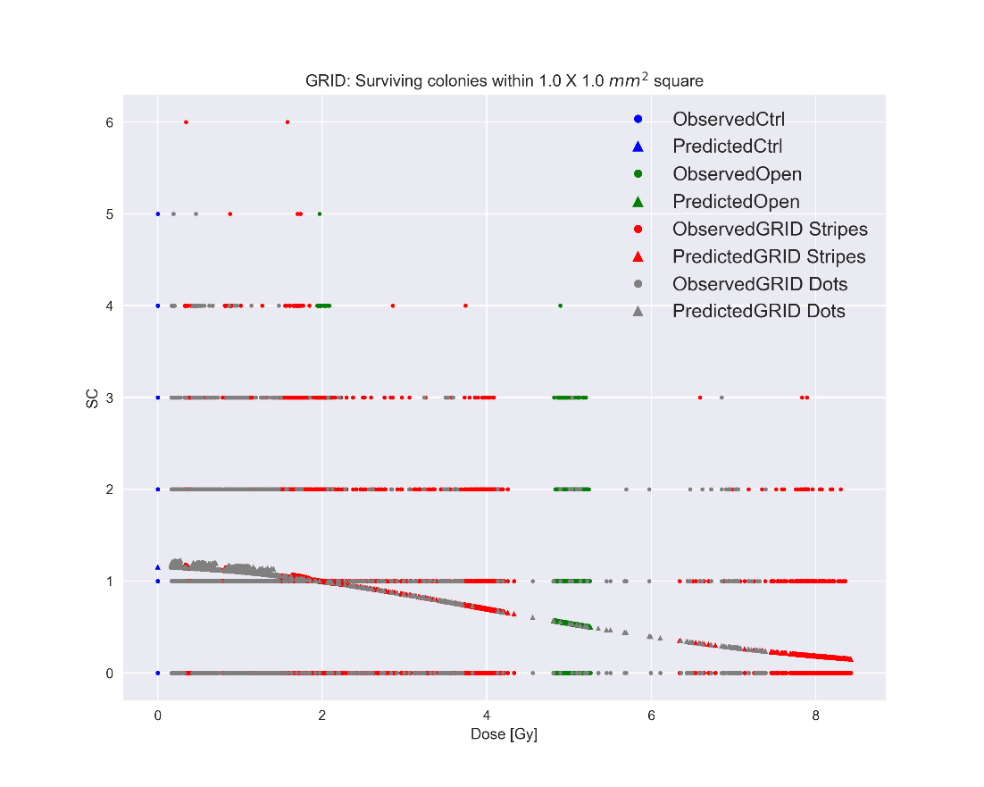

Figure 3‑22. Observed survival vs survival predicted by a trained Poisson regression model for 1 x 1 mm2 quadrat size and 3 explanatory variables (D, $D^{2}$ and peak distance). All survival data was fed to the model, but we plotted each irradiation configuration separately. SC stands for surviving colonies.

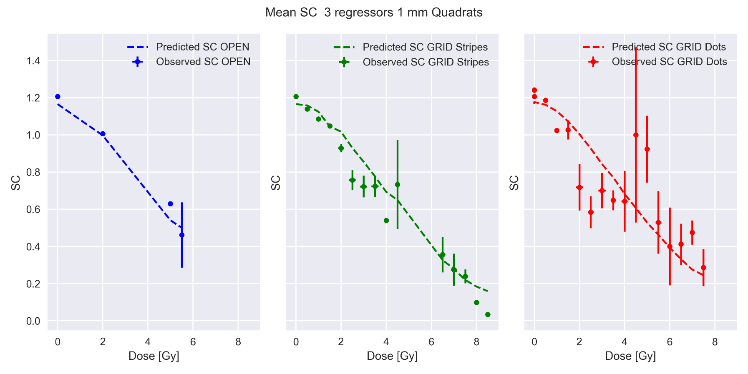

Figure 3‑23. SC for OPEN, GRID stripes and GRID dots. For easier visualization of the data presented in Figure 3‑22 the doses were separated into dose categories with 0.5 Gy separation (0,0.5,1,1.5 etc.). The mean SC was found within each dose category with standard error (vertical error bars). The standard deviation of each dose category are the horizontal error bars. Because peak distance was used as the third explanatory variable, it was not possible to generate a regression line for the predicted SC by interpolating. We therefore had to bin doses and find mean SC the same way as for the observed data.

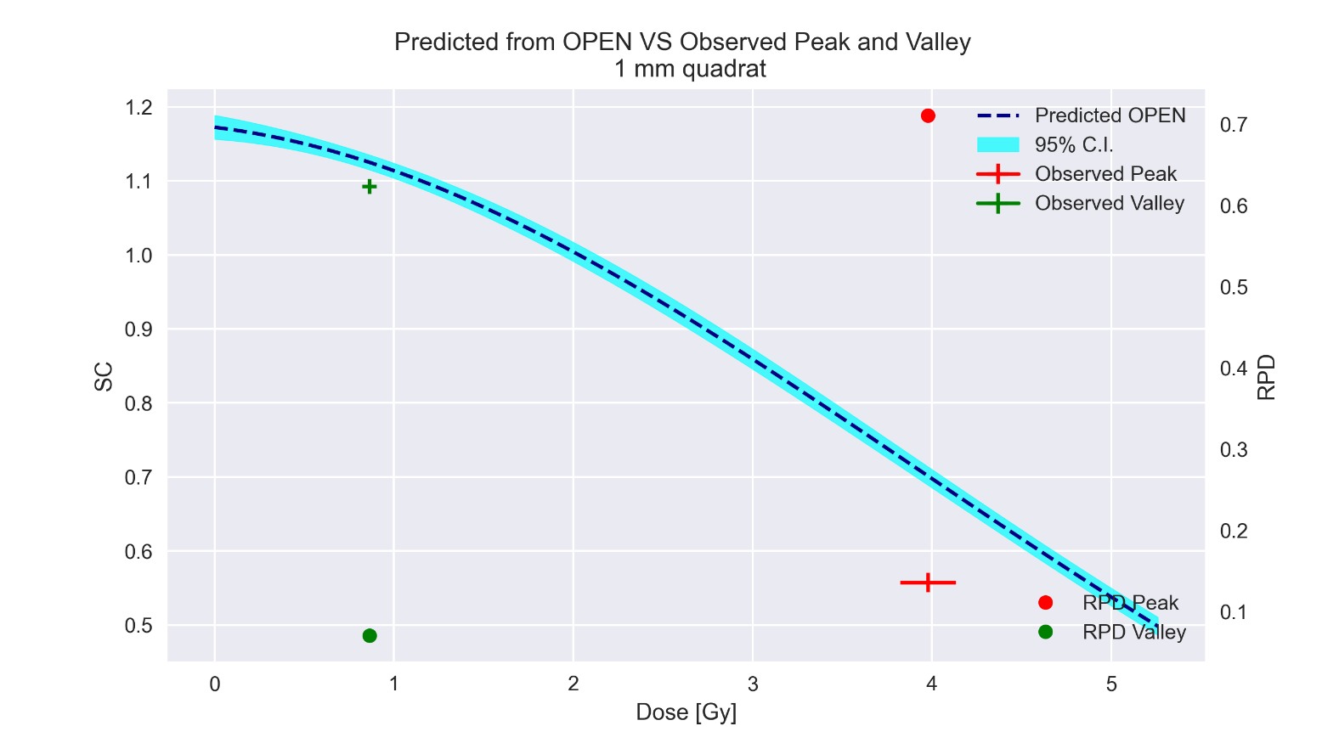Figure 3‑14 was generated as a comparison to the survival profiles generated from the band shown in Figure 3‑19 and Figure 3‑20. The plot compares the peak and valley survival of cells irradiated with 5 Gy nominally, to predicted survival found by using the coefficients from Table 3‑6. From the plot we observed the same tendency as shown in Figure 3‑19 and Figure 3‑20 with mostly the same survival in valley regions indicated by the small RPD and a decreased survival in the peak regions indicated by a larger RPD.

Figure 3‑24. Poisson regression line generated using the coefficients found in Table 3‑6. Observed survival was found by separating the quadrats into either the peak or valley category, before finding the mean survival of said category. The vertical error bar represents the standard deviation of the mean SC, and the horizontal error bar represents the standard deviation in doses within peak or valley.

#### Model evaluation

AIC scores were found for increasing number of explanatory variables. The first two variables were always dose and dose squared, but the third variable could either be PAR or peak distance. For four variables both PAR and peak distance was used. Figure 3‑25 shows the AIC scores for 1 x 1 mm2 quadrats. For this quadrat size, the optimal model resulting in the lowest overall AIC score was three explanatory variables with peak distance being the third one.

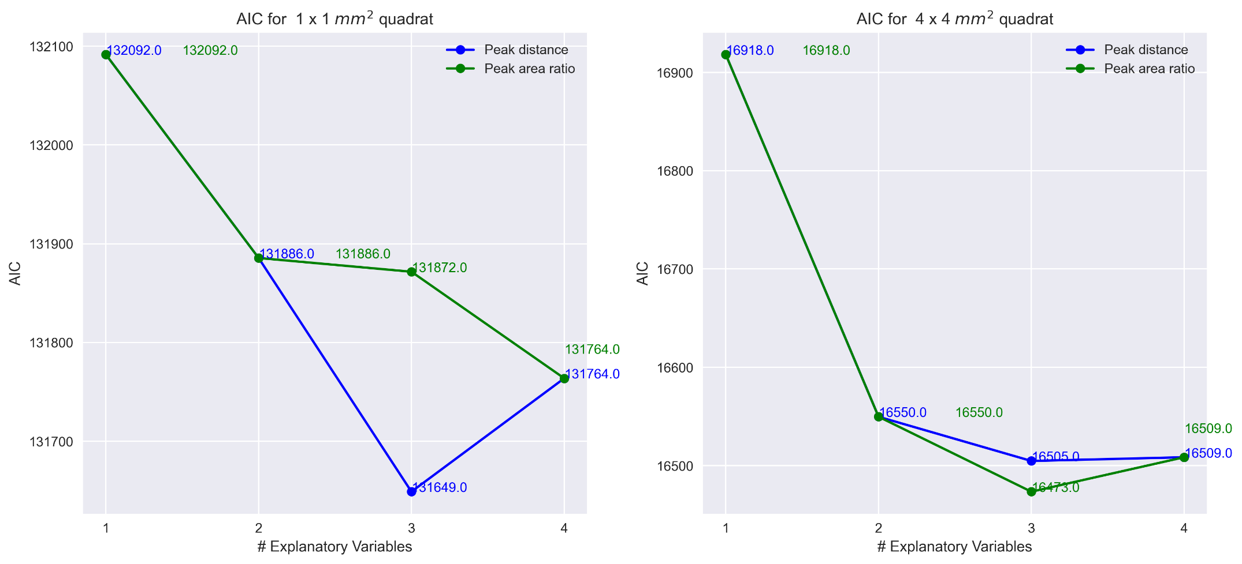

Figure 3‑25. AIC score for increasing model complexity. The first and second explanatory variables were always dose and dose squared. The plot compares adding peak distance or PAR as the third explanatory variable to predict SC in the Poisson regression. When four variables were added to the model, we had both peak distance and PAR, and the score was therefore equal.

MSE was found comparing the observed and predicted data from Figure 3‑22 for individual irradiation configurations. We were also interested in comparing the MSE of the train and test data. Both MSE comparisons can be found in Figure 3‑26. All irradiation configurations yielded similar MSE values, with GRID dots and Control being slightly higher. The difference between train and test was negligible.

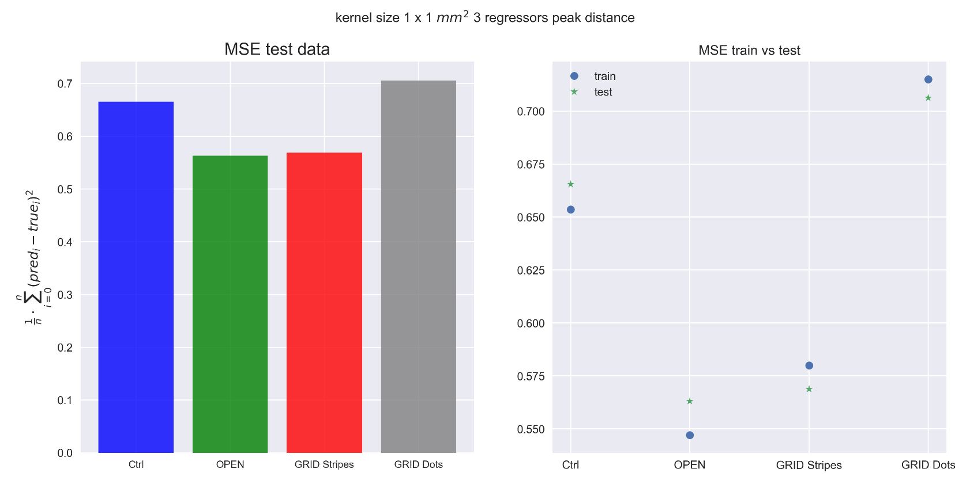

Figure 3‑26. Prediction performance of test data measuring MSE (left) and comparing train and test (right) for all irradiation configurations for optimal quadrat size of 1 x 1 mm2 for 4 regressors.

# Discussion

## X-ray Dosimetry

With a mean $R^{2}$ of $0.9976±0.0001$ we could safely conclude with a linear dose-time relationship. But with a slight delay in beam production indicated by the negative intercept of $-0.029±0.003$. Upscaling the dose rate from the fit to $Gy/min$ we got $\dot{D}=0.60±0.01 Gy/min$ *.* Dose rate obtained from 60 s measurements was found to be $\dot{D}= 0.59±0.02 Gy/min$. These are within each other’s standard error, and the ramp-up time would be small enough to neglect for the low doses used in this experiment (0.1, 0.2, 0.5 Gy).

The dose rate obtained from the second calibration was $\dot{D}= 0.60±0.02 Gy/min$ (13.10.21), which is within one standard error of the dose rate obtained from the first calibration. This indicates that the X-ray machine was consistent, and the correction factors used when converting output in $nC$ to dose in $Gy$ were precise.

## Gafchromic film dosimetry

Cutting the EBT3 films ourselves using a guillotine paper cutter was sufficient when the films were cut in rectangular shapes. Once the films were cut to match the shape of the cell flask, it resulted in positional shifts of the films inside the cell flask, thereby shifting the grid pattern shown in the film response. For striped GRID the consequences were not too severe because the stripes were continuous and the shift only impacting a small part of the total peak area. But for dotted GRID, with only one or two dots per GRID row (see Figure 2‑7), the shifts caused some films to have a pattern where part of the dots fell outside the film’s edges. A solution would be to order precut films or to cut them ourselves using a laser cutter. This would increase the similarity between the films, making the films fit better inside the cell flasks, thereby reducing required transformation to match them. It would center the GRID pattern, keeping it further away from the damaged edges of the films, where dose measurements are imprecise (see 2.1.2.3).

For field sizes (area of radiation field at a specified SDD) between 10 x 10 mm2 and 100 x 100 mm2 , an ROI of 4 x 4 mm2 was recommended (Gholizadeh Sendani et al., 2018). We found that the optimal ROI size for RED channel was 3 x 3 mm2, resulting in lowest MSE when fitting equation 2‑6. However, comparing the total MSE for 4 x 4 mm2 and 2 x 2 mm2 we saw that the RPD was approximately 0.5% and 1%, respectively, which was low enough to use either one. In hindsight we figured it would have been better to use 4 x 4 mm2 to capture more of the variation within each film.

Choosing the right color channel had a bigger impact on the fit. The sensitivity of the BLUE channel was much lower compared to RED channel, as seen in Figure 3‑4 and Figure 3‑5**.** In Figure 3‑5 we also observe that some of the films irradiated with low doses (0.1,0.2 and 0.5 Gy) have 0 netOD. This means that the BLUE channel intensity was higher than the average control intensity (see 2.1.2.3), and the data was not viable. The data was also split into high and low resposne, decreasing the available data for fitting, thereby increasing the uncertainty of the fitting parameters, as seen in Table 6‑3, making it even more important to choose a color channel with high enough sensitivity.   
Another possibility is to perform multichannel dosimetry. Micke et al. showed that including the intensity of all channels to remove disturbances in the scanned images from film inhomogeneity and artefacts generated by the scanner. Multichannel dosimetry is a possibility for future work and would utilize otherwise abandoned data in single channel dosimetry.

As mentioned in 2.1.2, we tried to eliminate the possibility of getting a split response from scanning orientation by increasing the difference between the sides of the films during the second calibration. However, we were unsuccessful in doing so. Another potential reason for the split response was variation in dose received by films’, caused by different positioning in the radiation field. As mentioned in 2.1.1 all positions were irradiated at once, looking at Table 6‑1 (31.08.21) we saw an increase in output going from position A and B to C and D. However, the measured RPD of mean output of positions A and B, compared to positions C and D was only around 0.8%.   
The split response was also observed in the control films. As they were not irradiated, the split response cannot be explained by the different positioning in the radiation field.   
This indicates a split response within the batch, as well as between batches. For future work, it would be desirable to perform our dosimetry on two separate batches, and record which sheet each film originated from.

In the dose profiles generated for OPEN field and striped GRID in Figure 3‑8**.** we can qualitatively observe a match between the high and low fitted dose profiles. For dotted GRID, where little to no separation of high and low response was observed, we used two different approaches. First, we fitted all data, ignoring any split response. The resulting dose profiles seen in

show a clear separation in the profiles. Using the fitting parameters from the first calibration from equation 3‑2, we achieved a greater match of the profiles seen in

, proving the need for separate fitting. Estimated dose for OPEN filed was 4.98(4.93,5.03). Assuming 5 Gy being the true dose, the relative error was 0.4%. Additionally, the results from the Monte Carlo simulations of striped GRID seen in Figure 3‑13 shows a match between predicted relative dose and observed dose, further support our dosimetry. Peak dose was smaller compared to OPEN field, which may be caused by scattered photon’s being attenuated in the GRID collimator openings. We also obtained a nonzero dose in valley areas, likely caused by low thickness of the GRID block, allowing more divergent photons with a nonzero incident angle to reach the EBT3 film in the valley areas illustrated in Figure 4‑1. The distance between the grid block and the cells was approximately 2.5 cm, giving the photons space to diverge after passing the grid openings and possibly increase the valley dose. The nonzero valley dose was in line with previous studies (R. S. Asur et al., 2012; Gholami et al., 2016).   
No simulations were performed for dotted GRID. However, the reduction in dose compared to striped GRID seen in Table 3‑2 can be explained by the GRID pattern. The dotted GRID pattern had a smaller peak area, which reduced the fluence of photons through the openings of the GRID, thereby reducing both the peak and valley dose received by the EBT3 film. This scenario was illustrated in Figure 4‑2.

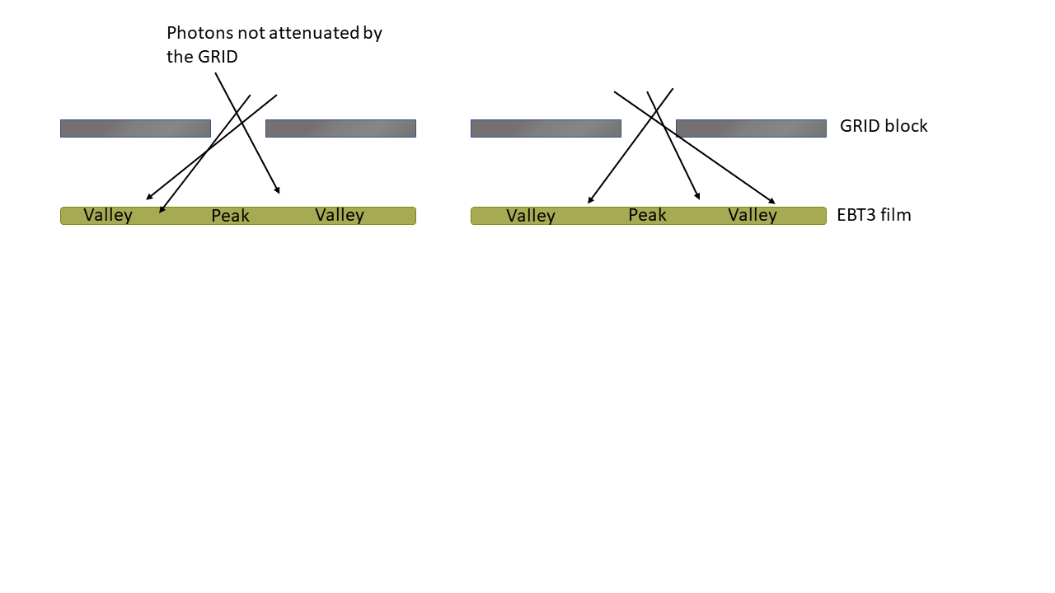

Figure 4‑1



Figure 4‑2. Striped GRID block. We observe that exchanging the continuous stripes (5 mm opening) for circles (5 mm diameter), results in a smaller opening. Thereby reducing dose in the peak areas.

## Cell Survival

Data from the cell experiments was chosen based on the plating efficiency and how close the survival in the control flasks were between the experiments. Looking at Figure 3‑14 we observe a very low PE 17.12.2020 and an abnormally low PE for 03.01.2020. The flask with abnormally low PE was studied by under the microscope (Magnus Børsting, 2020, section 4.2.1) to confirm the result. It was speculated that seeding 30 000 cells resulted the confluency (fraction of cell flask area covered by cells) being so high, that the cells had left their logarithmic growing phase. Another possibility was undercounting by the segmentation algorithm. The data from 18.11.2019 and 20.11.2019 had a low but enhanced PE and was therefore included in the survival analysis. But it was still worth examining the algorithm’s capabilities. The control cell flasks in Figure 6‑4 was inspected by Nina Edin (experienced cell counter), as well as delineated data from the segmentation. Her assessment was that the algorithm did not successfully separate all the BLOBs into individual colonies. A possible explanation for this was the resolution of the scanned cell flasks being too low. A Gaussian filter was applied to the PCA images to suppress noise (Arous et al., 2022). The slight smoothing might wash away small intensity differences, that constitutes the difference between two cell colonies. Increasing the resolution might mitigate the merging of cell colonies and should be tested in future experiments, as well as comparing the algorithm with manually counted data. Different number of cells should also be tested, with the intention of retaining highest possible segmentation accuracy, while still seeing the effects of the dose gradient.

## 1D survival analysis

$α$ and $β$ found from OPEN field irradiated cell flasks was $0.06±0.04$ and $0.011±0.008$, respectively. Neither had p-values below 0.05, indicating no significant correlation between our survival and the dose (and dose squared). The resulting $α/β$ ratio from the OPEN field irradiated cell flasks was $6±5 Gy$. A high uncertainty in both estimated parameters (see Table 3‑4) lead to a high uncertainty seen in the $α/β$ ratio, likely caused by the amount of data being relatively low with only 8 datapoints per dose. It also did not help that 10 Gy data was unusable because of unsuccessful segmentation leaving only three dose points for the analysis 0, 2 and 5 Gy.   
In future experiments one should include more doses and try to include doses representative of received doses in peak and valley. Hilde Solesvik Skeie reported in her master thesis: *“The relative biological effectiveness of low energy protons for human lung carcinoma cells”* an $α/β$-ratio of $12.9±0.05$ using the same irradiation setup. The results deviate quite significantly and supports the need for further analysis and potential improvements of the algorithm.

The survival analysis using bands of 0.5 mm width resulted in the plots seen in Figure 3‑19. For 5 Gy the predicted survival was higher than the observed survival in peak areas, and mostly the same in valley areas. As mentioned in the previous section, we believed that the segmentation algorithm underestimated number of viable colonies. Intuitively one might think that low doses result in a higher degree of underestimation because there are more colonies and more BLOBs to separate. However, the predicted and observed survival in peak area was based on the same dose, and the difference cannot necessarily be explained by segmentation error. Another explanation was possible bystander effects and communication between the cells in the peak areas, leading to increased cytotoxicity. Based on the number of cells seeded we found the average distance between the cells to be approximately 0.2 mm (see Appendix A). A previous study used inverted microscopy to find the diameter of an A549 cell of 14.93 µm (Jiang et al., 2010). This implied that the cells were not close enough to communicate through gap junction.

We also observe, an increase in RPD from 2 to 5 Gy nominal dose, which could indicate an increase in bystander effect for larger doses. However, the survival data for 2 Gy GRID was noisy and hard to interpret. In the 2015 article: “*High dose bystander effects in spatially fractionated radiation therapy*” by (R. Asur et al., 2015), showed results with higher survival in peak areas, and lower survival in valley areas. It should be noted that most of these SFRT experiments used different experimental setups, utilizing 6 MV photons with 50/50 peak valley area and different cell lines.

Results from (Peng et al., 2017) indicate a dependency of GRID configuration, where 2.5 mm openings in the striped grid resulted in significant difference in survival for the NCI-H460 cancer cell lines compared to OPEN field, but the significance was lost when using a GRID with 5 mm openings after being given an average dose of 3.5 Gy. This coincides with our results as overall survival was reduced for our 5 Gy survival, but it is not shown whether the decreased survival was in peak or valley region.

## 2D survival analysis

A dotted GRID configuration does not lend itself well to survival band analysis. Therefore, we analyzed survival in 2D by summing up colonies within quadrats of different sizes, before using Poisson regression to fit the data. Evaluating which quadrat size was best suited for the Poisson regression, we calculated different criteria values. The results can be seen in Table 3‑5 and Figure 3‑19, we also included the histograms for all doses, all quadrat sizes, peak or valley in Appendix A. The table shows that for most doses and quadrat sizes we were unable to reject the null hypothesis. I.e., there was no statistically significant difference between the theoretical Poisson distribution and our observed data. We only rejected the null hypothesis for peak survival 10 Gy of 2 x 2 and 3 x 3 mm2. This can be explained by the associated histograms seen in Appendix A, which showed elongated tails (compared to expected) and outliers.   
The optimal quadrat size was 1 x 1 mm2. It did not have the smallest RPD but had a low number of zero colony quadrats and retained more variance in dose. Also, decreasing quadrat size makes the nearest peak distance a more realistic explanatory variable. As mentioned, nearest peak distance was defined as the distance from the center of the quadrat to the nearest peak. For a larger quadrat, this distance becomes less representative of colonies located further from the center.

**Discuss the regression results including plot**

**BAD first draft:**

The 2D analysis for OPEN field with 1 x 1 mm2 quadrats resulted in $α$ and $β$ of $0.06±0.01$ and $0.014±0.002$, respectively. These results were comparative to the 1D OPEN field regression seen in Table 3‑4). But the uncertainties were lower and both dose and dose squared had p<0.05, caused by the increase in datapoints when dividing the cell flasks into quadrats. However, we still observe a low $α/β$-ratio compared to previous findings (Hilde Solesvik Skeie, 2021). Despite this, it was positive that both the Poisson regression and the fitting of the LQ model had similar results.

The resulting regression plot in Figure 3‑20 for OPEN, GRID stripes and GRID dots for 1 x 1mm2 was difficult to interpret, but a slight decrease in survival was observed where number of quadrats with more than 3 colonies decrease for doses above 4 Gy. This effect was much easier to observe for a 4 x 4 mm2 quadrat size (see Appendix A Figure 6‑9), however this result was put into the appendix because of the results from the Poisson evaluation indicating a 1 x 1 mm2 being the optimal quadrat size. We also wanted to make the model independent of grid configuration, and increasing grid size would compromise this goal, as discussed in 2.4.3.1.

The regression output for 1 x 1 mm2 quadrat showed that al combinations of the 4 proposed explanatory variables dose, dose squared, peak distance and PAR yielded significant coefficients, indicating that the additional variables explain some of the GRID block’s effect on survival. Additionally, the $χ^{2}$ test showed **no** evidence of the data **not** following the estimated model (p>0.05).   
If we focus on the low dose area of **Error! Reference source not found.** we see slight fan shaped curve of the predicted striped and dotted GRID survival data, not seen in the OPEN field survival data. The effect was seen for typical valley doses showing an increase in survival in these regions. We also observed a generally higher survival for OPEN field data compared to GRID when receiving the same dose. Drawing any conclusion from this plt

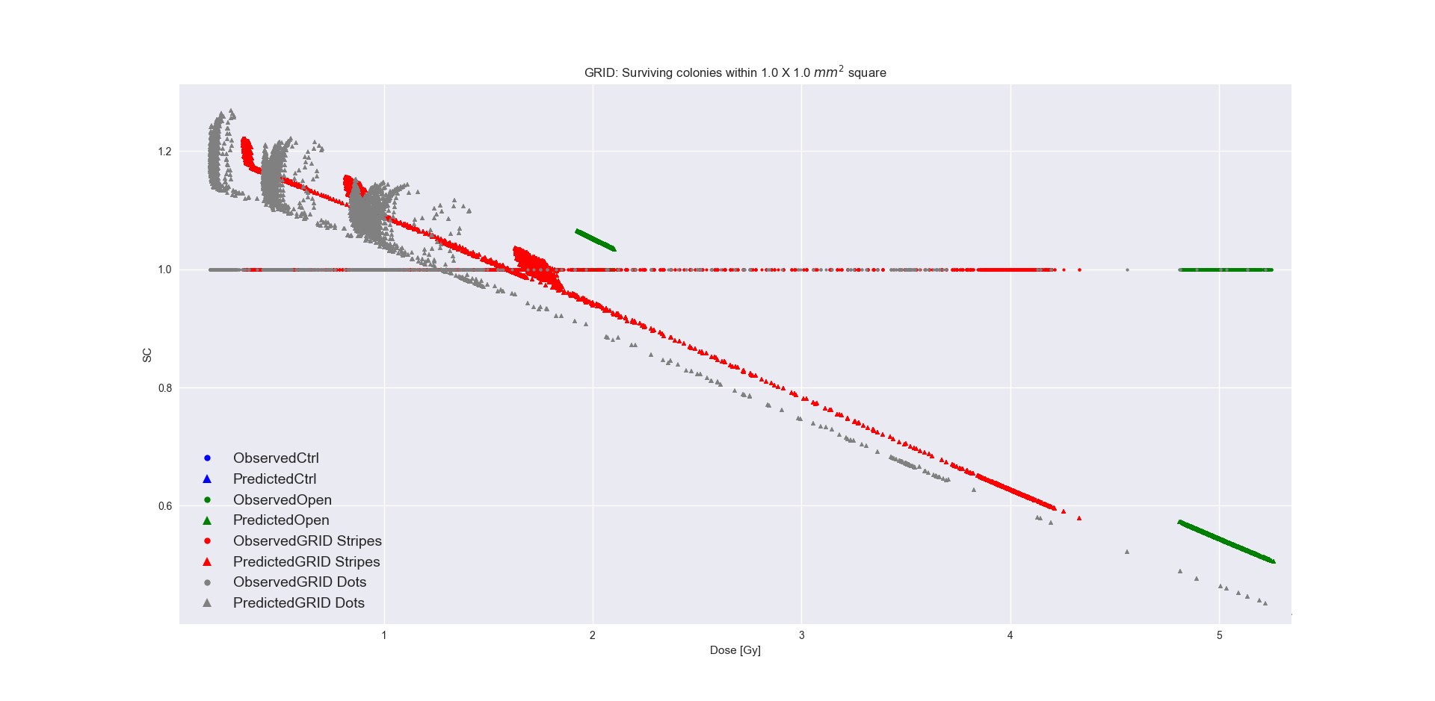

Figure 4‑3

correlation between the explanatory variables in Table 3‑8. Dose and dose squared showed an expected high correlation. Nevertheless, this would not be problematic. As mentioned, $α$ and $β$ represents the mode 1 and mode 2 DSBs (1.7.5), respectively. They are therefore not meant to explain survival separately. There was a relatively high correlation between PAR and dose (0.56). However, it did not affect its significance, which could indicate that PAR might hold additional explanatory power that explain how spatially fractionating the radiation field effect the survival. Peak distance showed a moderate negative correlation with the other explanatory variables, -0.4, -0.35 and -0.43 with dose, dose squared and PAR, respectively. This was expected, as dose decrease with distance away from the peak areas, and a larger PAR results in lower peak distances. In and of itself, the result was not revolutionary, but it showed that the introduced variables acted according to expectations.   
AIC scores in **Error! Reference source not found.** evaluated the cost versus benefit of including additional variables in the model. For 1 x 1 mm2 it was better to include peak distance as the third variable and discard PAR. But when including PAR as the third variable, including all variables gave the lowest AIC. This could indicate that peak distance better explains survival of the cells. Peak distance had the lowest correlation which might explain why it adds more explanatory power to the model compared to PAR. However, the result flipped when using a 4 x 4 mm2 quadrat making PAR the optimal variable. This supported our theory about peak distance being less accurate for larger quadrat sizes.   
An interesting observation was that, when introduced as the third explanatory variable, peak distance was not significant for quadrat sizes above 1 x 1 mm2. In Table 6‑5 we see that peak distance has a p-value of 0.98 and a coefficient of 0.0004, but when PAR was included the p-value sunk to 0.004 and the coefficient increased to 0.0544 (136 times larger). A possible explanation was that the moderate correlation between peak distance and PAR (-0.43) resulted in a scenario where peak distance both explained its own effect on survival, as well as a portion of PAR’s effect on survival. But when PAR was introduced only the true effect of peak distance remained, making PAR a confounding variable. However, peak distance was significant for 1 x 1 mm2 with a p-value of 0.023. The correlation between peak distance and PAR remained mostly the same for 1- and 4-mm quadrat sizes (-0.43 and -0.44), but the number of datapoints were very different as 1 mm quadrats resulted in 16 times more quadrats. A larger sample size increases precision, thereby reducing the p-value (Thiese et al., 2016). Additionally, multicollinearity is known to have a larger effect on smaller sample sizes (Sari et al., 2018) and might explain the significance of peak distance.   
  
**Note to self:**

Maybe peak distance needs peak area when quadrats become larger. Maybe they work in tandem, like D and D^2. But that wouldn't explain why 3 regressors are better than 4 regressors for 1 x 1 mm. Why does peak distance work best on its own for this quadrat size ? Maybe peak distance becomes more and more dependent on peak area for larger quadrats.

**MSE discussion**

**Bad first draft**

Explain OPEN vs GRID first

As Figure 3‑22 showed, the model performed best for OPEN field survival data. Comparing with the control data, this made sense because the control data had a larger span of possible number of SC. When the cells were irradiated with an OPEN field, this variation shrinks, resulting in a smaller MSE. This explanation was not sufficient when comparing the MSE of OPEN field and GRID. The curving effect seen in Figure 4‑3 indicated that there was an added effect of GRID irradiation not sufficiently explained by dose, we could therefore argue that the higher MSE of GRID might be caused by not being able to fully explain the effects of GRID irradiation using PAR and peak distance. It would therefore be of interest to develop our explanatory variables further. Peak distance could be exchanged with a diffusion variable, explaining diffusion of the soluble factors into the growth medium of the cells. It would also be interesting to explore the possibility of adding a bystander factor. This factor could be decided by performing bystander effect experiments where medium of irradiated cells is transferred to non-irradiated cells (Liu et al., 2006).   
GRID dots had the highest MSE. This was probably caused by a combination of two things: The error of separating the flasks into quadrats, and the lower amount of survival data from cells irradiated with dotted GRID. We were only able to extract data from one experiment because of the very low plating efficiency seen in the other experiments. This might have caused a slight bias in the model towards striped GRID.

1 x 1 mm2 control survival standard deviation

0.8091246692335142

Standard deviation survival OPEN 2 Gy

0.7903678778536044

Standard deviation survival OPEN 5 Gy

0.6847885007383124

Standard deviation survival GRID stripes 2 Gy

0.8133311624459209

Standard deviation survival GRID stripes 5 Gy

0.7909118185779087

Standard deviation survival GRID stripes 10 Gy

0.8205627459919868

As mentioned, we wanted to separate into training and test, test data was kept in separate categories to evaluate how the model performed on ctrl, open and grid survival.

For 1 x 1 mm2 model performed better for striped compared to dotted data. We suspect the model to be better suited for striped grid because we split the data into quadrats, but also because there was more striped grid data.   
The model also performed best for OPEN field. We have most likely not included the necessary explanatory variables to perfectly explain the effects of the GRID.

**Note: Would it be better to set PAR to 0 for OPEN field**

**Generated results with PAR being 0 for OPEN, have not included it in methods**

**Did not work, try to work around this**

**When setting PAR to 0 then OPEN reduces to LQ, but when including the remaining data something else is off.**

.

For some reason we see a lower MSE for test data in the case of ctrl and OPEN. What have I done wrong.

We observe that training data has the largest MSE. This makes sense because the model will predict the same mean for all control data because dose dose squared PAR and peak distance are all 0. The only source of difference is variation in the test data. Because we have more data in the training set, we therefore have more variation in the counted cell colonies, hence the larger MSE.

**Discuss MSE PAR vs peak dist**

Klassen et al. proposed cleaning the films, because of their tendency to gather dust. This was not discovered until after the experiments were performed.

When finding nearest peak, we used the same area within each film as for survival analysis. What this means was that if a colony was nearest a peak located outside this area, then this distance was not found. For future work, a more realistic approach should be applied to find nearest peak distance, by including the distance to peaks outside the analysis area and potentially find an average distance from all colonies within a quadrat, instead of the center.

DUMP

(Peñagarícano et al., 2010)

Getting ${σ_{\overline{PV}}}_{ctrl}$ and $σ_{{\overline{PV}}_{bckg}}$ we need to combine the standard deviations of the individual films using pooled standard deviation. With the assumption of independent images, equal variance, and sample size we can use the formula

$$\sqrt{\frac{\sum_{i=0}^{n}{σ_{i}^{2}}}{k},}$$

where k is the number of samples.

We can also find confidence intervals from the covariance matrix. A confidence interval for e.g., 95% confidence claims that the true population mean will be within the limits of the confidence interval 95% of the times a sample mean is measured. For a general mean value $\overline{X}$, the confidence interval is found using the formula

$$\overline{X }±t_{crit}σ_{\overline{X}}=t_{crit}\frac{σ}{\sqrt{n}} ,$$

if the t distribution has a mean of $μ$, then $t_{crit}$ is the number of standard deviations out from $μ$ in both directions that encapsulates the allowed variations of $μ$. $σ_{\overline{X}}$ is the standard deviation of the mean $\overline{X}$.

**we ended up not using this to generate confidence interval**

In the general case of fitting a function $G(x)$ with LM, $σ_{\overline{X}}$ was found with the delta method. Differentiating $G(x)$ w.r.t. all the parameters $p$ and multiplying with $Σ$ on both sides gives the variance of $G(x)$ for all $x$ (Thomas S. Robinson, 2020)

$$Var\left(G\left(x\right)\right)= G^{'}\left(x\right)Σ G^{'}\left(x\right) ,$$ squaring this expression and dividing by the square root of number of observed values n.

For evaluation of interpolation performance, we used the mean dosimetry map for OPEN field irradiation and performed a welch t-test on the relative errors of the dose profiles for the unchanged and the upscaled image.

Then the difference between the mean intensity values of the four scans were tested using analysis of variance (ANOVA). The method performs an F-test by calculating the ratio $F= \frac{variance between samples}{variance within samples} ,$ and finding the probability (p-value) of the scans being significantly different (Ross & Willson, 2017, p. 21). The test resulted in 23.2% of the films having significant difference between the four scans. The calibration films for striped GRID had a resolution of 507 x 484 pixels, resulting in a large sample size for ANOVA. This in turn reduced the standard deviation of the F-distribution, resulting in low p-values.

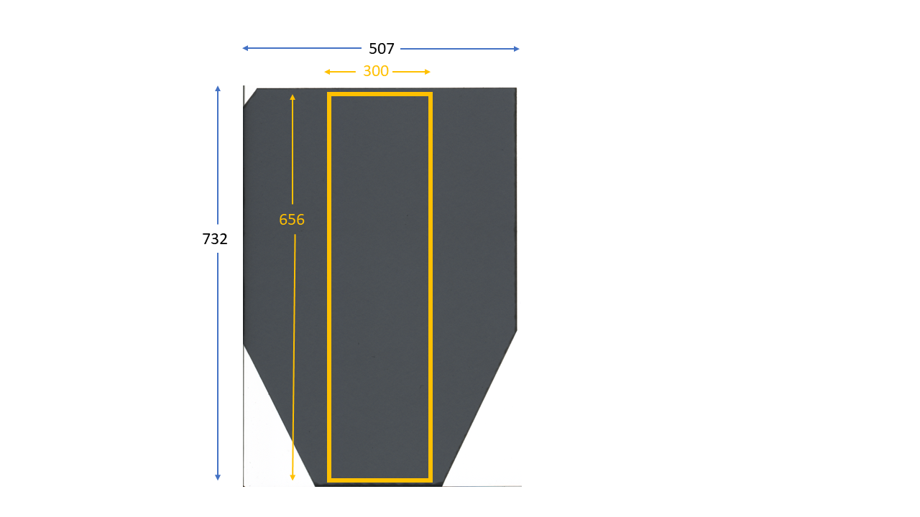

Figure 4‑4. Area within the OPEN field dose map where relative error is found.

However, we were unable to include the fitting error from equation 2‑7 because of the increasing complexity of the necessary calculations. As mentioned, the mean dose was based on 16 profiles, which was found calculating the mean dose on each row in the dose map. A dose map generated by combining high and low response dose maps, of which there were 8 high and low response films, respectively. Each dose map has $x⋅y$ number of pixels based on how they are cropped, with their own uncertainty from the netOD to dose conversion. Additional complexity was added when the peak and valley dose was found. Each profile was separated into peak and valley. The number of peak and valley points in each profile was not necessarily equal.

We found the standard error of the points in peak and valley. Including the fitting error, we used the standard error in the dose maps for both high and low response but kept them separate. First, we found mean standard error of each row, to have the same shape as the dose profiles.

$$(\# films, rows)$$

Then we extracted the standard errors of the points in the dose profiles categorized as either peak or valley. All points, either low or high response was added to a fit std array for peak and valley.

Then the mean standard error of all points was found and combined with the standard error we found first.

# References

*A549 Cell Subculture Protocol – A549 Cell Line: Cell Culture and Transfection Protocol*. (n.d.). Retrieved April 5, 2022, from https://www.a549.com/cell-subculture-protocol/

*Adenosine triphosphate | Definition, Structure, Function, & Facts | Britannica*. (2020, March 12). https://www.britannica.com/science/adenosine-triphosphate

Aksnes, I. (2020, November 8). History of X-rays—125 years in the making (pt 2). *Excillum*. https://www.excillum.com/history-of-x-rays-x-ray-tubes/

Alberts, B., Johnson, A., Lewis, J., Raff, M., Roberts, K., & Walter, P. (2014). *Molecular Biology of the Cell* (6th ed.). Garland Science.

Aldelaijan, S., & Devic, S. (2018). Comparison of dose response functions for EBT3 model GafChromicTM film dosimetry system. *Physica Medica*, *49*, 112–118. https://doi.org/10.1016/j.ejmp.2018.05.014

Alin, A. (2010). Multicollinearity. *WIREs Computational Statistics*, *2*(3), 370–374. https://doi.org/10.1002/wics.84

Alm Carlsson, G. (2001). *Bragg-Gray Dosimetry: Theory of Burch*. Linköping University Electronic Press. http://urn.kb.se/resolve?urn=urn:nbn:se:liu:diva-57834

Alm Carlsson, G. (2002). *Spencer-Attix Cavity Theory*. Linköping University Electronic Press. http://urn.kb.se/resolve?urn=urn:nbn:se:liu:diva-57893

Amiri, S., Ali, P. J. M., Mohammed, S., Hanus, R., Abdulkareem, L., Alanezi, A. A., Eftekhari-Zadeh, E., Roshani, G. H., Nazemi, E., & Kalmoun, E. M. (2021). Proposing a Nondestructive and Intelligent System for Simultaneous Determining Flow Regime and Void Fraction Percentage of Gas–Liquid Two Phase Flows Using Polychromatic X-Ray Transmission Spectra. *Journal of Nondestructive Evaluation*, *40*(2), 47. https://doi.org/10.1007/s10921-021-00782-w

Andreo, P. (2015). Dose to ‘water-like’ media or dose to tissue in MV photons radiotherapy treatment planning: Still a matter of debate. *Physics in Medicine and Biology*, *60*(1), 309–337. https://doi.org/10.1088/0031-9155/60/1/309

Andreo, P., Burns, D. T., Nahum, A. E., Seuntjens, J., & Attix, F. H. (2017). Chemical Dosimeters. In *Fundamentals of Ionizing Radiation Dosimetry* (1st ed., pp. 562–562). John Wiley &amp; Sons, Incorporated.

*Apoptosis | cytology | Britannica*. (2013, September 27). https://www.britannica.com/science/apoptosis

Arous, D., Schrunner, S., Hanson, I., Frederike Jeppesen Edin, N., & Malinen, E. (2022). Principal component-based image segmentation: A new approach to outline in vitro cell colonies. *Computer Methods in Biomechanics and Biomedical Engineering: Imaging & Visualization*, *0*(0), 1–13. https://doi.org/10.1080/21681163.2022.2035822

Ashburner, J., & Friston, K. (2007). CHAPTER 4—Rigid Body Registration. In K. Friston, J. Ashburner, S. Kiebel, T. Nichols, & W. Penny (Eds.), *Statistical Parametric Mapping* (pp. 49–62). Academic Press. https://doi.org/10.1016/B978-012372560-8/50004-8

Asur, R., Butterworth, K. T., Penagaricano, J. A., Prise, K. M., & Griffin, R. J. (2015). High dose bystander effects in spatially fractionated radiation therapy. *Cancer Letters*, *356*(1), 52–57. https://doi.org/10.1016/j.canlet.2013.10.032

Asur, R. S., Sharma, S., Chang, C.-W., Penagaricano, J., Kommuru, I. M., Moros, E. G., Corry, P. M., & Griffin, R. J. (2012). Spatially Fractionated Radiation Induces Cytotoxicity and Changes in Gene Expression in Bystander and Radiation Adjacent Murine Carcinoma Cells. *Radiation Research*, *177*(6), 751–765.

Attix, F. H. (1986). *Introduction to Radiological Physics and Radiation Dosimetry*. John Wiley & Sons.

Attix, F. H. (2008). *Introduction to Radiological Physics and Radiation Dosimetry*. John Wiley & Sons.

*AvgPool2d—PyTorch 1.11.0 documentation*. (n.d.). Retrieved April 28, 2022, from https://pytorch.org/docs/stable/generated/torch.nn.AvgPool2d.html

Battistoni, G., Boehlen, T., Cerutti, F., Chin, P. W., Esposito, L. S., Fassò, A., Ferrari, A., Lechner, A., Empl, A., Mairani, A., Mereghetti, A., Ortega, P. G., Ranft, J., Roesler, S., Sala, P. R., Vlachoudis, V., & Smirnov, G. (2015). Overview of the FLUKA code. *Annals of Nuclear Energy*, *82*, 10–18. https://doi.org/10.1016/j.anucene.2014.11.007

Billena, C., & Khan, A. J. (2019). A Current Review of Spatial Fractionation: Back to the Future? *International Journal of Radiation Oncology*Biology*Physics*, *104*(1), 177–187. https://doi.org/10.1016/j.ijrobp.2019.01.073

Bingham, N. H., & Fry, J. M. (2010). *Regression*. Springer London. https://doi.org/10.1007/978-1-84882-969-5

*Biomolecule | Definition, Structure, Functions, Examples, & Facts | Britannica*. (2020, March 18). https://www.britannica.com/science/biomolecule

Bjørg Vårli Håland. (2020). *2D dosimetry and radiobiological modelling in GRID therapy*. University of Oslo.

Blyth, B. J., & Sykes, P. J. (2011). Radiation-induced bystander effects: What are they, and how relevant are they to human radiation exposures? *Radiation Research*, *176*(2), 139–157. https://doi.org/10.1667/rr2548.1

Böhlen, T. T., Cerutti, F., Chin, M. P. W., Fassò, A., Ferrari, A., Ortega, P. G., Mairani, A., Sala, P. R., Smirnov, G., & Vlachoudis, V. (2014). The FLUKA Code: Developments and Challenges for High Energy and Medical Applications. *Nuclear Data Sheets*, *120*, 211–214. https://doi.org/10.1016/j.nds.2014.07.049

Borca, V. C., Pasquino, M., Russo, G., Grosso, P., Cante, D., Sciacero, P., Girelli, G., Porta, M. R. L., & Tofani, S. (2013). Dosimetric characterization and use of GAFCHROMIC EBT3 film for IMRT dose verification. *Journal of Applied Clinical Medical Physics*, *14*(2), 158–171. https://doi.org/10.1120/jacmp.v14i2.4111

Burnham, K. P., & Anderson, D. R. (1998). Information Theory and Log-Likelihood Models: A Basis for Model Selection and Inference. In K. P. Burnham & D. R. Anderson (Eds.), *Model Selection and Inference: A Practical Information-Theoretic Approach* (pp. 32–74). Springer. https://doi.org/10.1007/978-1-4757-2917-7_2

Cameron, A. C., & Trivedi, P. K. (Eds.). (2013a). Introduction. In *Regression Analysis of Count Data* (2nd ed., pp. 1–20). Cambridge University Press. https://doi.org/10.1017/CBO9781139013567.004

Cameron, A. C., & Trivedi, P. K. (Eds.). (2013b). Model Specification and Estimation. In *Regression Analysis of Count Data* (2nd ed., pp. 21–68). Cambridge University Press. https://doi.org/10.1017/CBO9781139013567.005

Cavazzuti, M. (2013). *Optimization Methods*. Springer Berlin Heidelberg. https://doi.org/10.1007/978-3-642-31187-1

*Centromere | biology | Britannica*. (2012, May 24). https://www.britannica.com/science/centromere

Chadwick, K. H., & Leenhouts, H. P. (1973). A molecular theory of cell survival. *Physics in Medicine and Biology*, *18*(1), 78–87. https://doi.org/10.1088/0031-9155/18/1/007

Chen, P. (2011). Hessian Matrix vs. Gauss–Newton Hessian Matrix. *SIAM Journal on Numerical Analysis*, *49*(4), 1417–1435. https://doi.org/10.1137/100799988

*Collinearity | statistics | Britannica*. (2013, December 24). https://www.britannica.com/topic/collinearity-statistics

Cooper, G. M. (2000a). DNA Repair. *The Cell: A Molecular Approach. 2nd Edition*. https://www.ncbi.nlm.nih.gov/books/NBK9900/

Cooper, G. M. (2000b). DNA Replication. *The Cell: A Molecular Approach. 2nd Edition*. https://www.ncbi.nlm.nih.gov/books/NBK9940/

Devic, S., Seuntjens, J., Hegyi, G., Podgorsak, E. B., Soares, C. G., Kirov, A. S., Ali, I., Williamson, J. F., & Elizondo, A. (2004). Dosimetric properties of improved GafChromic films for seven different digitizers. *Medical Physics*, *31*(9), 2392–2401. https://doi.org/10.1118/1.1776691

Devic, S., Seuntjens, J., Sham, E., Podgorsak, E. B., Schmidtlein, C. R., Kirov, A. S., & Soares, C. G. (2005). Precise radiochromic film dosimetry using a flat-bed document scanner. *Medical Physics*, *32*(7Part1), 2245–2253. https://doi.org/10.1118/1.1929253

Devic, S., Tomic, N., & Lewis, D. (2016). Reference radiochromic film dosimetry: Review of technical aspects. *Physica Medica*, *32*(4), 541–556. https://doi.org/10.1016/j.ejmp.2016.02.008

Einstein, A., & Infeld, L. (1938). *Evolution of Physics*. Simon and Schuster.

*Epithelium | anatomy | Britannica*. (2009, April 1). https://www.britannica.com/science/epithelium

Franken, N. A. P., Rodermond, H. M., Stap, J., Haveman, J., & van Bree, C. (2006). Clonogenic assay of cells in vitro. *Nature Protocols*, *1*(5), 2315–2319. https://doi.org/10.1038/nprot.2006.339

GafChromic. (n.d.). *1GafChromic®EBT2 and EBT3 Films for Ball Cube II Phantom*. Retrieved March 31, 2022, from https://hobbydocbox.com/Photography/67018394-Gafchromic-ebt2-and-ebt3-films-for-ball-cube-ii-phantom.html

Galvin, J. M., Smith, A. R., & Lally, B. (1993). Characterization of a multileaf collimator system. *International Journal of Radiation Oncology*Biology*Physics*, *25*(2), 181–192. https://doi.org/10.1016/0360-3016(93)90339-W

Gavin, H. P. (2020). *The Levenberg-Marquardt algorithm for nonlinear least squares curve-ﬁtting problems*. 19.

Gholami, S., Nedaie, H. A., Longo, F., Ay, M. R., Wright, S., & Meigooni, A. S. (2016). Is grid therapy useful for all tumors and every grid block design? *Journal of Applied Clinical Medical Physics*, *17*(2), 206–219. https://doi.org/10.1120/jacmp.v17i2.6015

Gholizadeh Sendani, N., Karimian, A., Ferreira, C., & Alaei, P. (2018). Technical Note: Impact of region of interest size and location in Gafchromic film dosimetry. *Medical Physics*, *45*(5), 2329–2336. https://doi.org/10.1002/mp.12885

Ghosh, S., Ghosh, A., & Krishna, M. (2015). Role of ATM in bystander signaling between human monocytes and lung adenocarcinoma cells. *Mutation Research/Genetic Toxicology and Environmental Mutagenesis*, *794*, 39–45. https://doi.org/10.1016/j.mrgentox.2015.10.003

Gianfaldoni, S., Gianfaldoni, R., Wollina, U., Lotti, J., Tchernev, G., & Lotti, T. (2017). An Overview on Radiotherapy: From Its History to Its Current Applications in Dermatology. *Open Access Macedonian Journal of Medical Sciences*, *5*(4), 521–525. https://doi.org/10.3889/oamjms.2017.122

Giard, D. J., Aaronson, S. A., Todaro, G. J., Arnstein, P., Kersey, J. H., Dosik, H., & Parks, W. P. (1973). In vitro cultivation of human tumors: Establishment of cell lines derived from a series of solid tumors. *Journal of the National Cancer Institute*, *51*(5), 1417–1423. https://doi.org/10.1093/jnci/51.5.1417

Girard, F., Bouchard, H., & Lacroix, F. (2012). Reference dosimetry using radiochromic film. *Journal of Applied Clinical Medical Physics*, *13*(6), 339–353. https://doi.org/10.1120/jacmp.v13i6.3994

Giridhar, P., & Rath, G. K. (2020). Clinical Significance of Cell Survival Curves. In S. Mallick, G. K. Rath, & R. Benson (Eds.), *Practical Radiation Oncology* (pp. 171–175). Springer. https://doi.org/10.1007/978-981-15-0073-2_27

Goel, A. (2021a, September 19). *Filament circuit | Radiology Reference Article | Radiopaedia.org*. Radiopaedia. https://doi.org/10.53347/rID-29738

Goel, A. (2021b, September 20). *Filters | Radiology Reference Article | Radiopaedia.org*. Radiopaedia. https://doi.org/10.53347/rID-29737

Grass, G. D., Krishna, N., & Kim, S. (2016). The immune mechanisms of abscopal effect in radiation therapy. *Current Problems in Cancer*, *40*(1), 10–24. https://doi.org/10.1016/j.currproblcancer.2015.10.003

Grieken, R. van, & Markowicz, A. (1993). *Handbook of X-ray spectrometry: Methods and techniques*. Marcel Dekker.

Griliches, Z., & Ringstad, V. (1970). Error-in-the-Variables Bias in Nonlinear Contexts. *Econometrica*, *38*(2), 368–370. https://doi.org/10.2307/1913020

Grote, S. J., & Revell, S. H. (1972). CORRELATION OF CHROMOSOME DAMAGE AND COLONY-FORMING ABILITY IN SYRIAN HAMSTER CELLS IN CULTURE IRRADIATED IN G. *Curr. Top. Radiat. Res. Quart. 7: No. 3, 303-9(Jun 1972).* https://www.osti.gov/biblio/4599614

Guido van Rossum & and the Python development team. (2020). *Python Tutorial Release 3.8.1 Guido van Rossum and the Python development team*.

Hall, E. J., & Giaccia, A. J. (2012). *Radiobiology for the radiologist* (7th ed). Wolters Kluwer Lippincott Williams & Wilkins.

Han, D. (2013). *Comparison of Commonly Used Image Interpolation Methods*. 1556–1559. https://doi.org/10.2991/iccsee.2013.391

Haralick, R. M., Shanmugam, K., & Dinstein, I. (1973). Textural Features for Image Classification. *IEEE Transactions on Systems, Man, and Cybernetics*, *SMC-3*(6), 610–621. https://doi.org/10.1109/TSMC.1973.4309314

Harding, S. M., Benci, J. L., Irianto, J., Discher, D. E., Minn, A. J., & Greenberg, R. A. (2017). Mitotic progression following DNA damage enables pattern recognition within micronuclei. *Nature*, *548*(7668), 466–470. https://doi.org/10.1038/nature23470

Harrison, X. A. (2014). Using observation-level random effects to model overdispersion in count data in ecology and evolution. *PeerJ*, *2*, e616. https://doi.org/10.7717/peerj.616

Heales, J. C., Harrett, A., & Blake, S. (1998). Timer error and beam quality variation during “ramp-up” of a superficial X-ray therapy unit. *The British Journal of Radiology*, *71*(852), 1306–1309. https://doi.org/10.1259/bjr.71.852.10319006

Heiberger, R. M., & Holland, B. (2015). Introductory Inference. In R. M. Heiberger & B. Holland, *Statistical Analysis and Data Display* (pp. 123–165). Springer New York. https://doi.org/10.1007/978-1-4939-2122-5_5

*High Accuracy Electrometers for Low Current/High Resistance Applications | Tektronix*. (n.d.). Retrieved March 28, 2022, from https://www.tek.com/en/documents/brochure/high-accuracy-electrometers-low-current-high-resistance-applications

Hilde Solesvik Skeie. (2021). *The relative biological effectiveness of low energy protons for human lung carcinoma cells* [Master Thesis]. University of Oslo.

Hu, W., Xu, S., Yao, B., Hong, M., Wu, X., Pei, H., Chang, L., Ding, N., Gao, X., Ye, C., Wang, J., Hei, T. K., & Zhou, G. (2014). MiR-663 inhibits radiation-induced bystander effects by targeting TGFB1 in a feedback mode. *RNA Biology*, *11*(9), 1189–1198. https://doi.org/10.4161/rna.34345

Iyer, R., & Lehnert, B. E. (2002). Low dose, low-LET ionizing radiation-induced radioadaptation and associated early responses in unirradiated cells. *Mutation Research/Fundamental and Molecular Mechanisms of Mutagenesis*, *503*(1), 1–9. https://doi.org/10.1016/S0027-5107(02)00068-4

Jabbari, K. (2011). Review of Fast Monte Carlo Codes for Dose Calculation in Radiation Therapy Treatment Planning. *Journal of Medical Signals and Sensors*, *1*(1), 73–86.

James, G., Witten, D., Hastie, T., & Tibshirani, R. (Eds.). (2013). *An introduction to statistical learning: With applications in R*. Springer.

Jeffers, J. R., Parganas, E., Lee, Y., Yang, C., Wang, J., Brennan, J., MacLean, K. H., Han, J., Chittenden, T., Ihle, J. N., McKinnon, P. J., Cleveland, J. L., & Zambetti, G. P. (2003). Puma is an essential mediator of p53-dependent and -independent apoptotic pathways. *Cancer Cell*, *4*(4), 321–328. https://doi.org/10.1016/S1535-6108(03)00244-7

Jiang, R., Shen, H., & Piao, Y.-J. (2010). The morphometrical analysis on the ultrastructure of A549 cells. *Romanian Journal of Morphology and Embryology = Revue Roumaine De Morphologie Et Embryologie*, *51*(4), 663–667.

Jolliffe, I. T. (2002). *Principal component analysis* (2nd ed). Springer.

Kanagavelu, S., Gupta, S., Wu, X., Philip, S., Wattenberg, M. M., Hodge, J. W., Couto, M. D., Chung, K. D., & Ahmed, M. M. (2014). In Vivo Effects of Lattice Radiation Therapy on Local and Distant Lung Cancer: Potential Role of Immunomodulation. *Radiation Research*, *182*(2), 149–162. https://doi.org/10.1667/RR3819.1

Khan, A. ul M., Mikut, R., & Reischl, M. (2016). A New Feedback-Based Method for Parameter Adaptation in Image Processing Routines. *PLOS ONE*, *11*(10), e0165180. https://doi.org/10.1371/journal.pone.0165180

Kirkup, L. (2012). *Data Analysis for Physical Scientists: Featuring Excel®* (2nd ed.). Cambridge University Press. https://doi.org/10.1017/CBO9781139005258

Klassen, N. V., van der Zwan, L., & Cygler, J. (1997). GafChromic MD-55: Investigated as a precision dosimeter. *Medical Physics*, *24*(12), 1924–1934. https://doi.org/10.1118/1.598106

Koturbash, I., Loree, J., Kutanzi, K., Koganow, C., Pogribny, I., & Kovalchuk, O. (2008). In Vivo Bystander Effect: Cranial X-Irradiation Leads to Elevated DNA Damage, Altered Cellular Proliferation and Apoptosis, and Increased p53 Levels in Shielded Spleen. *International Journal of Radiation Oncology*Biology*Physics*, *70*(2), 554–562. https://doi.org/10.1016/j.ijrobp.2007.09.039

Lewis, D., & Chan, M. F. (2015). Correcting lateral response artifacts from flatbed scanners for radiochromic film dosimetry. *Medical Physics*, *42*(1), 416–429. https://doi.org/10.1118/1.4903758

Liu, Z., Mothersill, C. E., McNeill, F. E., Lyng, F. M., Byun, S. H., Seymour, C. B., & Prestwich, W. V. (2006). A dose threshold for a medium transfer bystander effect for a human skin cell line. *Radiation Research*, *166*(1 Pt 1), 19–23. https://doi.org/10.1667/RR3580.1

Lloyd, S. (1982). Least squares quantization in PCM. *IEEE Transactions on Information Theory*, *28*(2), 129–137. https://doi.org/10.1109/TIT.1982.1056489

*LPPool2d—PyTorch 1.11.0 documentation*. (n.d.). Retrieved April 28, 2022, from https://pytorch.org/docs/stable/generated/torch.nn.LPPool2d.html

Luce, A., Courtin, A., Levalois, C., Altmeyer-Morel, S., Romeo, P.-H., Chevillard, S., & Lebeau, J. (2009). Death receptor pathways mediate targeted and non-targeted effects of ionizing radiations in breast cancer cells. *Carcinogenesis*, *30*(3), 432–439. https://doi.org/10.1093/carcin/bgp008

Magnus Børsting. (2020). *GRID irradiation and bystander effects in lung cancer cells* [MasterThesis, University of Oslo]. https://www.duo.uio.no/bitstream/handle/10852/81244/1/Magnus-B-rsting---masteroppgave.pdf

Mandal Ananya. (2019, February 26). *What are Cytokines?* https://www.news-medical.net/health/What-are-Cytokines.aspx

Mao, X., Boyd, L. K., Yáñez-Muñoz, R. J., Chaplin, T., Xue, L., Lin, D., Shan, L., Berney, D. M., Young, B. D., & Lu, Y.-J. (2011). Chromosome rearrangement associated inactivation of tumour suppressor genes in prostate cancer. *American Journal of Cancer Research*, *1*(5), 604–617.

Mao, Z., Bozzella, M., Seluanov, A., & Gorbunova, V. (2008). Comparison of nonhomologous end joining and homologous recombination in human cells. *DNA Repair*, *7*(10), 1765–1771. https://doi.org/10.1016/j.dnarep.2008.06.018

Mason, K. A., Losos, J. B., & Duncan, T. (2020). *Biology* (Twelfth edition). McGraw-Hill Education.

Matson, S. W., Bean, D. W., & George, J. W. (1994). DNA helicases: Enzymes with essential roles in all aspects of DNA metabolism. *BioEssays: News and Reviews in Molecular, Cellular and Developmental Biology*, *16*(1), 13–22. https://doi.org/10.1002/bies.950160103

McKinney, W. & others. (2010). Data structures for statistical computing in python. *Proceedings of the 9th Python in Science Conference*, *445*, 51–56.

McLaughlin, W. L., & Chalkley, L. (1965). Measurement of Radiation Dose Distributions with Photochromic Materials. *Radiology*, *84*(1), 124–125. https://doi.org/10.1148/84.1.124

McLaughlin, W. L., Puhl, J. M., Al-Sheikhly, M., Christou, C. A., Miller, A., Kovács, A., Wojnarovits, L., & Lewis, D. F. (1996). Novel Radiochromic Films for Clinical Dosimetry. *Radiation Protection Dosimetry*, *66*(1–4), 263–268. https://doi.org/10.1093/oxfordjournals.rpd.a031731

McMahon, S. J. (2018). The linear quadratic model: Usage, interpretation and challenges. *Physics in Medicine & Biology*, *64*(1), 01TR01. https://doi.org/10.1088/1361-6560/aaf26a

*Mean free path | physics | Britannica*. (2007, February 12). https://www.britannica.com/science/mean-free-path

Mesnil, M., Piccoli, C., Tiraby, G., Willecke, K., & Yamasaki, H. (1996). Bystander killing of cancer cells by herpes simplex virus thymidine kinase gene is mediated by connexins. *Proceedings of the National Academy of Sciences of the United States of America*, *93*(5), 1831–1835.

Micke, A., Lewis, D. F., & Yu, X. (2011). Multichannel film dosimetry with nonuniformity correction. *Medical Physics*, *38*(5), 2523–2534. https://doi.org/10.1118/1.3576105

Mitchel, R. E. J. (2004). The Bystander Effect: Recent Developments and Implications for Understanding the Dose Response. *Nonlinearity in Biology, Toxicology, Medicine*, *2*(3), 173–183. https://doi.org/10.1080/15401420490507512

Mohiuddin, M., Fujita, M., Regine, W. F., Megooni, A. S., Ibbott, G. S., & Ahmed, M. M. (1999). High-dose spatially-fractionated radiation (GRID): A new paradigm in the management of advanced cancers. *International Journal of Radiation Oncology*Biology*Physics*, *45*(3), 721–727. https://doi.org/10.1016/S0360-3016(99)00170-4

*Monomer | Definition & Facts | Britannica*. (2022, March 5). https://www.britannica.com/science/monomer

Morgenroth, K., & Ebsen, M. (2008). CHAPTER 8—Anatomy. In P. J. Papadakos, B. Lachmann, & L. Visser-Isles (Eds.), *Mechanical Ventilation* (pp. 69–85). W.B. Saunders. https://doi.org/10.1016/B978-0-7216-0186-1.50012-0

Mothersill, C., & Seymour, C. (1997). Medium from irradiated human epithelial cells but not human fibroblasts reduces the clonogenic survival of unirradiated cells. *International Journal of Radiation Biology*, *71*(4), 421–427. https://doi.org/10.1080/095530097144030

N. Reynaert et.al. (2006). *Monte Carlo Treatment Planning An Introduction* (No. 16). Netherlands Commission on Radiation Dosimetry.

Nadrljanski, M. M. (2021a, June 7). *Anode (x-ray tube) | Radiology Reference Article | Radiopaedia.org*. Radiopaedia. https://doi.org/10.53347/rID-8178

Nadrljanski, M. M. (2021b, September 18). *Cathode (x-ray tube) | Radiology Reference Article | Radiopaedia.org*. Radiopaedia. https://doi.org/10.53347/rID-8180

Nagasawa, H., & Little, J. B. (1992). Induction of sister chromatid exchanges by extremely low doses of alpha-particles. *Cancer Research*, *52*(22), 6394–6396.

Najafi, M., Fardid, R., Hadadi, G., & Fardid, M. (2014). The Mechanisms of Radiation-Induced Bystander Effect. *Journal of Biomedical Physics & Engineering*, *4*(4), 163–172.

Nambiar, M., Kari, V., & Raghavan, S. C. (2008). Chromosomal translocations in cancer. *Biochimica et Biophysica Acta (BBA) - Reviews on Cancer*, *1786*(2), 139–152. https://doi.org/10.1016/j.bbcan.2008.07.005

Narayanan, P. K., Goodwin, E. H., & Lehnert, B. E. (1997). Alpha particles initiate biological production of superoxide anions and hydrogen peroxide in human cells. *Cancer Research*, *57*(18), 3963–3971.

Niclas Börlin. (2007, November 22). *Nonlinear Optimization Least Squares Problems—The Gauss-Newton method*.

Niroomand-Rad, A., Blackwell, C. R., Coursey, B. M., Gall, K. P., Galvin, J. M., McLaughlin, W. L., Meigooni, A. S., Nath, R., Rodgers, J. E., & Soares, C. G. (1998). Radiochromic film dosimetry: Recommendations of AAPM Radiation Therapy Committee Task Group 55. *Medical Physics*, *25*(11), 2093–2115. https://doi.org/10.1118/1.598407

*Nucleotide | biochemistry | Britannica*. (2008, July 17). https://www.britannica.com/science/nucleotide

O’Connor-Cox, E., Mochaba, F. M., Lodolo, E., Majara, M., & Axcell, B. (1997). Methylene blue staining: Use at your own risk. *Master Brew Assoc Am Tech Q*, *34*, 306–312.

Paelinck, L., Neve, W. D., & Wagter, C. D. (2006). Precautions and strategies in using a commercial flatbed scanner for radiochromic film dosimetry. *Physics in Medicine and Biology*, *52*(1), 231–242. https://doi.org/10.1088/0031-9155/52/1/015

P.Andreo, A.E. Nahum, K.Hohlfeld, & H.Svensson. (1996). *Review of Data and Methods Recommended in the International Code of Practice, IAEA Technical Reports Series No. 277, Absorbed Dose Determination in Photon and Electron Beams*. INTERNATIONAL ATOMIC ENERGY AGENCY. https://www.iaea.org/publications/5546/review-of-data-and-methods-recommended-in-the-international-code-of-practice-iaea-technical-reports-series-no-277-absorbed-dose-determination-in-photon-and-electron-beams

Panzacchi, S., Gnudi, F., Mandrioli, D., Montella, R., Strollo, V., Merrick, B. A., Belpoggi, F., & Tibaldi, E. (2019). Effects of short and long-term alcohol-based fixation on Sprague-Dawley rat tissue morphology, protein and nucleic acid preservation. *Acta Histochemica*, *121*(6), 750–760. https://doi.org/10.1016/j.acthis.2019.05.011

Pardee, A. B. (1974). A Restriction Point for Control of Normal Animal Cell Proliferation. *Proceedings of the National Academy of Sciences of the United States of America*, *71*(4), 1286–1290.

Park, S., Kang, S.-K., Cheong, K.-H., Hwang, T., Kim, H., Han, T., Lee, M.-Y., Kim, K., Bae, H., Su Kim, H., Han Kim, J., Jae Oh, S., & Suh, J.-S. (2012). Variations in dose distribution and optical properties of GafchromicTM EBT2 film according to scanning mode. *Medical Physics*, *39*(5), 2524–2535. https://doi.org/10.1118/1.3700731

Pedregosa, F., Varoquaux, G., Gramfort, A., Michel, V., Thirion, B., Grisel, O., Blondel, M., Prettenhofer, P., Weiss, R., Dubourg, V., Vanderplas, J., Passos, A., Cournapeau, D., Brucher, M., Perrot, M., & Duchesnay, E. (2011). Scikit-learn: Machine Learning in Python. *Journal of Machine Learning Research*, *12*, 2825–2830.

Peñagarícano, J. A., Moros, E. G., Ratanatharathorn, V., Yan, Y., & Corry, P. (2010). Evaluation of spatially fractionated radiotherapy (GRID) and definitive chemoradiotherapy with curative intent for locally advanced squamous cell carcinoma of the head and neck: Initial response rates and toxicity. *International Journal of Radiation Oncology, Biology, Physics*, *76*(5), 1369–1375. https://doi.org/10.1016/j.ijrobp.2009.03.030

Peng, V., Suchowerska, N., Rogers, L., Claridge Mackonis, E., Oakes, S., & McKenzie, D. R. (2017). Grid therapy using high definition multileaf collimators: Realizing benefits of the bystander effect. *Acta Oncologica*, *56*(8), 1048–1059. https://doi.org/10.1080/0284186X.2017.1299939

Philip Mayes, Alan Nahum, & Jean-Claude Rosenwald. (2007). *Handbook of Radiotherapy Physics*. Taylor & Francis group.

*Photon Dose Distributions | Oncology Medical Physics*. (n.d.). Retrieved March 23, 2022, from https://oncologymedicalphysics.com/photon-dose-distributions/

Podgorsak, E. B. (2016). *Radiation Physics for Medical Physicists*. Springer International Publishing. https://doi.org/10.1007/978-3-319-25382-4

Pomp, J., Wike, J. L., Ouwerkerk, I. J. M., Hoogstraten, C., Davelaar, J., Schrier, P. I., Leer, J. W. H., Thames, H. D., & Brock, W. A. (1996). Cell density dependent plating efficiency affects outcome and interpretation of colony forming assays. *Radiotherapy and Oncology*, *40*(2), 121–125. https://doi.org/10.1016/0167-8140(96)01767-7

Potts, P. J. (2005). X-RAY FLUORESCENCE AND EMISSION | Wavelength Dispersive X-Ray Fluorescence. In P. Worsfold, A. Townshend, & C. Poole (Eds.), *Encyclopedia of Analytical Science (Second Edition)* (pp. 419–429). Elsevier. https://doi.org/10.1016/B0-12-369397-7/00674-9

Preim, B., & Botha, C. (2014). Chapter 4—Image Analysis for Medical Visualization. In B. Preim & C. Botha (Eds.), *Visual Computing for Medicine (Second Edition)* (pp. 111–175). Morgan Kaufmann. https://doi.org/10.1016/B978-0-12-415873-3.00004-3

*RADIATION BIOLOGY: A HANDBOOK FOR TEACHERS AND STUDENTS*. (2010). IAEA.

Rahman, Md. A., Sultana, N., Ayman, U., Bhakta, S., Afrose, M., Afrin, M., & Haque, Z. (2022). Alcoholic fixation over formalin fixation: A new, safer option for morphologic and molecular analysis of tissues. *Saudi Journal of Biological Sciences*, *29*(1), 175–182. https://doi.org/10.1016/j.sjbs.2021.08.075

*Recommendation ITU-R BT.601-7*. (2011). International telecommunication Union. https://www.itu.int/dms_pubrec/itu-r/rec/bt/R-REC-BT.601-7-201103-I!!PDF-E.pdf

*Risk Factors: Age - NCI* (nciglobal,ncienterprise). (2015, April 29). [CgvArticle]. https://www.cancer.gov/about-cancer/causes-prevention/risk/age

Ross, A., & Willson, V. L. (2017). One-Way Anova. In A. Ross & V. L. Willson (Eds.), *Basic and Advanced Statistical Tests: Writing Results Sections and Creating Tables and Figures* (pp. 21–24). SensePublishers. https://doi.org/10.1007/978-94-6351-086-8_5

Samuel, T., Weber, H. O., & Funk, J. O. (2002). Linking DNA Damage to Cell Cycle Checkpoints. *Cell Cycle*, *1*(3), 161–167. https://doi.org/10.4161/cc.1.3.118

Sandy McDowell. (2019, January 25). *Understanding Cancer Death Rates*. https://www.cancer.org/latest-news/understanding-cancer-death-rates.html

Sari, B. G., Lúcio, A. D., Olivoto, T., Krysczun, D. K., Tischler, A. L., & Drebes, L. (2018). Interference of sample size on multicollinearity diagnosis in path analysis. *Pesquisa Agropecuária Brasileira*, *53*, 769–773. https://doi.org/10.1590/S0100-204X2018000600014

Seabold, S., & Perktold, J. (2010). statsmodels: Econometric and statistical modeling with python. *9th Python in Science Conference*.

Seuntjens, J. P., Strydom, W., & Shortt, K. R. (2005). Chapter 2 DOSIMETRIC PRINCIPLES, QUANTITIES AND UNITS. In *Radiation oncology physics: A handbook for teachers and students*. International Atomic Energy Agency.

Shareef, M. M., Cui, N., Burikhanov, R., Gupta, S., Satishkumar, S., Shajahan, S., Mohiuddin, M., Rangnekar, V. M., & Ahmed, M. M. (2007). Role of Tumor Necrosis Factor-α and TRAIL in High-Dose Radiation–Induced Bystander Signaling in Lung Adenocarcinoma. *Cancer Research*, *67*(24), 11811–11820. https://doi.org/10.1158/0008-5472.CAN-07-0722

Shortt, K. R., Bielajew, A. F., Ross, C. K., Stewart, K. J., Burke, J. T., & Corsten, M. J. (2002). The effect of wall thickness on the response of a spherical ionization chamber. *Physics in Medicine and Biology*, *47*(10), 1721–1731. https://doi.org/10.1088/0031-9155/47/10/308

Silverman, B. W. (1998). *Density estimation for statistics and data analysis*. Chapman & Hall/CRC.

Soleymanifard, S., & Bahreyni, M. T. T. (2012). Comparing the level of bystander effect in a couple of tumor and normal cell lines. *Journal of Medical Physics / Association of Medical Physicists of India*, *37*(2), 102–106. https://doi.org/10.4103/0971-6203.94745

Sterzing, F., Kalz, J., Sroka-Perez, G., Schubert, K., Bischof, M., Röder, F., Debus, J., & Herfarth, K. (2009). Megavoltage CT in Helical Tomotherapy—Clinical Advantages and Limitations of Special Physical Characteristics. *Technology in Cancer Research & Treatment*, *8*(5), 343–352. https://doi.org/10.1177/153303460900800504

Stevens, M. A., Turner, J. R., Hugtenburg, R. P., & Butler, P. H. (1996). High-resolution dosimetry using radiochromic film and a document scanner. *Physics in Medicine and Biology*, *41*(11), 2357–2365. https://doi.org/10.1088/0031-9155/41/11/008

Strang, G. (2006). *Linear algebra and its applications* (4th ed). Thomson, Brooks/Cole.

Studzinski, G. P., & Danilenko, M. (2005). CHAPTER 92—Differentiation and the Cell Cycle. In D. Feldman (Ed.), *Vitamin D (Second Edition)* (pp. 1635–1661). Academic Press. https://doi.org/10.1016/B978-012252687-9/50096-6

*Thermionic emission | physics | Britannica*. (2021, March 23). https://www.britannica.com/science/thermionic-emission

Thevenaz, P., Ruttimann, U. E., & Unser, M. (1998). A pyramid approach to subpixel registration based on intensity. *IEEE Transactions on Image Processing*, *7*(1), 27–41. https://doi.org/10.1109/83.650848

Thiese, M. S., Ronna, B., & Ott, U. (2016). P value interpretations and considerations. *Journal of Thoracic Disease*, *8*(9), E928–E931. https://doi.org/10.21037/jtd.2016.08.16

Thomas S. Robinson. (2020). Chapter 7 Delta Method. In *10 Fundamental Theorems for Econometrics*. https://bookdown.org/ts_robinson1994/10_fundamental_theorems_for_econometrics/dm.html

*Transcription | Definition, Steps, & Biology | Britannica*. (2019, September 26). https://www.britannica.com/science/transcription-genetics

van Leeuwen, C. M., Oei, A. L., Crezee, J., Bel, A., Franken, N. A. P., Stalpers, L. J. A., & Kok, H. P. (2018). The alfa and beta of tumours: A review of parameters of the linear-quadratic model, derived from clinical radiotherapy studies. *Radiation Oncology*, *13*(1), 96. https://doi.org/10.1186/s13014-018-1040-z

Villarraga-Gómez, H. (2016, July 26). *X-ray Computed Tomography for Dimensional Measurements*.

Virtanen, P., Gommers, R., Oliphant, T. E., Haberland, M., Reddy, T., Cournapeau, D., Burovski, E., Peterson, P., Weckesser, W., Bright, J., van der Walt, S. J., Brett, M., Wilson, J., Millman, K. J., Mayorov, N., Nelson, A. R. J., Jones, E., Kern, R., Larson, E., … SciPy 1.0 Contributors. (2020). SciPy 1.0: Fundamental Algorithms for Scientific Computing in Python. *Nature Methods*, *17*, 261–272. https://doi.org/10.1038/s41592-019-0686-2

Waldeland, E., Hole, E. O., Sagstuen, E., & Malinen, E. (2010). The energy dependence of lithium formate and alanine EPR dosimeters for medium energy x rays. *Medical Physics*, *37*(7Part1), 3569–3575. https://doi.org/10.1118/1.3432567

Weinstein, I. B. (2002). Addiction to Oncogenes—The Achilles Heal of Cancer. *Science*, *297*(5578), 63–64. https://doi.org/10.1126/science.1073096

Weisstein, E. W. (n.d.). *Square Line Picking* [Text]. Wolfram Research, Inc. Retrieved May 25, 2022, from https://mathworld.wolfram.com/

Wu, X., Ahmed, M. M., Wright, J., Gupta, S., & Pollack, A. (2010). On Modern Technical Approaches of Three-Dimensional High-Dose Lattice Radiotherapy (LRT). *Cureus*, *2*(3). https://doi.org/10.7759/cureus.9

Yan, L., Xu, Y., Chen, X., Xie, X., Liang, B., & Dai, J. (2019). A new homogeneity index definition for evaluation of radiotherapy plans. *Journal of Applied Clinical Medical Physics*, *20*(11), 50–56. https://doi.org/10.1002/acm2.12739

Yan, W., Khan, M. K., Wu, X., Simone, C. B., Fan, J., Gressen, E., Zhang, X., Limoli, C. L., Bahig, H., Tubin, S., & Mourad, W. F. (2019). Spatially fractionated radiation therapy: History, present and the future. *Clinical and Translational Radiation Oncology*, *20*, 30–38. https://doi.org/10.1016/j.ctro.2019.10.004

Yung, Y., Walker, J. L., Roberts, J. M., & Assoian, R. K. (2007). A Skp2 autoinduction loop and restriction point control. *The Journal of Cell Biology*, *178*(5), 741–747. https://doi.org/10.1083/jcb.200703034

Zhang, D., Zhou, T., He, F., Rong, Y., Lee, S. H., Wu, S., & Zuo, L. (2016). Reactive oxygen species formation and bystander effects in gradient irradiation on human breast cancer cells. *Oncotarget*, *7*(27), 41622–41636. https://doi.org/10.18632/oncotarget.9517

Zhang, X., Penagaricano, J., Yan, Y., Sharma, S., Griffin, R. J., Hardee, M., Han, E. Y., & Ratanatharathom, V. (2016). Application of Spatially Fractionated Radiation (GRID) to Helical Tomotherapy using a Novel TOMOGRID Template. *Technology in Cancer Research & Treatment*, *15*(1), 91–100. https://doi.org/10.7785/tcrtexpress.2013.600261

# Appendix

## Appendix A

### Compton Scattering

Here we derive the photon energy scattered after interaction with a free electron at rest. We will use the four-momentum vector $\vec{P}=\left[p^{0}, p^{1}, p^{2}, p^{3}\right]$  , which consist of a time component $p^{0}$ and three space components $[p^{0}, p^{1},p^{2}, p^{3}]=$ $\vec{p}=\left[p_{x}, { p}_{y},{ p}_{z}\right]$.   
  
First, we use conservation of energy.

$$E= E^{'}$$

$$E_{γ}+E_{e}={E^{'}}_{γ}+E_{e}^{'}$$

The energy of the incident photon is $hν$. Because of the assumption of an electron at rest, we only have rest energy $m_{e}c^{2}$. The energy of the photon after the interaction is simply $hν^{'}$, and the energy of the electron after the interaction is unknown. We end up with this equation

|  |  |
| --- | --- |
| $$hν+m_{e}c^{2}=hν^{'}+E_{e}^{'}$$ | 6‑1 |

Finding $E_{e}^{'}$ requires that we introduce conservation of momentum. We need to find the components of the four-momentum vector for the photon and the electron. We’ll use Figure 1‑3 as a basis for our calculations.

For the incident photon, the time component become $p_{γ}^{0}=\frac{E_{γ}}{c}=\frac{hν}{c}$. We only have momentum in the x-direction. Using the relation

|  |  |
| --- | --- |
| $$E^{2}={\left(pc\right)}^{2}+{\left(m_{0}c^{2}\right)}^{2},$$ | 6‑2 |

and the fact that the photon is massless, we get $p_{γ}^{1}=\frac{E}{c}=\frac{hν}{c}$.

The electron at rest does not have momentum, but it does have rest energy. The time component become $p_{e}^{0}=\frac{E_{e}}{c}=\frac{m_{e}c^{2}}{c}=m_{e}c$. Where $m_{e}$ is the rest mass of the electron.

We use trigonometry to find the spatial components of the momentum for the electron and photon after the interaction. Combining all the results, we get four four-momentum vectors

|  |  |
| --- | --- |
| $$\vec{P_{γ}}= \left[\begin{matrix}\frac{hν}{c} \\ \frac{hν}{c} \\ 0\end{matrix}\right], \vec{P_{γ}^{'}}= \left[\begin{matrix}\frac{hν^{'}}{c} \\ \frac{hν^{'}}{c}⋅cosϕ \\ \frac{hν^{'}}{c}⋅sinϕ\end{matrix}\right], \vec{P_{e}}= \left[\begin{matrix}m_{e}c \\ 0 \\ 0\end{matrix}\right], \vec{P_{e}^{'}}= \left[\begin{matrix}\frac{E_{e}^{'}}{c} \\ p_{e}^{'}⋅cosθ \\ p_{e }^{'}⋅sinθ\end{matrix}\right]$$ | 6‑3 |

With all the components in place, we use conservation of momentum.

$$P=P^{'}$$

$$P_{γ}+P_{e}=P_{γ}^{'}+P_{e}^{'}$$

First, we separate the $γ$ and $e$, then we square both sides of the equation. For simplicity, we remove the vector sign above our four-vectors. We get this equation

|  |  |
| --- | --- |
| $$P_{γ}^{2}-2P_{γ}P_{γ}^{'}+{P_{γ}^{'}}^{2}=P_{e}^{2}-2P_{e}P_{e}^{'}+{P^{'}}_{e}^{2} .$$ | 6‑4 |

The product of two four-vectors is $X⋅Y=x_{0}y^{0}-\left(\vec{x}⋅ \vec{y}\right)$, we see that $P_{γ}^{2}$ becomes $0$. And $P_{e}^{2}$ becomes $m_{e}^{2}c^{2}$.   
We use the dot product to find $P_{γ}P_{γ}^{'}$, $P_{e}P_{e}^{'}$, ${P_{γ}^{'}}^{2}$, and ${P^{'}}_{e}^{2}$.

$$P_{γ}P_{γ}^{'}=p_{γ}^{0}{⋅p}_{γ}^{'0}-\left(p_{γ}^{1}{⋅p}_{γ}^{'1}+ p_{γ}^{2}{⋅p}_{γ}^{'2} \right) \\ =\frac{hν}{c}⋅\frac{hν^{'}}{c}-\frac{hν}{c}⋅\frac{hν^{'}}{c} cosϕ+0 \\ =\frac{hν}{c}\frac{hν^{'}}{c}\left(1-\cos{ϕ}\right) \\ P_{e}P_{e}^{'} = p_{e}^{0}{⋅p}_{e}^{'0}-\left(p_{e}^{1}{⋅p}_{e}^{'1}+ p_{e}^{2}{⋅p}_{e}^{'2}\right) \\ =m_{e}c⋅\frac{E_{e}^{'}}{c}-\left(p_{e}^{'}\cos{θ}⋅0+p_{e}\sin{θ}⋅0\right) \\ =m_{e}c⋅\frac{E_{e}^{'}}{c}$$

$${P_{γ}^{'}}^{2}=p_{γ}^{' 0}⋅p_{γ}^{' 0}-\left(p_{γ}^{' 1 }⋅p_{γ}^{' 1} + p_{γ}^{' 2}⋅p_{γ}^{' 2}\right) \\ ={\left(\frac{hν^{'}}{c}\right)}^{2}-{\left(\frac{hν^{'}}{c}\right)}^{2}\left(\cos^{2}{ϕ+\sin^{2}{ϕ}}\right) \\ =0 \\ {P_{e}^{'}}^{2}={\left(\begin{matrix}\frac{E_{e}^{'}}{c}\end{matrix}\right)}^{2}-\left({p_{e}^{'}}^{2}\cos^{2}{θ}+{p_{e}^{'}}^{2} \sin^{2}{θ}\right)= = {\left(\begin{matrix}\frac{E_{e}^{'}}{c}\end{matrix}\right)}^{2}-{p_{e}^{'}}^{2}$$

If we use equation 6‑2, we can exchange ${\left(\begin{matrix}\frac{E_{e}^{'}}{c}\end{matrix}\right)}^{2}$ with ${p_{e}^{'}}^{2}+m_{e}^{2} c^{2}$. We get

$${P_{e}^{'}}^{2}=m_{e}c^{2} .$$

Finally, we put all our calculations together and rewrite equation 6‑4 to get

$$-2\frac{hν}{c}⋅\frac{hν}{c}\left(1-cosϕ\right)= -2m_{e}E_{e}^{'}+{2m}_{e}^{2}c^{2} ,$$

solving for $E_{e}^{'}$ we get

$$E_{e}^{'}=\frac{hνhν^{'}}{m_{e}c^{2}}\left(1-cosϕ\right)+m_{e}c^{2}$$

Inserting this expression into equation 6‑1 and solving for photon energy after the interaction we get

|  |  |
| --- | --- |
| $$hν+m_{e}c^{2}=hν^{'}+ \frac{hνhν^{'}}{m_{e}c^{2}}\left(1-cosϕ\right)+m_{e}c^{2} \\ hν^{'}=\frac{hν}{1+\frac{hν}{\left(m_{e}c^{2}\right)\left(1-cosϕ\right)}}$$ | 6‑5 |

Which is the expression for the energy of the photon after the interaction, with scattering angle $ϕ$.

### Mean free path

Here we derive the mean free path of a photon.

Assume that you have incoming photons hitting a slab of material with infinitesimal area dA and width dx (see Figure 6‑1). The total probability of N photons hitting the slab, with an interaction probability of $σ$ is

|  |  |
| --- | --- |
| $$P=\frac{Nσ}{dA} =nσdx$$ | 6‑6 |

Where n is atoms per unit volume

$$n=\frac{N}{dV}=\frac{N}{dAdx} .$$

The probability of **not** interacting ­is of course $1-P$, then number of photons after the slab $N\left(x+dx\right)$ becomes

$$N(x+dx)=N(x)(1-P)=N(x)-N(x)P .$$

Rearranging and inserting our expression for P we get

$$N(x+dx)-N(x)= -N(x) nσdx .$$

If we divide by $dx$ and let $dx$ approach $0$, we get

$$\lim_{dx → 0}{\frac{N\left(x+dx\right)-N\left(x\right)}{dx}}=\frac{dN}{dx}= -N\left(x\right) nσdx .$$

Solving the differential equation, we get

$$N(x)=N_{0}e^{-nσx} →\frac{N\left(x\right)}{N_{0}} = e^{-nσx} = 1-P=Q,$$

where $N_{0}$ is the number of photons entering the slab. Now we have the fraction of photons that doesn’t interact in the slab. If we multiply Q with P, we get a binomial looking probability density function, which describes the probability of an interaction happening somewhere between $x$ and $dx$

$$PQ=nμ e^{-nσx}dx.$$

Integrating over possible pathlength from $0$ to $∞$ we get an expected pathlength of

$$<x> = \int_{0}^{∞}{x⋅nμe^{-nσx}dx} .$$

Solving the integral using partial integration we get

$$<x> =nσ \left[-\frac{x}{nσ}e^{-nσx}-\frac{1}{{\left(nσ\right)}^{2}}e^{-nσx}\text{|}\begin{matrix}∞ \\ 0\end{matrix}\right]$$

Using L’Hôpital’s rule we see that

$$\lim_{x→∞}{xe^{-nσx}}=0 .$$

For the second term we get $1/{\left(nσ\right)}^{2}$. This results in a mean free path of

$$<x> =\frac{1}{nσ}$$

We know that $n$ is atoms per unit volume, and from 1.1.1 that $σ$ has the unit $cm^{2}$. Multiplying them, we get the attenuation coefficient $μ$, resulting in the expression

|  |  |
| --- | --- |
| $$<x> =\frac{1}{μ}$$ | 6‑7 |

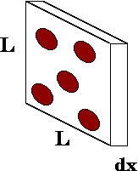

Figure 6‑1. A thin slab of material with atoms that might interact with an incoming photon (“Mean Free Path,” 2021)

### Nearest Peak Code



### Reference conditions of FC65-G ionization chamber

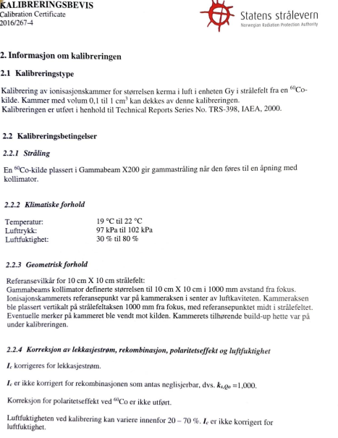

### X-ray dosimetry

Table 6‑1. Output values from ionization chamber in nC from both calibrations. Three and four repeated measurements in each position were made in the first and second calibration, respectively.

|  |  |  |  |  |
| --- | --- | --- | --- | --- |
| Ion chamber output [nc] | 31.08.21 |  |  |  |
| Position  Time [s] | A | B | C | D |
| 5 | [0.46,0.49,0.45] | [0.45,0.47,0.39] | [0.48,0.46,0.4] | [0.41,0.37,0.41] |
| 10 | [1.52,1.56,1.45] | [1.4,1.39,1.32] | [1.4,1.59,1.54] | [1.57,1.51,1.54] |
| 15 | [2.5,2.38,2.47] | [2.46,2.42,2.44] | [2.61,2.48,2.57] | [2.5,2.6,2.53] |
| 20 | [3.45,3.49,3.58] | [3.44,3.58,3.39] | [3.55,3.56,3.5] | [3.75,3.55,3.68] |
| 60 | [11.74,11.89,11.71] | [11.71,11.62,11.78] | [12.14,12.06,12.08] | [12.26,12.21,12.13] |
|  | 13.10.21 |  |  |  |
|  | A | B | C | D |
| 5 | [0.47,0.52,0.44,0.5] | [0.37,0.38,0.41,0.4] | [0.55,0.4,0.39,0.36] | [0.44,0.38,0.45,0.35] |
| 10 | [1.56,1.52,1.44,1.41] | [1.37,1.36,1.51,1.42] | [1.54,1.48,1.48,1.44] | [1.57,1.35,1.41,1.39] |
| 15 | [2.62,2.39,2.55,2.48] | [2.45,2.35,2.48,2.4] | [2.43,2.54,2.56,2.55] | [2.48,2.48,2.56,2.54] |
| 20 | [3.47,3.56,3.6,3.55] | [3.52,3.49,3.54,3.53] | [3.6,3.55,3.62,3.51] | [3.53,3.55,3.53,3.6] |
| 60 | [11.75,11.69,11.79,11.82] | [11.74,11.7,11.62,11.73] | [12.1,11.98,12.03,12.02] | [12,11.96,12.03,11.99] |

Table 6‑2. Exposure times. Low dose (0.1 to 0.5 Gy) was extracted from low dose regression, while 1 Gy and higher was found using mean dose rate found with 60 second irradiations in all positions.

|  |  |  |  |  |  |  |  |
| --- | --- | --- | --- | --- | --- | --- | --- |
| Dose [Gy] Exposure Time | 0.1 | 0.2 | 0.5 | 1 | 2 | 5 | 10 |
| 31.08.21 | $$13.1s±0.3$$ | $$23.4s±0.4$$ | $$54s±8$$ | $$1 m 43 s \\ ± 2 s$$ | $$3 m 27 s \\ ±5 s$$ | $$8 m 39 s \\ ± 13 s$$ | $$17 m 19 s \\ ± 26 s$$ |
| 13.10.21 | $$13.0s \\ ± 0.3$$ | $$23.1s±0.5$$ | $$53.3s±0.9$$ | $$1 m 40 s \\ ± 1 s$$ | $$3 m 21 s \\ ±3 s$$ | $$8 m 22 s \\ ± 9 s$$ | $$16 m 45 s \\ ± 19 s$$ |

### Gafchromic film fitting

Table 6‑3. Estimated parameters from fitting of netOD values with equation 2‑6. The fitting was performed on high and low response films separately.

|  |  |  |  |
| --- | --- | --- | --- |
| Color channel  Fitting parameters | BLUE | GREEN | GREY |
| a (high, low) | $$19±2 \\ 37±9$$ | 8 $.9±0.2$ $$11±1$$ | $$8.6±0.3 \\ 10±2$$ |
| b (high, low) | $$87±8 \\ 59±51$$ | $$40±1 \\ 39±6$$ | $$67±3 \\ 61±10$$ |
| n (high, low) | $$1.8±0.1 \\ 1.8±0.9$$ | $$2.60±0.06 \\ 2.4±0.3$$ | $$2.59±0.06 \\ 2.3±0.3$$ |

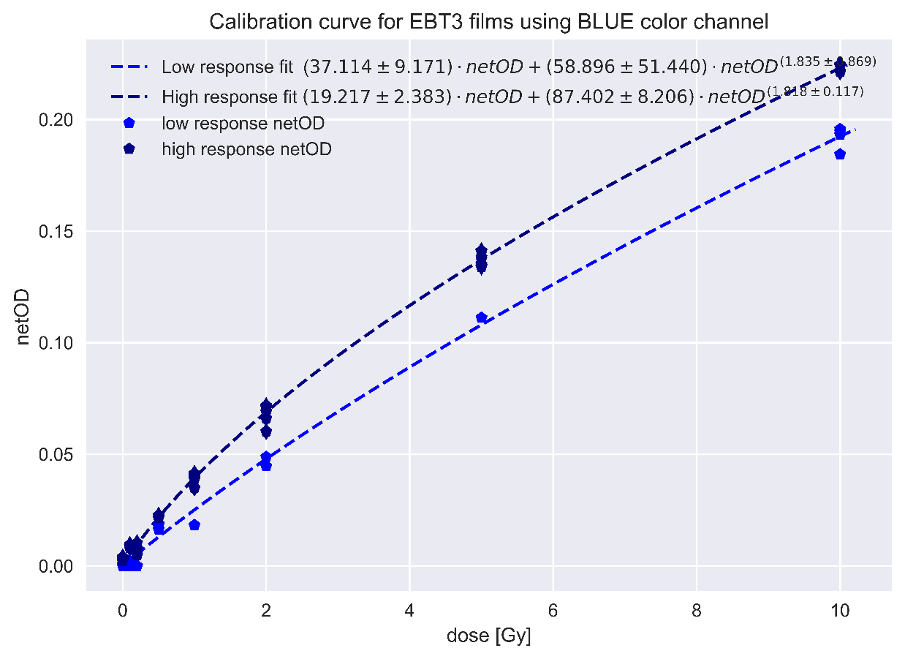

Figure 6‑2

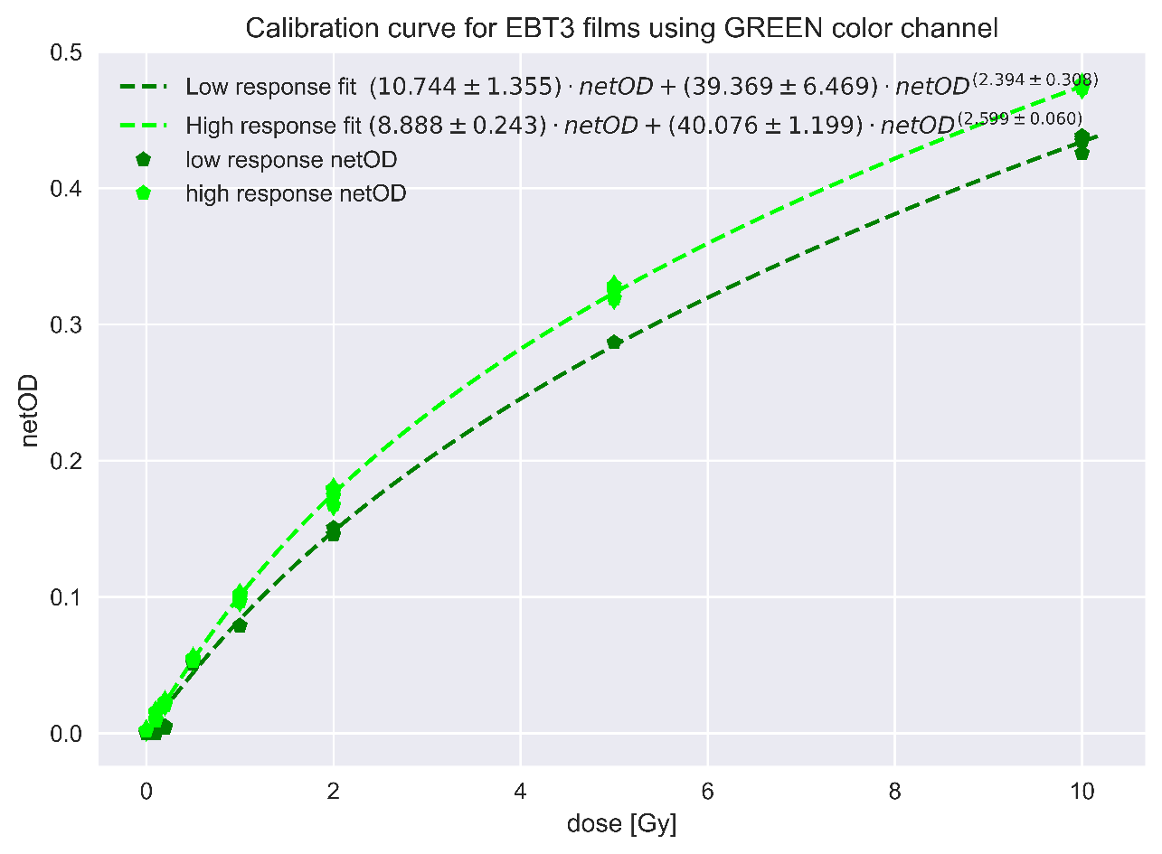

Figure 6‑3

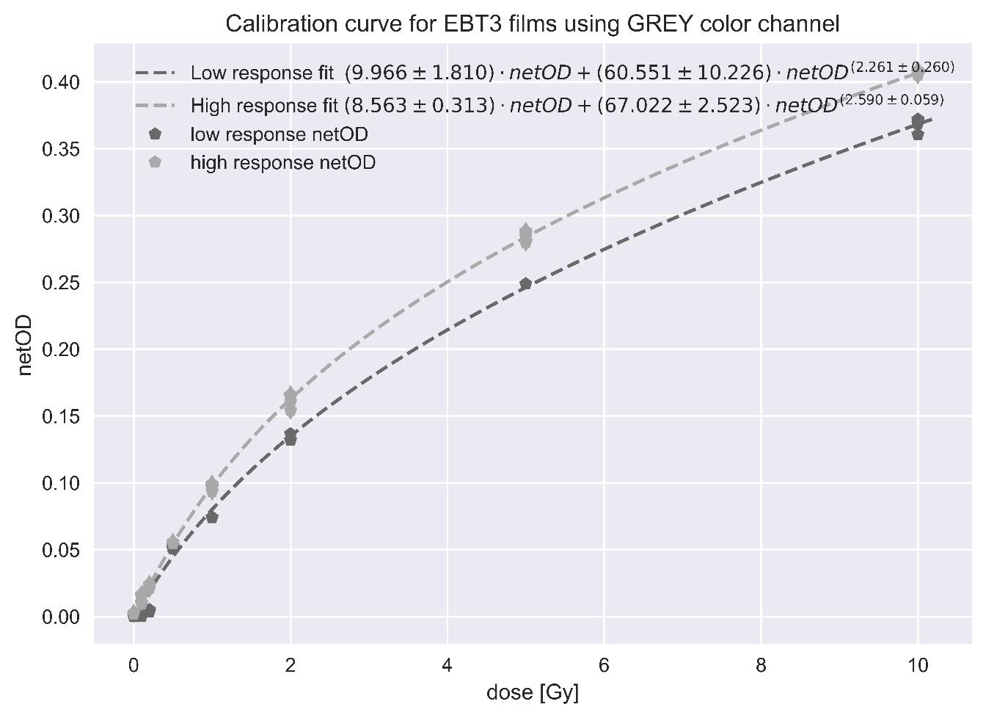

### Initial guess LM

|  |  |  |  |  |
| --- | --- | --- | --- | --- |
| Initial guess of unknown parameters of the model $$D=a⋅netOD+b⋅netOD^{n}$$ | | | Estimated parameters  [a,b,n] |  |
| a | b | n | Low response | High response |
| -2.505 | -0.994 | 0.207 | [7.238, 50.375, 2.625] | [6.205, 50.815, 2.954] |
| 1.333 | -1.283 | 0.711 | [77223.095, -77194.254, 1.0] | [100403.926, -100379.48, 1.0] |
| -0.39 | -1.349 | 1.001 | [7.238, 50.375, 2.625] | [6.205, 50.815, 2.954] |
| 0.176 | 0.17 | 0.715 | [7.238, 50.375, 2.625] | [6.205, 50.815, 2.954] |
| -0.3 | -0.358 | 0.114 | [7.238, 50.374, 2.625] | [6.205, 50.815, 2.954] |
| -0.551 | -0.035 | 0.535 | [7.238, 50.375, 2.625] | [6.205, 50.815, 2.954] |
| 1.387 | -1.142 | 0.445 | [7.238, 50.375, 2.625] | [6.205, 50.815, 2.954] |
| -0.328 | -0.096 | 0.88 | [7.238, 50.374, 2.625] | [6.205, 50.815, 2.954] |
| -0.428 | 0.308 | 0.468 | [7.238, 50.375, 2.625] | [6.205, 50.815, 2.954] |
| -1.604 | -1.323 | 0.271 | [7.238, 50.374, 2.625] | [6.205, 50.815, 2.954] |

Table 6‑4. Initial guesses made for nonlinear fitting of dose model, to test robustness of the estimations.

### Cell Segmentation

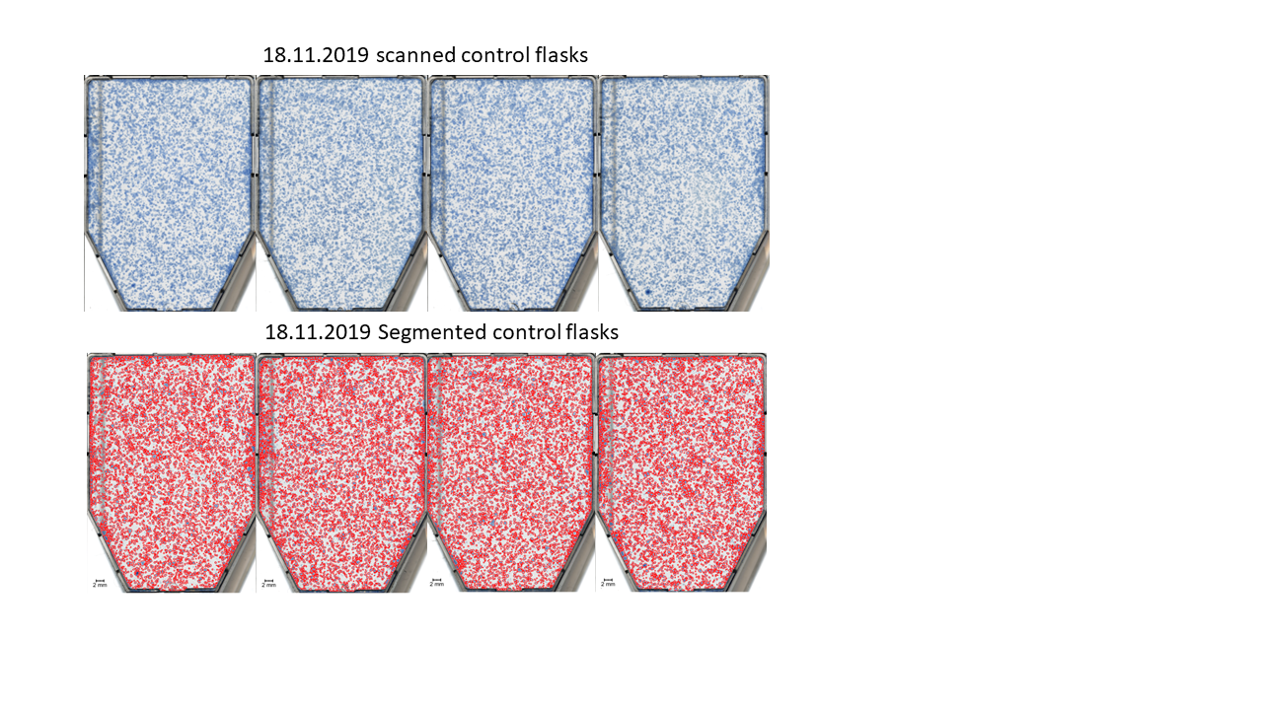

Figure 6‑4. Stained control flasks (top) and segmented control flask (bottom), for evaluation of segmentation algorithm.

### Cell flask registration

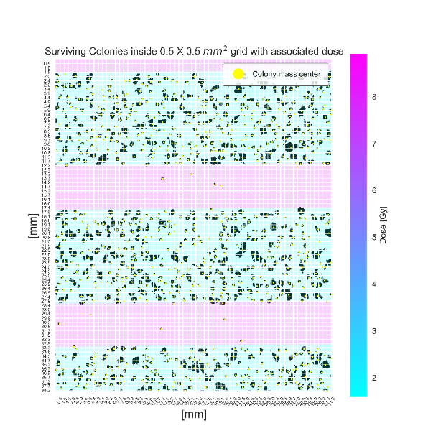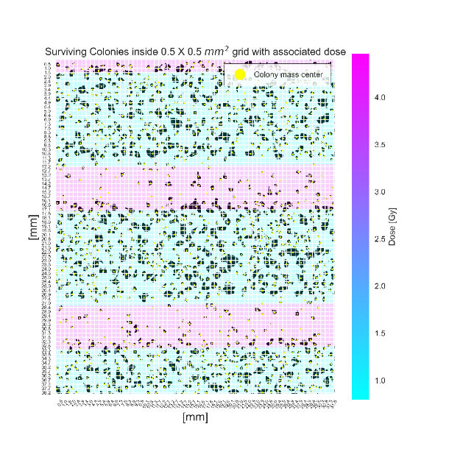Dose map registered to segmented cell flasks for 2, 5 og 10 Gy stripes and dots with quadrat size of 0.5 (top) and 4 (bottom) mm.

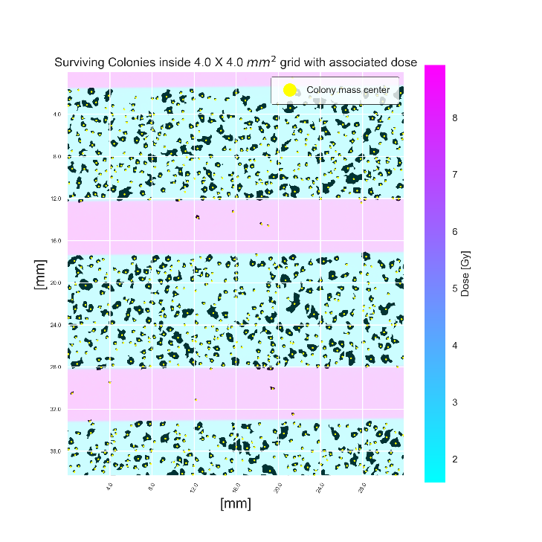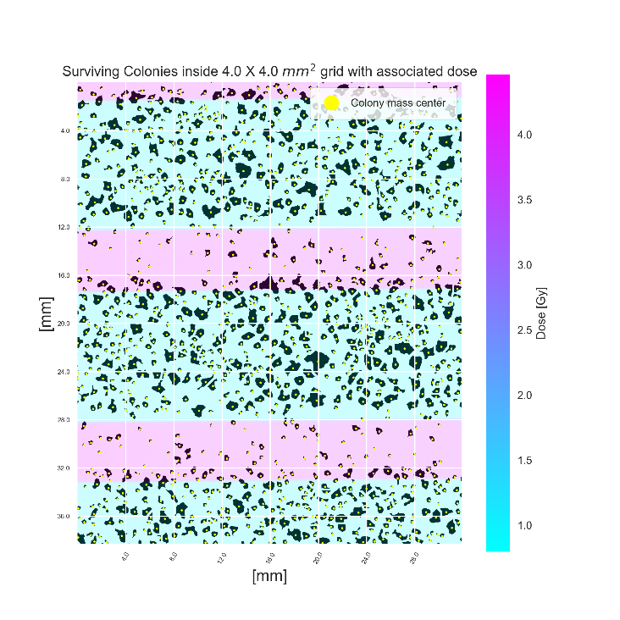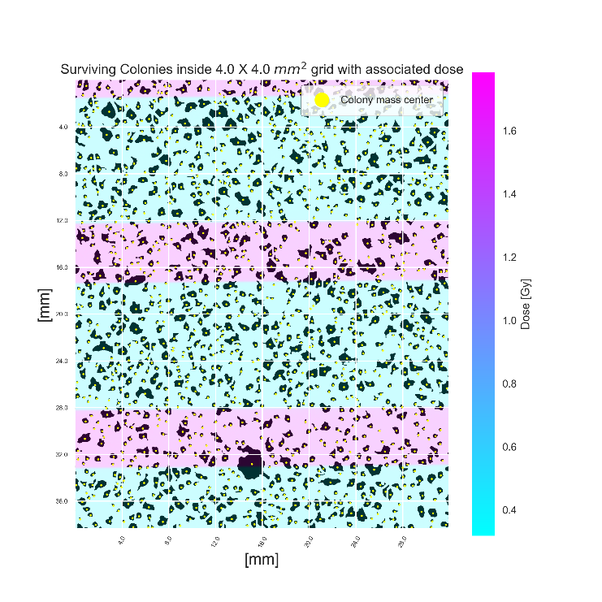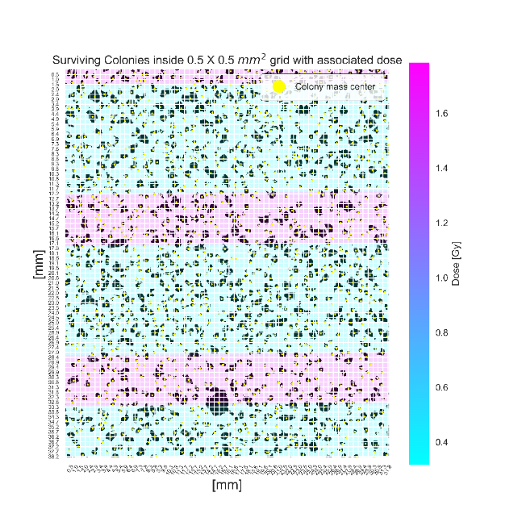

Figure 6‑5. Segmented cell flasks irradiated using a striped GRID configuration and registered to their respective dose map. The cell flask data was gathered from experiments performed 18.11.2019 and flasks were irradiated in position A.

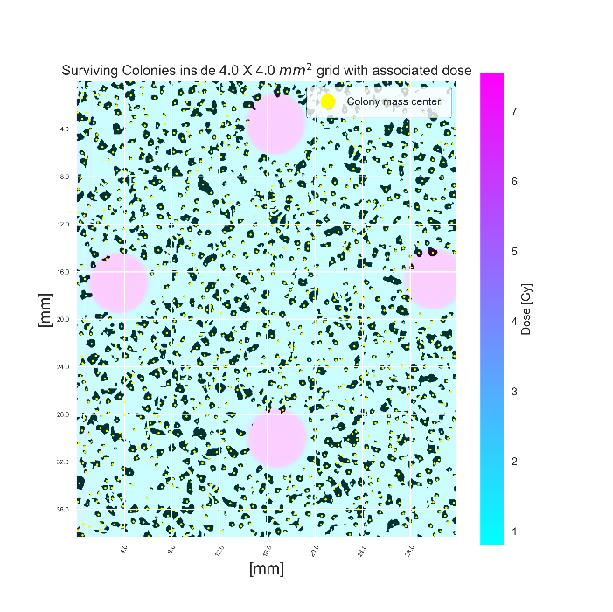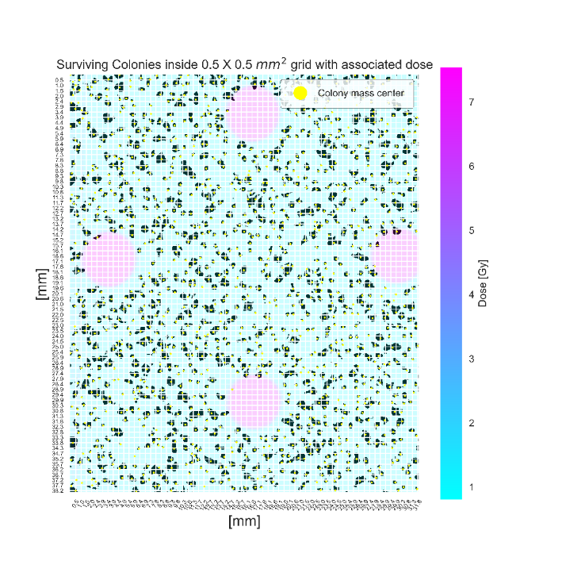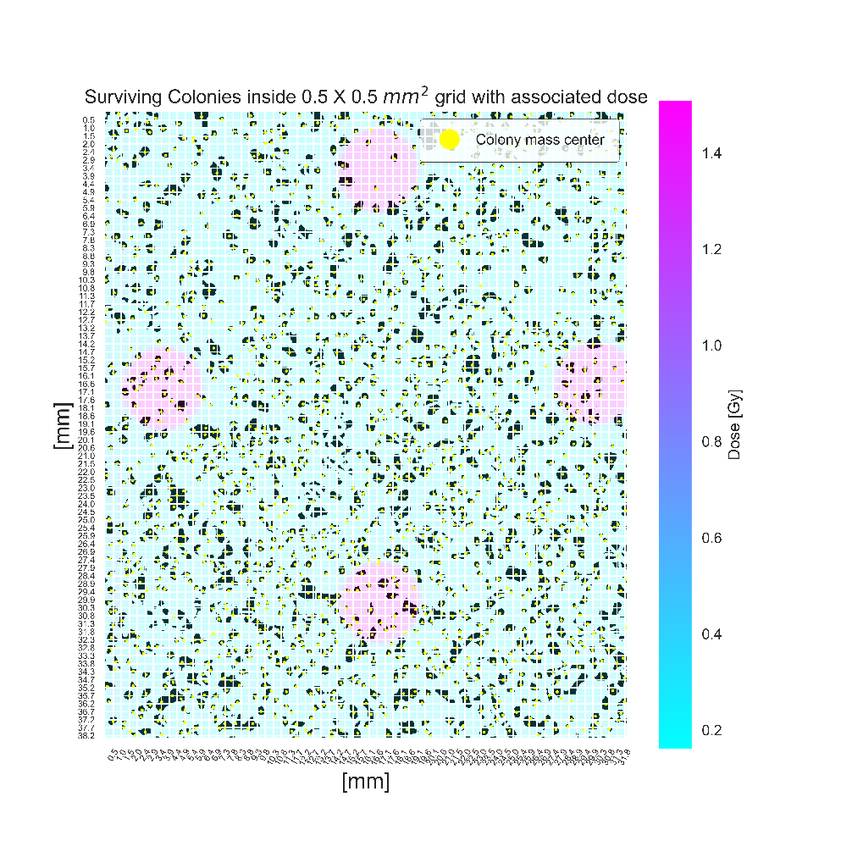

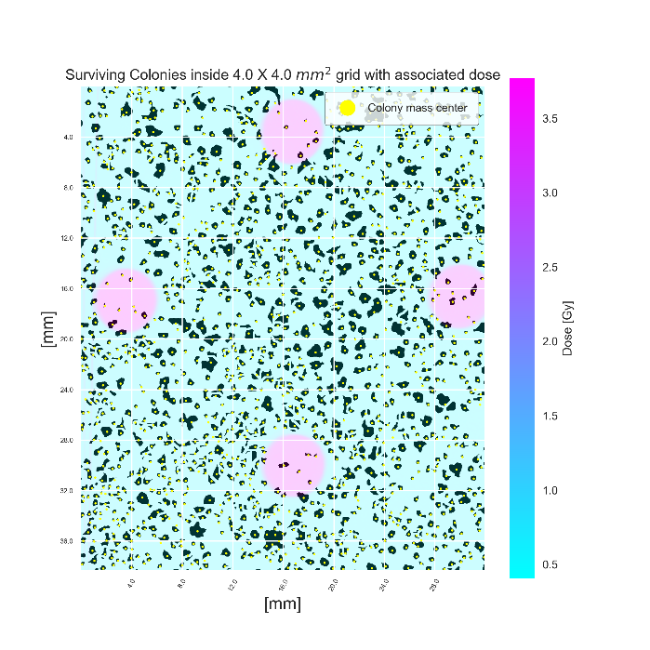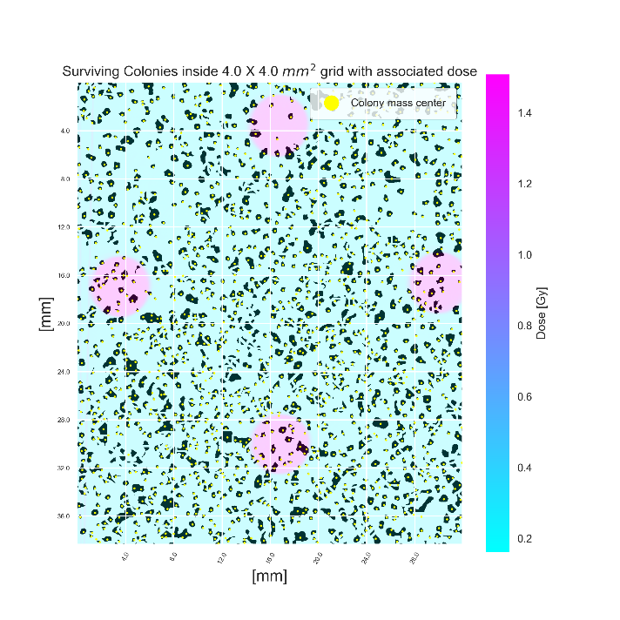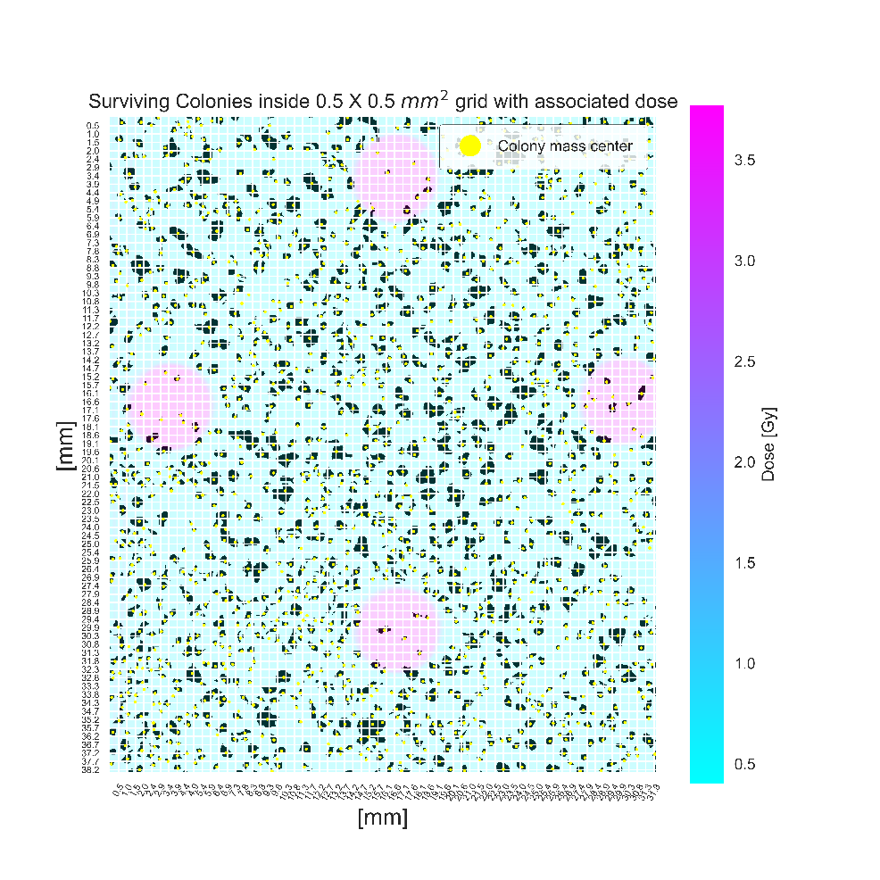

Figure 6‑6. Segmented cell flasks irradiated using a dotted GRID configuration and registered to their respective dose map. The cell flask data was gathered from experiments performed 20.11.2019 and flasks were irradiated in position A.

### Poisson eval

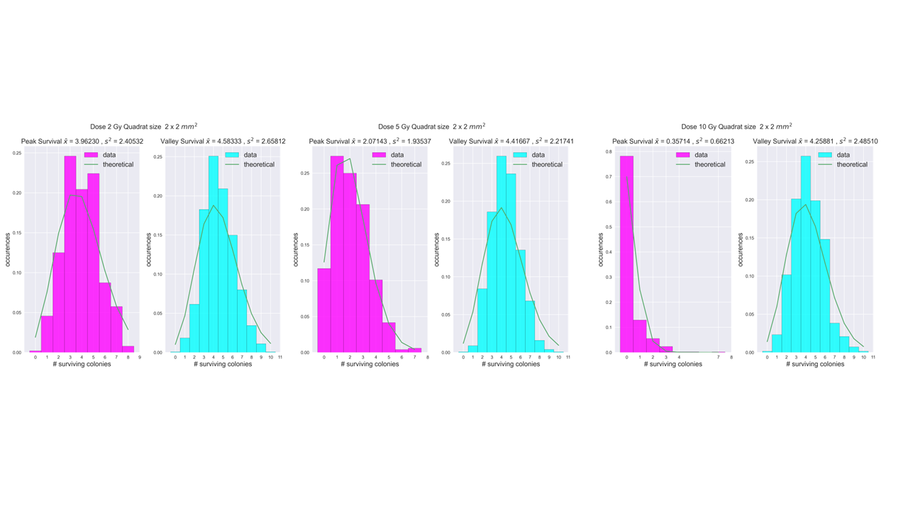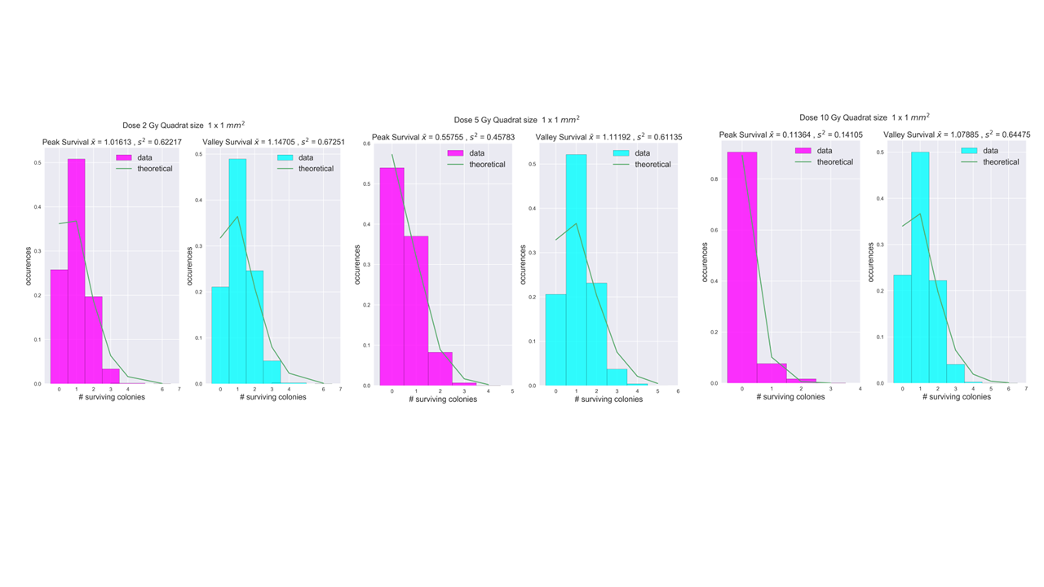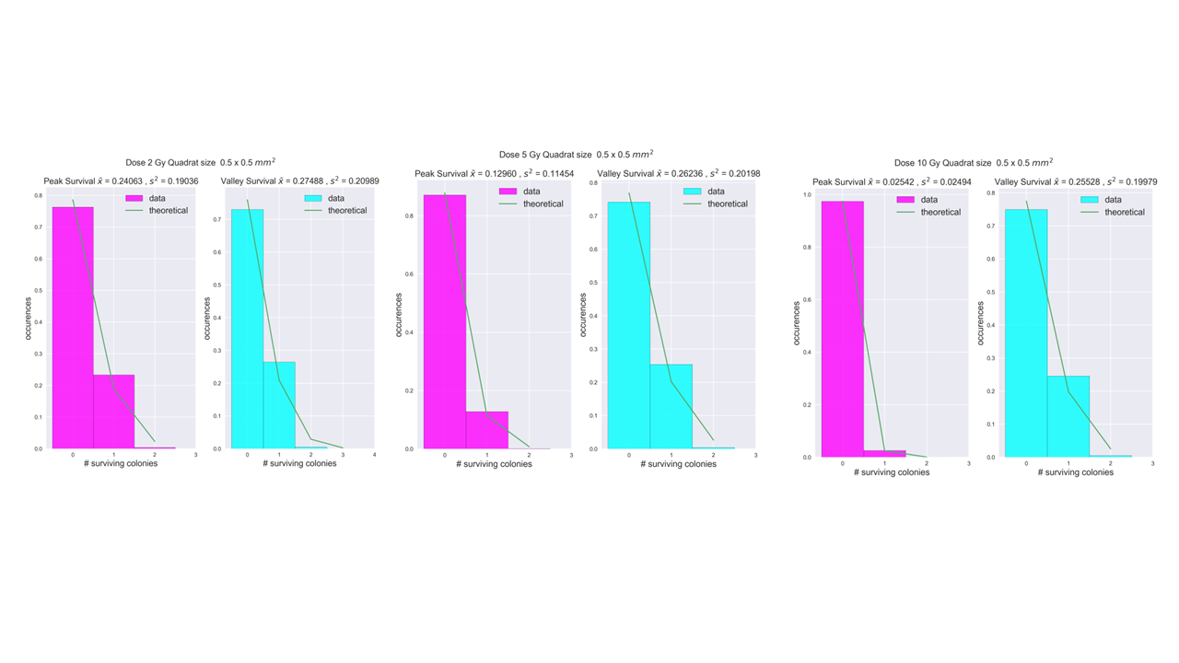Histograms of peak and valley survival, with increasing dose to the right (2,5,10 Gy), and increasing quadrat size (0.5,1,2,3,4 mm) further down.

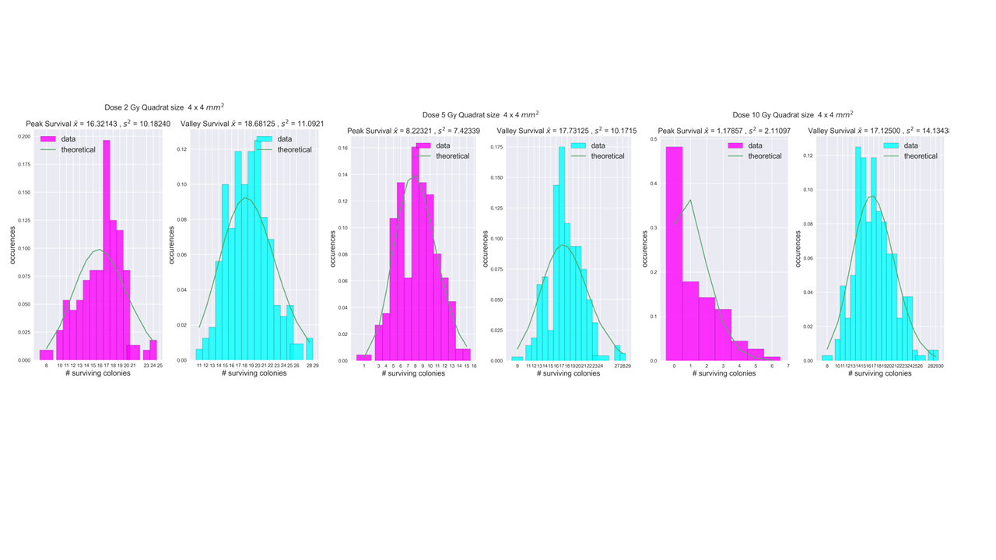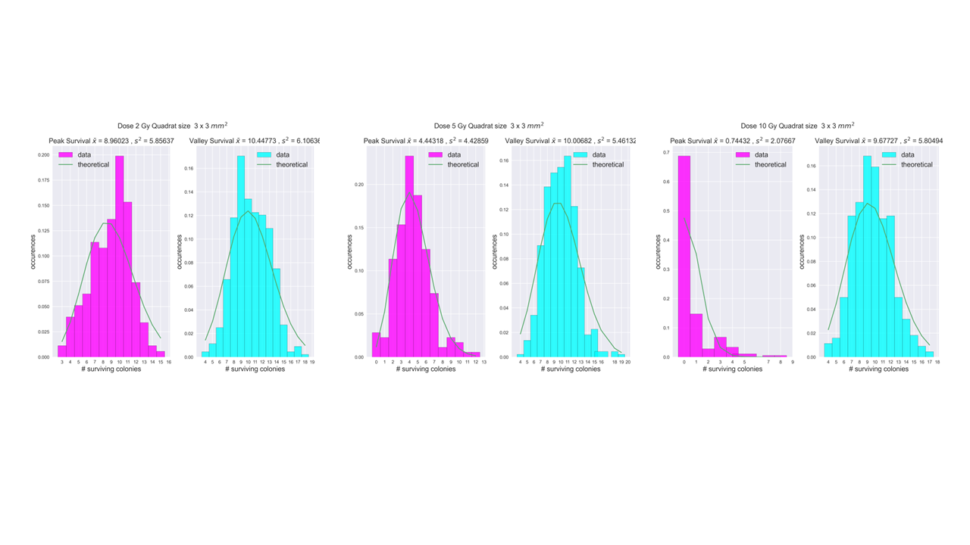

### 4 x 4 mm2 2D analysis results

Table 6‑5,. Poisson regression output for 4 x 4 mm2 with increasing number of explanatory variables. The fitting parameters are const, x1, x2, x3 and x4. Const is the intercept, x1 and x2 is dose and dose squared, respectively. x3 is either peak distance or peak area when number of explanatory variables are 3. x4 is peak distance when all explanatory variables are included.

|  |  |  |
| --- | --- | --- |
| Number of explanatory variables | Poisson regression output 4 x 4 mm2 quadrat size | $χ^{2}$ (p-value) |
| 2 |  | 0.885 |
| 3 (peak dist) |  | 0.982 |
| 3 (peak area) |  | 0.990 |
| 4 |  | 0.956 |

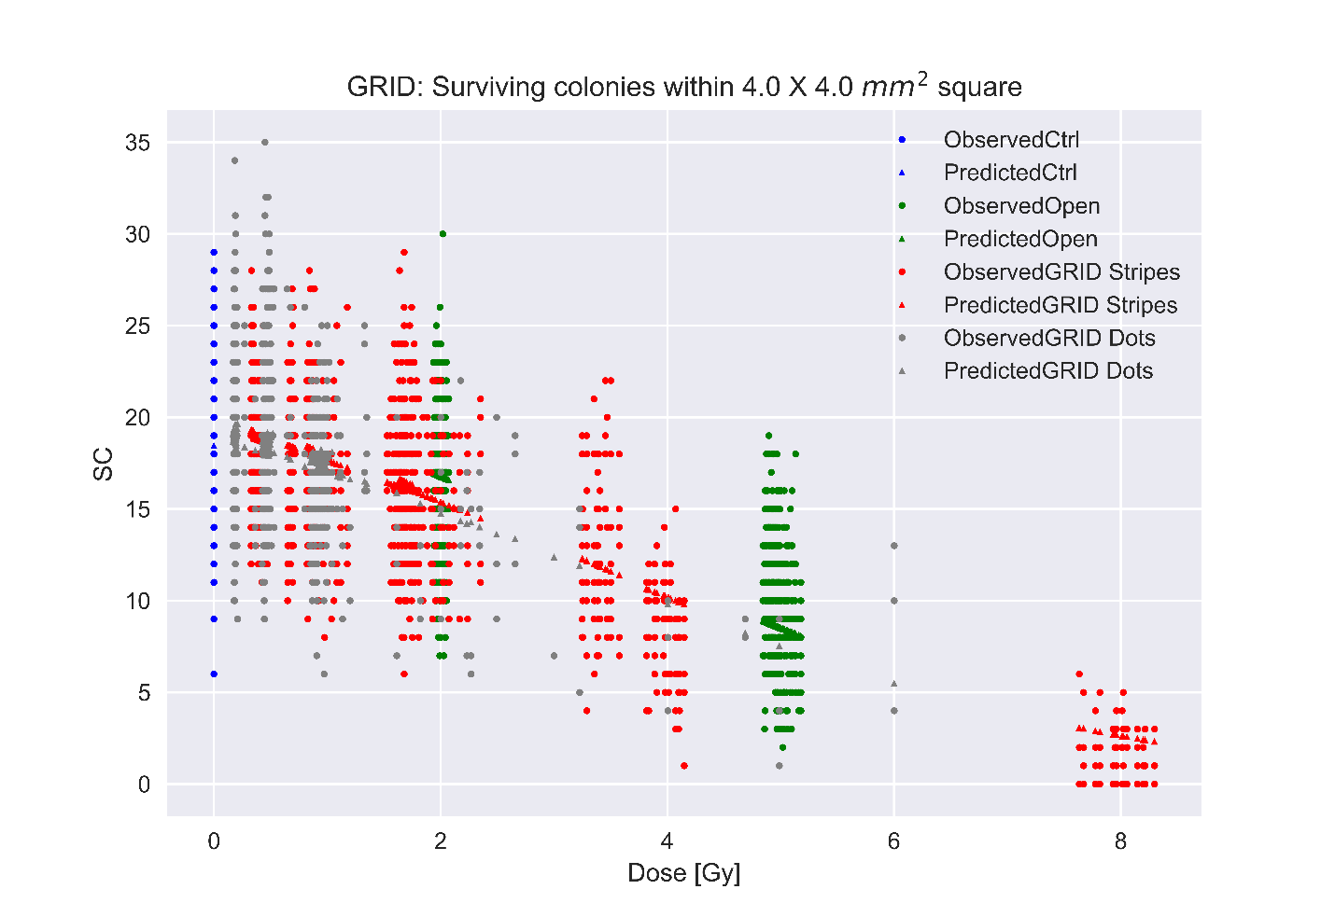

Figure 6‑10. Predicted versus observed survival data for 4 x 4 mm2 quadrat size and 4 explanatory variables. SC stands for surviving colonies.

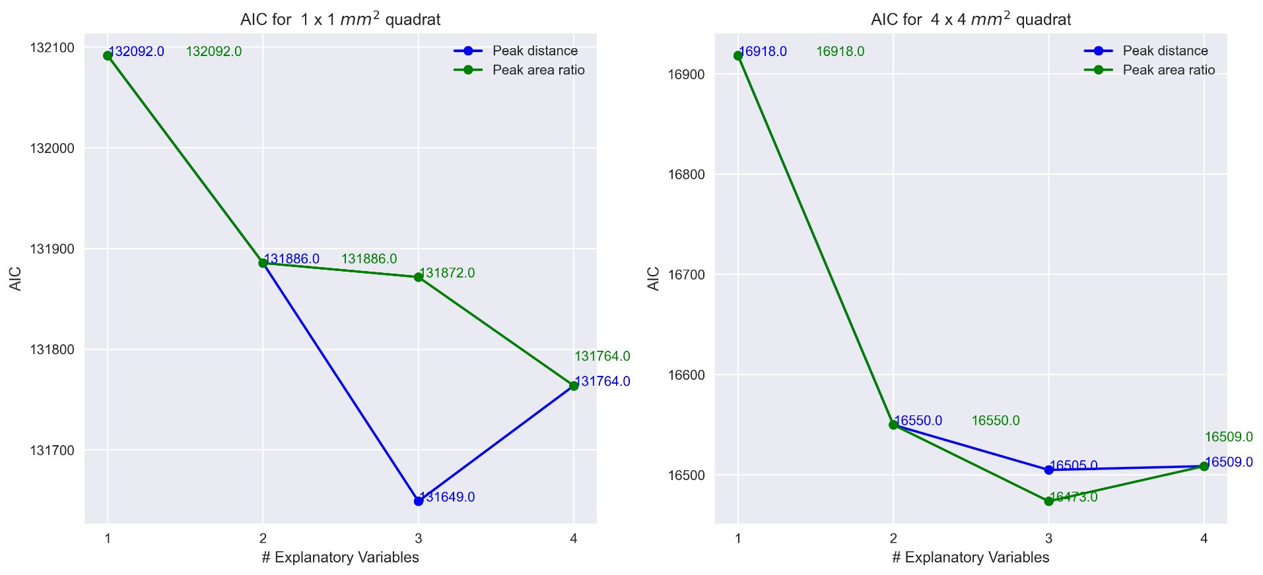

Figure 6‑9

Table 6‑6.

|  |  |  |  |  |
| --- | --- | --- | --- | --- |
| Explanatory variables | $$D$$ | $$D^{2}$$ | PAR | Peak Distance |
| $$D$$ | 1 | 0.94 | 0.60 | -0.37 |
| $$D^{2}$$ | 0.94 | 1 | 0.40 | -0.32 |
| PAR | 0.60 | 0.40 | 1 | -0.44 |
| Peak Distance | -0.37 | -0.32 | -0.44 | 1 |

### Average distance

The average distance between the 30 000 cells in the T25 cell flask (25 cm2) was done using a result from the mathematical concept of square line picking (Weisstein, n.d.), which states that picking two points randomly placed inside a unit square the average distance between them will be 0.52. Assuming uniformly distributed cells, we have a cell density of 12 cells per mm2. We want to know, how large the square needs to be to have 2 cells within the square.   
Solving the equation

$12\frac{cells}{mm^{2}}⋅x=2\frac{cells}{mm^{2}}$.

We get $x=\frac{1}{6}$. Which means that we need to reduce the 1 x 1 mm2 square by 1/6, thus a square of size $\frac{1}{\sqrt{6}}$ is expected to contain 2 cells on average with an average distance between those points of

$$0.52⋅\frac{1}{\sqrt{6}}= 0.2123≈0.2 mm .$$